

SEND and Inclusion Business Manager
Tees Valley Education Trust
Job Ref: DSA383

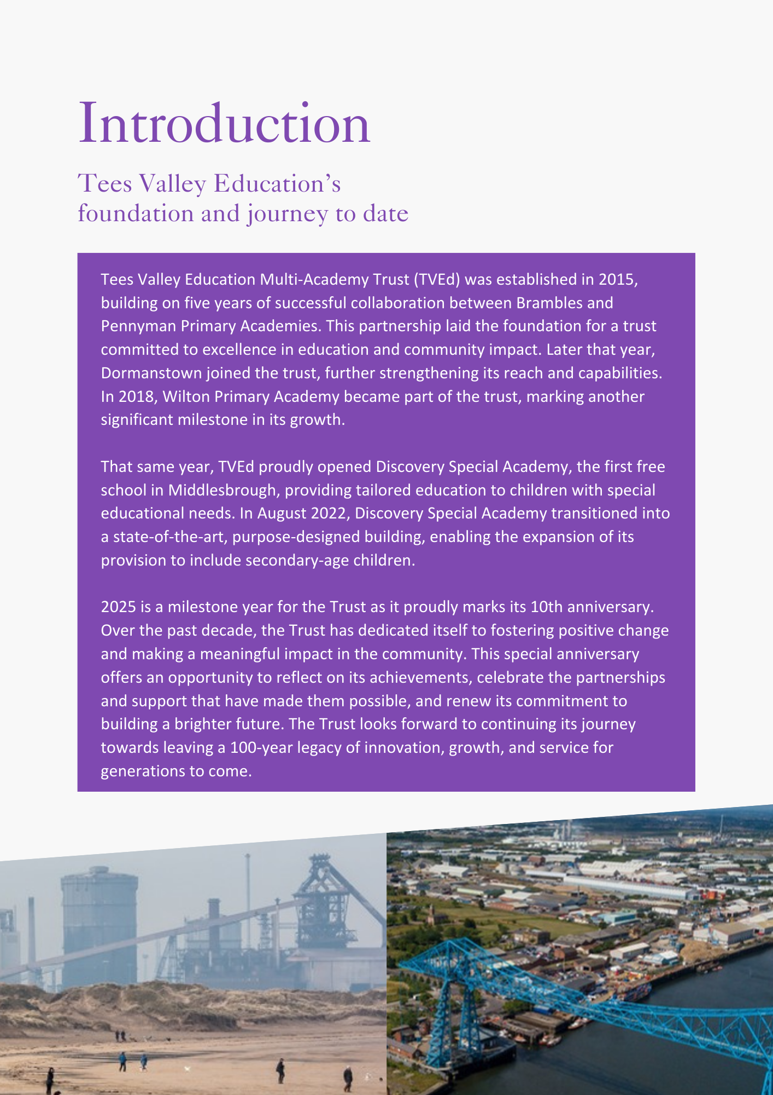

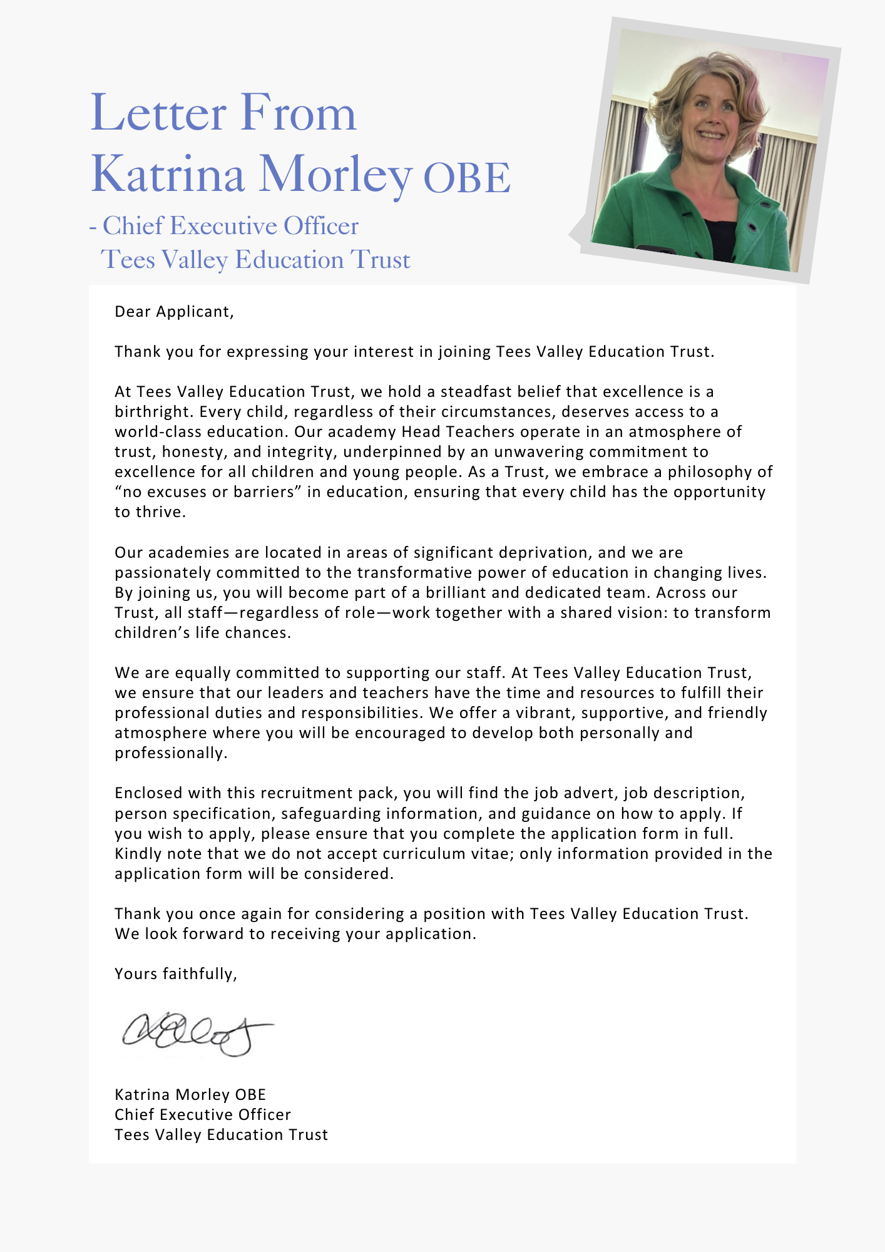

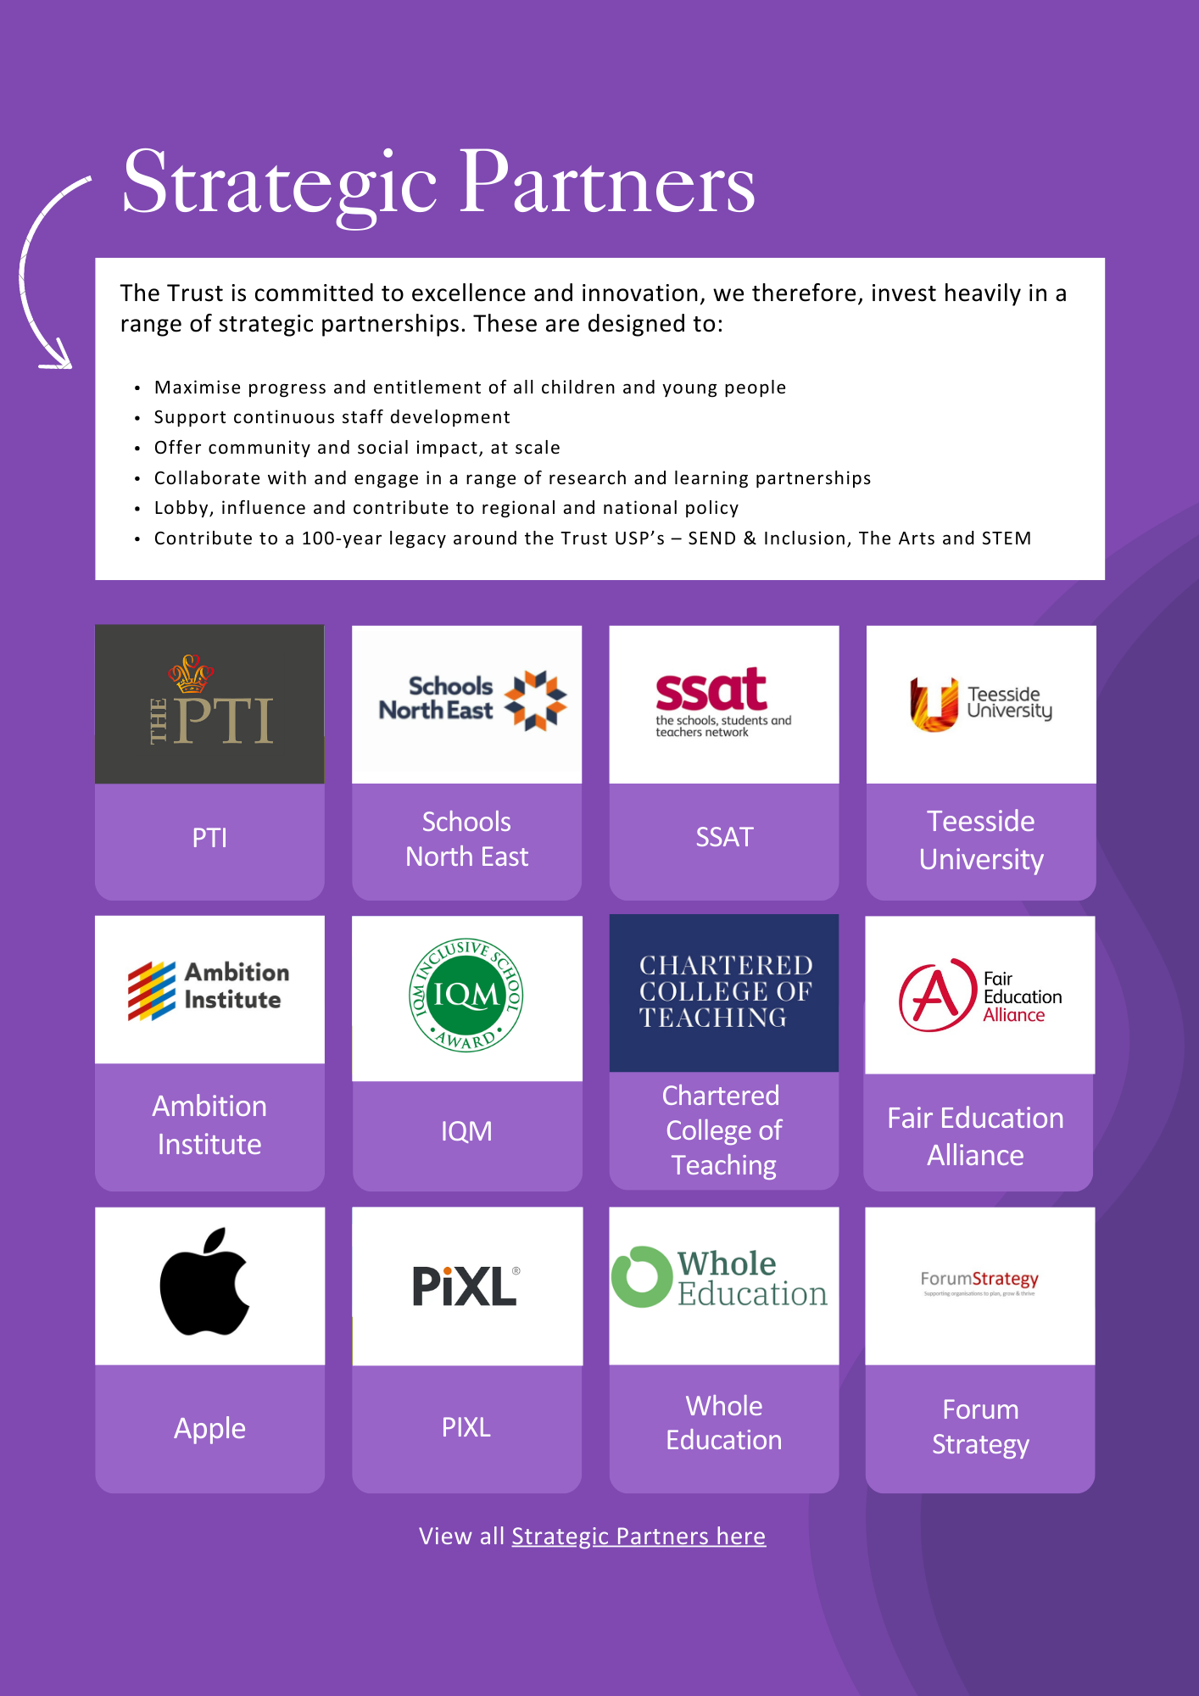



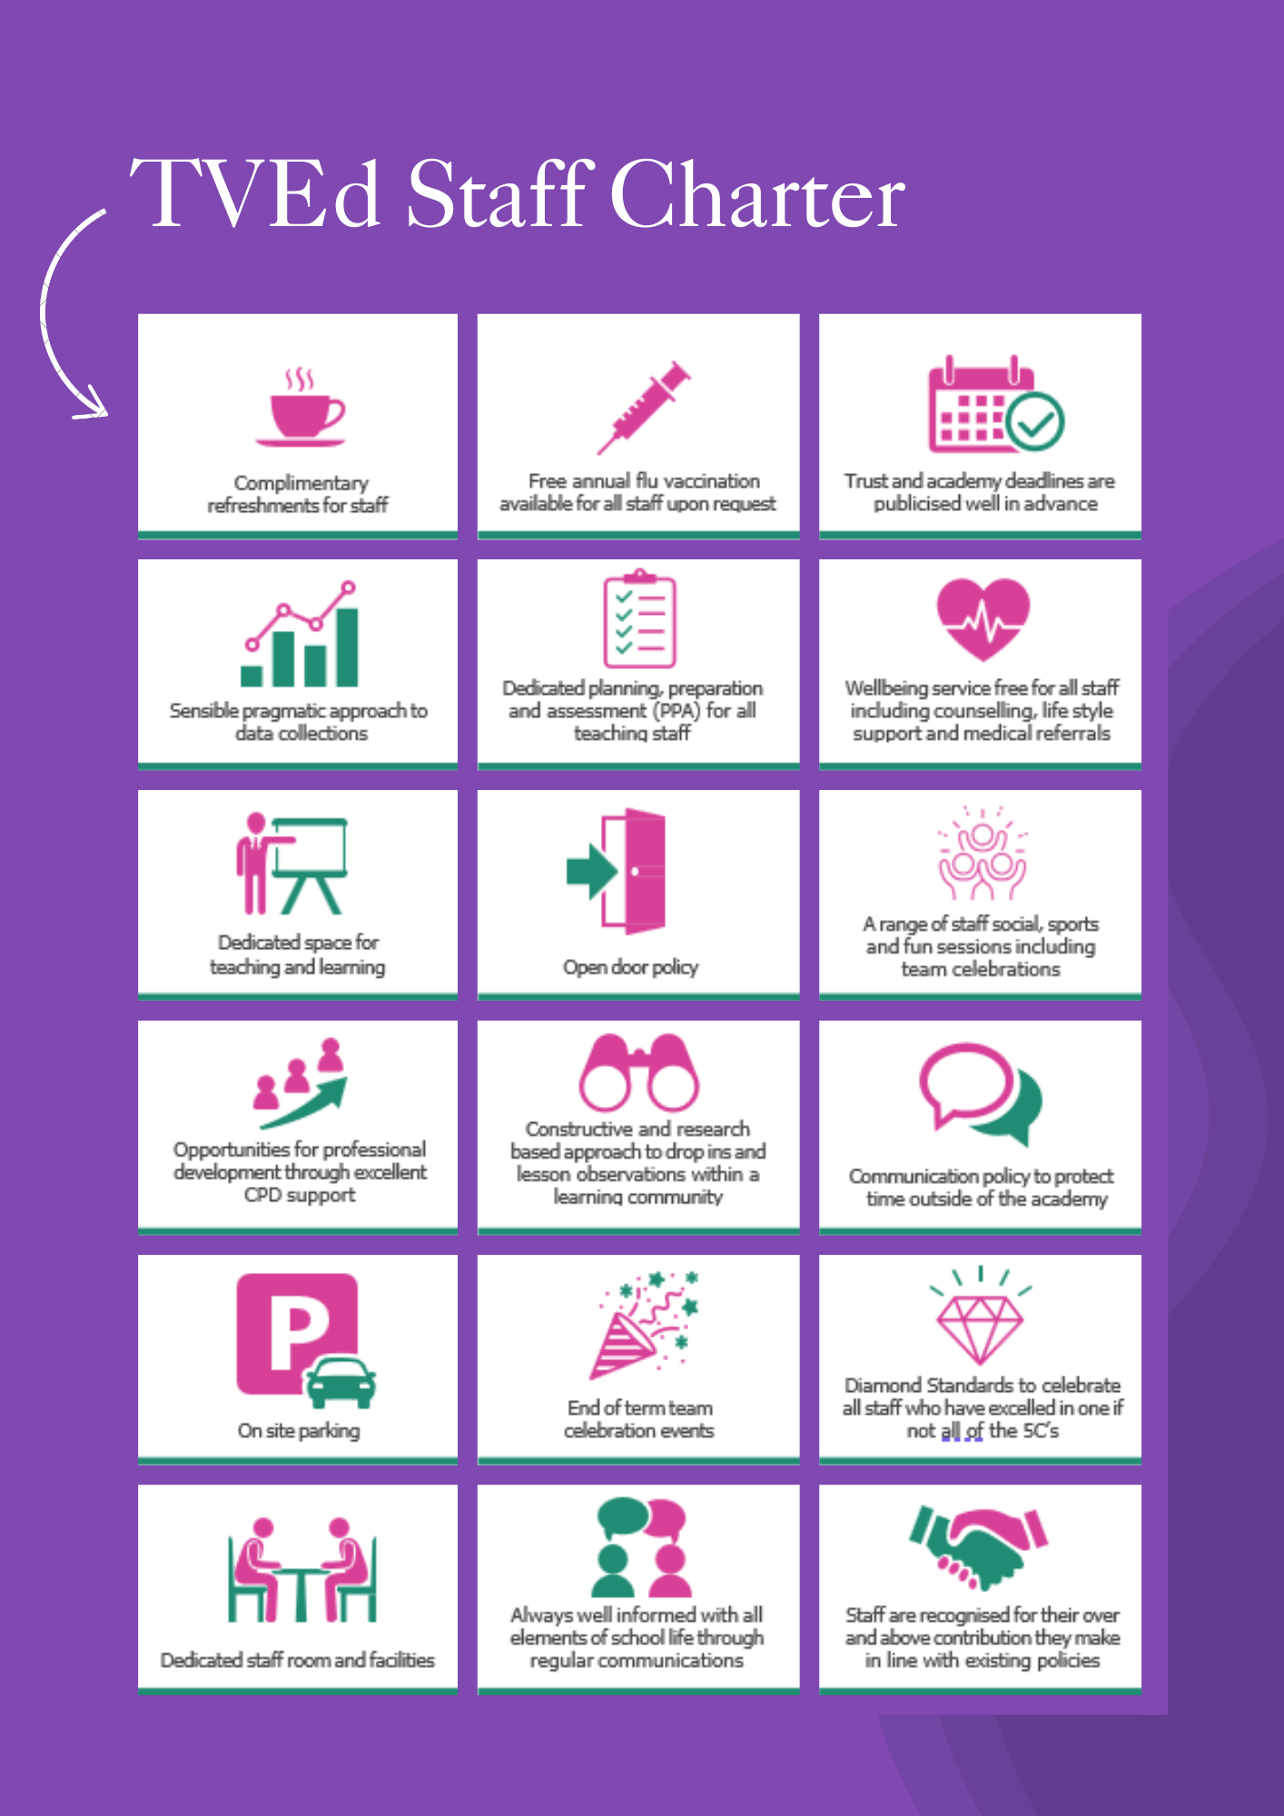

ADVERTISEMENT

SEND and Inclusion Business Manager
Status: Permanent, full time
Required: June 2026 or as soon as possible thereafter
Salary: NJC SCP 32 – 34 £40,810 to £42,955 (FTE £42,839 to £45,091)
Hours: 37 hours (Term time only, plus 5 weeks, open to conversation about whole time contract)
Reporting to: Deputy CEO for Inclusion, Standards and Sustainability
Academy base: Discovery Special Academy (working across the Trust)

About the Trust
The Trust was established in 2015 and provides education and enrichment activities to more than 1200 children across five Academies, located in Middlesbrough and Redcar and Cleveland local authority areas. Academies within the Trust are:
- Brambles Primary Academy (2 to 11 years),
- Discovery Special Academy (2 to 16 years),
- Dormanstown Primary Academy (2 to 11 years),
- Pennyman Primary Academy (2 to 11 years), and
- Wilton Primary Academy (3 to 11 years).

About the role we are looking to appoint:
As part of the Trust’s commitment to strengthening inclusion at every level, and in response to the national SEND and Inclusion reforms, the Trust has reviewed its structure. The SEND and inclusion team has been enhanced at academy level through the appointment of Deputy Headteachers with a lead for Pastoral and Inclusion and at a Trust level with the permanent appointment of a Deputy CEO for Inclusion, Standards and Sustainability. Therefore, the Trust has created a new leadership opportunity for an individual who is deeply committed to inclusive education and to securing excellent outcomes for all children, particularly those with special educational needs and disabilities. This post is suitable for anyone who has worked in a local authority in SEND policy and process, as well as business managers with SEND experience.
Together, this structure is designed to deliver sustainable improvement and to continue to grow inclusive provision, underpinned by a culture of creativity, curiosity, care, courage and commitment.
Working closely with children, families and multi-agency partners, the Deputy CEO for Inclusion, Standards and Sustainability, the Head of Inclusive and Pastoral Education and Trust leaders, the postholder will help shape and deliver the Trust’s inclusion strategy, ensuring high-quality provision, meaningful access to enrichment, and strong alignment with national and local policy developments. As a result, the role carries significant strategic and operational responsibility.
The role will report directly to the Deputy CEO for Inclusion, Standards and Sustainability, supported by the Head of Inclusive and Pastoral Education.
We are seeking to appoint a pro-active, enthusiastic, energetic and reliable Senior SEND and Inclusion Business Manager with responsibility for access to education for children and young people aged 2–16 with Special Educational Needs and Disabilities (SEND). This role will lead on ensuring quality assurance across all processes and will represent the Trust on stakeholder groups to advocate for pupils’ needs and promote best practice.
The post holder will have both strategic responsibility for quality assuring EHCPs across the Trust, liaising with professionals, leaders and teaching staff. Working closely with the Senior Leadership Team and with the SEND case officers, the role will oversee all referrals, in-year consultation response paperwork, tribunal paperwork, and support High Needs Funding applications, administration and tracking individual high needs pupil funding. By liaising with a wide range of partners and stakeholders—both internal and external—the Senior SEND and Inclusion Business Manager will ensure pupils with SEND receive appropriate and timely support, achieve the best possible outcomes, and the Trust’s standards for quality assurance are consistently upheld.
What we are looking for:
We are seeking a highly organised individual who can confidently manage a busy caseload and bring extensive relevant knowledge and experience, along with the skills and qualifications needed to thrive in a dynamic, supportive environment.

What the Trust will provide the successful candidate with:
- A workplace where all staff are valued and treated with respect as outlined within the Trust’s Diamond Standards
- A passionate, enthusiastic and supportive Leadership Team
- A listening and learning organisation where all staff are encouraged to be curious and share ideas for the Trust/academies/team to improve
- Hard working, committed and dedicated staff who strive to gain the best outcomes for all children across the Trust’s academies
- Dedicated approach to children’s learning to encourage them all to be the best they can be
- Career enhancement opportunities within areas of interest as well as supporting ongoing professional development and training specific to job role
- Dedicated line manager to discuss work streams and capacity
- Free access to the Trust’s Wellbeing offer, which includes counselling, access to a GP, Mindfulness and so much more.
- Free parking
- Enrolment into the local government pension scheme with employer contribution of 16%.
- All support contracts are employed on National Joint Council (NJC) for local government services (also known as Green book)
- Benefits of the Trust’s Staff Charter which can be found at TVED Staff Charter.
Safeguarding requirements for the role:
Tees Valley Education Multi Academy Trust is committed to safeguarding and promoting the welfare of children. All appointments will be subject to a satisfactory enhanced DBS check.
This post is exempt from the Rehabilitation of Offenders Act 1974 and, therefore, all convictions, cautions and bind-overs, including those regarded as “spent” must be declared. The Trust’s Recruitment of Ex-Offender policy can be requested or visit the Trust’s website.
Applications are invited from prospective candidates who demonstrate that they can meet the essential criteria set out in the person specification and who have the vision, values and tenacity to join an outstanding team and help continue the journey towards excellence.

JOB DESCRIPTION
SEND and Inclusion Business Manager
To champion and advance high-quality inclusive practice by proactively developing and implementing strategic initiatives, working collaboratively with pupils, families, staff and external partners to ensure effective and sustainable support for children and young people with special educational needs and disabilities (SEND). The post holder will be responsible for the strategic leadership, operational oversight, quality assurance and statutory compliance of SEND processes, including leading, coordinating and ensuring delivery of EHCP reviews and referral processes, driving continuous improvement and ensuring alignment with the Trust’s wider objectives. This post has strategic trust-wide oversight; sets standards; assures quality across multiple sites and leads improvement implementation.
SUPPORTING PUPILS AND FAMILIES
- Work in collaboration with children, young people, their families, education providers and other stakeholders to ensure the best possible outcomes for children and young people with SEND.
- Build partnerships and networks both internally and externally to ensure effective and improved service delivery for children and young people with SEND.
- Build and maintain strong partnerships with education providers, Local Authorities and external agencies to ensure effective collaboration in meeting the needs of pupils with SEND
- Offer specialist advice to academy staff, parents and other agencies on issues relating to SEND.
- Support SEND case officers and pastoral teams to liaise with LA transport teams regarding referrals and transport arrangements for eligible pupils.
- Support pupils and families at transition points including school moves and transition to secondary/post 16 provision ensuring information is shared effectively and appropriate place planning takes place.
- Ensure access to holiday clubs and, where appropriate, make use of holiday access funds. The postholder will support the smooth running and management of holiday club sessions at the specialist setting , being responsible for safety and wellbeing of pupils attending while the clubs are running.
- Lead and coordinate professional challenge in the event statutory processes are not being adhered to.
INCLUSION AND SEND SUPPORT
- Keep up to date with all developments in SEND, ensuring information and updates are disseminated to the trust SEND and Inclusion team.
- With the Trust SEND and Inclusion team, lead on commissioning to support access to services - this could include psychologists, health and social care providers, speech and language therapists and occupational therapists.
- Ensure knowledge of and compliance with relevant policies, guidance and procedures.
- Identify and lead implementation of improvements to working methods to enhance SEND service delivery.
- Develop, deliver and contribute to continued professional development of academy and trust staff.
- Represent the academy and trust at strategic and operational boards and multi-agency groups locally and regionally as required, including schools’ management forum.
- Be a visible presence and take a lead role as part of the Trust SEND and Inclusion team
- Develop trust wide quality assurances processes to ensure EHCPs and Individual Support Plans at an academy and trust level are robust and support with improving children’s outcomes.
- Quality assures key policies, including Accessibility Report, SEND Information Report, special school admissions and ensuring consistency of these across the trust.
- Identify opportunities to improve SEND systems, documentation and processes to enhance service delivery and efficiency.
- Act as a key point of contact for complex cases, supporting resolution and escalation where required.
- Provide specialist guidance to staff to ensure appropriate procedures are followed in SEND referrals and statutory processes.
- Ensure equitable access to all pupils, with timely referrals for support where required.
- Understand the legal frameworks in SEND accessibility and processes, being confident to seek legal advice and guidance, and to offer professional challenge where required.
- Support the SEND and Inclusion team at a Trust and Academy level, to ensure high expectations of attendance and behaviour, support the development and review of policy and practice in these areas.
- Take a lead role in implementing SEND reforms, including access to specialist provision packages through high quality EHCPs and individual student support plans, that clearly evidence complexity of need.
- Work with business managers across the trust to ensure safe environments for pupils with SEND, supporting the development of risk assessments and relevant policies.
EDUCATION, HEALTH AND CARE PLAN CO-ORDINATION AND QUALITY ASSURANCE
- Maintain oversight of EHCP caseloads across the Trust, ensuring reviews, amendments and statutory submissions are completed within required timelines.
- Liaise closely with the Local Authority regarding EHCP processes, consultations, amendments and placements.
- Quality assure EHCP documentation and Individual Support Plans across the Trust to ensure clarity, accuracy and compliance with statutory expectations.
- Support case officers to prepare and submit EHCP referral applications and supporting evidence to the Local Authority.
- Provide support to the case officers to promote effective management and thorough review of EHCPs across academies.
- Lead and coordinate legal advice and guidance required for complex cases at an academy and trust level
SEND CASE MANAGEMENT, FUNDING AND REPORTING
- Review and quality assure documentation for in-year consultations, place planning and SEND Tribunal submissions, including preparation of reports and supporting evidence, this may include attendance at tribunal hearings for more complex cases.
- Maintain accurate records and documentation relating to SEND processes and statutory casework.
- Monitor and manage High Needs Funding applications, ensuring accuracy, timely submission and effective tracking of funding allocations.
- Monitor SEND caseloads and maintain relevant data to support effective oversight of SEND processes.
- Produce reports and documentation as required to support senior leaders, the Trust SEND team, trustees and external stakeholders.
- Support senior leaders in reviewing SEND resource use and identifying funding opportunities.
- Maintain oversight of SEND related documentation required for funding, inspections and audits.
- Support leaders across the trust with exclusions and admissions appeals, including procurement of services for appeals where the local authority does not provide this.
SAFEGUARDING
All staff must adhere to the Trust’s safeguarding training (appropriate for job role) including policies, procedures, latest Keeping Children Safe in Education guidance and Working Together to Safeguard Children DfE 2018.
ADDITIONAL RESPONSIBILITIES
The job holder may be required to undertake additional duties as could be reasonably
required in exceptional or emergency situations. These may include:
- to work flexibly between the hours of 8am and 6pm.
- to work across the Trust if required.
- to undertake additional training, e.g. first aid.
This job description will be reviewed annually and may be subject to amendment or modification at any time after consultation with the post holder. It is not a comprehensive statement of procedures and tasks, but sets out the main expectations of the Trust in relation to the post holder’s professional responsibilities and duties.

Elements of this job description and changes to it may be negotiated at the request of either the line manager.

PERSON SPECIFICATION
QUALIFICATIONS
Relevant degree/professional qualification (or equivalent vocational qualification) with substantial experience in SEND/inclusion statutory processes. | A, I, R | E1
Grade C/4 (or equivalent) in English and Mathematics | A, I, R | E2
Evidence of continued professional development, including CPD in SEND leadership, quality assurance and/or change implementation. | A, I, R | E3
EXPERIENCE
Significant experience of leading statutory SEND processes (EHCP referrals, annual reviews, amendments) and ensuring statutory compliance, timeliness and quality. | A, I, R | E4
Experience of shaping and/or implementing SEND/inclusion strategy, service improvement priorities or reform implementation across an organisation (e.g., Trust-wide or multi-site). | A, I, R | E5
Experience of working in a multi-agency environment, building effective partnerships and influencing outcomes with education, health, care and Local Authority stakeholders. | A, I, R | E6
Experience of representing an organisation at strategic boards / multi-agency groups and communicating a clear professional position, including professional challenge. | A, I, R | D1
Ability to design, implement and report against quality assurance frameworks and improvement plans (e.g., auditing EHCP/SEND plan quality, statutory timeliness, and impact). | A, I, R | E7
Experience of developing and delivering CPD/training and building capability across a wider workforce (e.g., SEND processes, inclusive practice, statutory compliance). | A, I, R | E8
Demonstrable experience of acting as lead professional on highly complex/high-conflict statutory SEND cases (including mediation/tribunal preparation and attendance where required), including de-escalation and resolution. | A, I, R | D2
Experience of providing oversight and quality assurance of SEND casework completed by others (e.g., peer review, auditing, coaching and setting standards). | A, I, R | E9
Experience of coordinating/leading commissioning or service access pathways (SALT/OT/EP etc.) and evaluating impact. | A, I, R | D3
Experience of working with children and young people aged 3–16 with SEND and their families, including supporting transitions and securing appropriate provision. | A, I, R | E10
Experience of producing reports and presenting complex information to senior leaders/trustees and external stakeholders to inform decisions and demonstrate statutory compliance and impact. | A, I, R | E11
KNOWLEDGE, ABILITIES AND SKILLS
Demonstrative knowledge of the application, principles, theory and practice of the specialist area of responsibility, including up to date knowledge of relevant legislation, statutory guidance and local authority SEND procedures and those required to safeguard and promote the welfare of the child. | A, I, R | E12
Knowledge of services relevant to children, young people, families and carers, groups and partner agencies. | A, I, R | D4
Proven ability to implement and deliver effective implementation of complex and challenging solutions which are consistent with existing, new or evolving policy/procedure. | A, I, R | E13
Proven technical ability in the interpretation of reports from a wide range of professionals and in exercising technical ability and judgement of these. | A, I, R | E14
Ability to apply technical/specialist judgement to ensure service area objectives are achieved. | A, I, R | D5
Ability to plan and organise a range of complex activities and priorities. | A, I, R | E15
Flexible and responsive approach to work supporting effective and creative problem solving. | A, I, R | E16
Comprehensive understanding of all existing policy and procedures and application in a changeable and challenging environment. | A, I, R | D6
Experience of working independently with relevant specialised systems, equipment and/or software to utilize ICT skills to support working practice. | A, I, R | E17
Ability to work in a team and develop and sustain partnership across teams and services. | A, I, R | E18
Other
Commitment to equality and diversion. | A,I | E19
Commitment to health and safety. | A, I, R | E20
Always demonstrate the Trust values and behaviours and actively promote them in others. | A, I, R | E21
Essential car user | A, I, R | E22

AM (Assessment Method), A- Application Form, I – Interview, R – Reference,
E – Essential, D - Desirable
Important: In the first instance, applications are assessed against the criteria listed above, in addition to overall presentation, use of standard English and grammatical accuracy.

Where applications do not meet the expected standard, they will be rejected before being matched to the person specification.

HOW TO APPLY AND EXPLANATORY NOTES OF THE PROCESS

An application form is attached. Application packs can be downloaded or printed directly from the Trust website www.teesvalleyeducation.co.uk or requested from the academy. Only applications via the Trust’s official application form will be accepted. Please do not submit a CV as substitute for part or full application form, the information will not be accepted or considered.
If you are submitting your completed application form by e-mail to recruitment@tved.org.uk - please be aware the academy cannot be responsible for any formatting anomalies when printing. If you are unable to submit an electronic application form, handwritten or electronic printed copies should be posted or hand delivered to the following address for the attention of Mrs Lucy Simpson

Tees Valley Education
c/o Pennyman Primary Academy
Fulbeck Road
Middlesbrough
TS3 0QS

Shortlisting Process
After the closing date, short listing will be conducted by a panel, who will match your skills/experience against the criteria in the Person Specification. You will be selected for interview entirely on the contents of your application form, so please read the Job Description and Person Specification carefully before you complete your form.
Shortlisted candidates will receive:
- Letter confirming interview details.
- Details of original ID documentation is required to confirm candidates. Photocopies or certified copies are not accepted.
- Criminal Record Self-Declaration Form, which must be brought on the day of the interview in the sealed envelope provided.

References for successful Candidate/s
We may seek references for shortlisted candidate/s and we may also approach previous employers for information to verify particular experience or qualifications before the interview. Any relevant issues arising from references will be taken up post interview.

Interview process
In addition to candidates’ ability to perform the duties of the post, the interview will also explore issues relating to safeguarding and promoting the welfare of children, including:
- Motivation to work with children and young people
- Ability to form and maintain appropriate relationships and personal boundaries with children and young people
- Emotional resilience in working with challenging behaviours
- Attitudes to use of authority and maintaining discipline

Conditional Offer: Pre-Employment Checks
Any offer to a successful candidate will be conditional upon:
- Verification of right to work in the UK
- Receipt of at least two satisfactory references (if these have not already been received)
- Verification of identity checks and qualifications
- Satisfactory enhanced DBS check
- Verification of professional status such e.g. QTS Status, NPQH (where required)
- Satisfactory completion of a Health Assessment
- Satisfactory completion of the probationary period (where relevant)
- Where the successful candidate has worked or been resident overseas in the previous five years, such checks and confirmations as may be required in accordance with statutory guidance.

Please contact Miss Jennifer Duncan, Deputy CEO and Executive Headteacher on 01642 248333 to arrange a visit.
For your information, the recruitment timetable is detailed below:

Closing date: Thursday 14th May 2026 at 9:00am
Shortlisting date: Thursday 14th May 2026
Interview date: Tuesday 19th May 2026
UK General Data Protection Regulation
Refer to our privacy policy on how we will process your personal data including how you can request to access your personal data via Tees Valley Education website: http://www.teesvalleyeducation.co.uk.

EQUALITIES INFORMATION AND OBJECTIVES STATEMENT

As an academy we ensure that our vision, values and ethos meet the expectations of the equality and diversity guidelines and legislation set out by the Equality and Human Rights Commission. This includes the following 9 protected characteristics:
- Age
- Disability
- Gender Reassignment
- Marriage and Civil Partnerships
- Pregnancy and Maternity
- Race
- Religion or belief
- Sex
- Sexual Orientation

Objectives Statement
- To support children’s sensory, academic and communication skills to enable them to develop holistically.
- To ensure high expectations across all aspects of the academy (as outlined in objective 1) to ensure children make the best progress according to their individual starting points.
- To continue to monitor attendance of all groups of children in the academy.
- To review levels of parental and pupil engagement in learning and academy life, across all activities and ensure equality and fairness in access and engagement.
- To ensure the academy environment is as accessible as possible to pupils, staff and visitors.



