

Job Ref: DSA375

SEND Case Officer
Tees Valley Education Trust

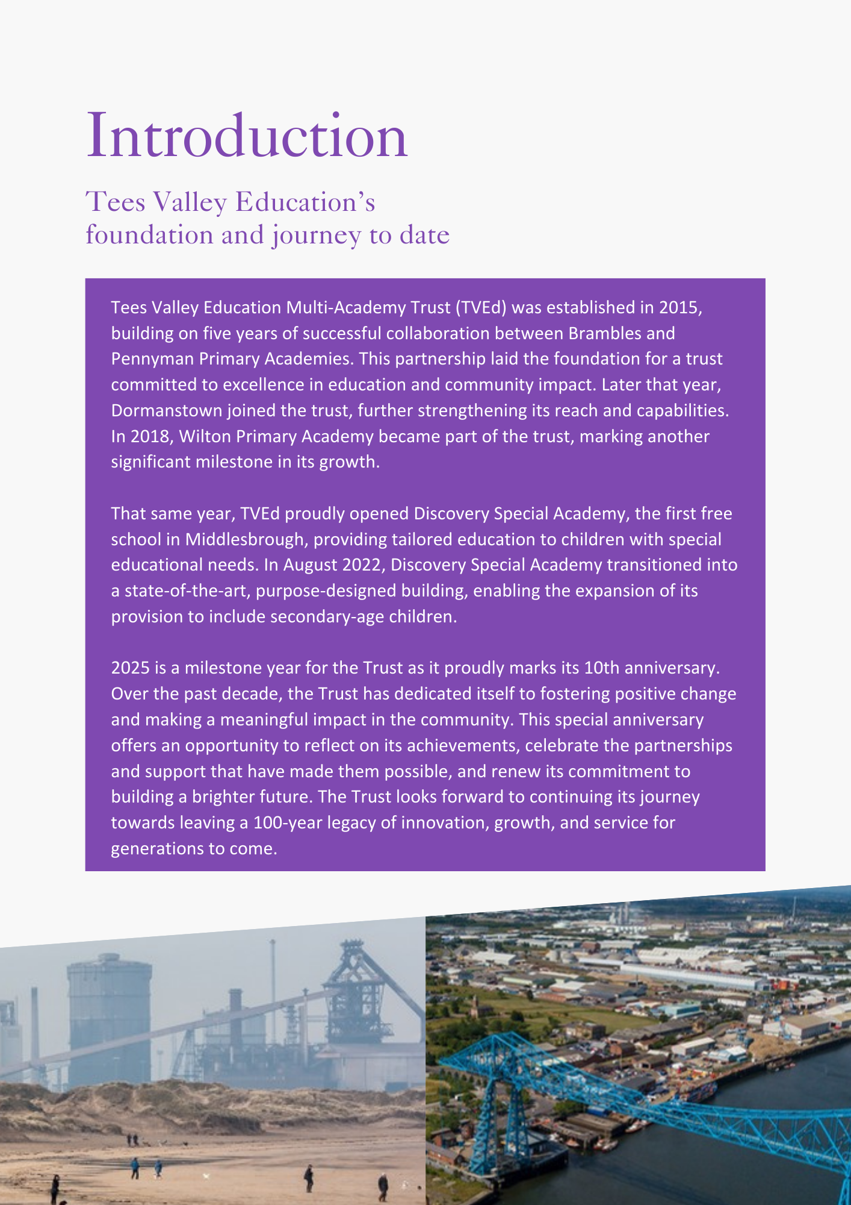

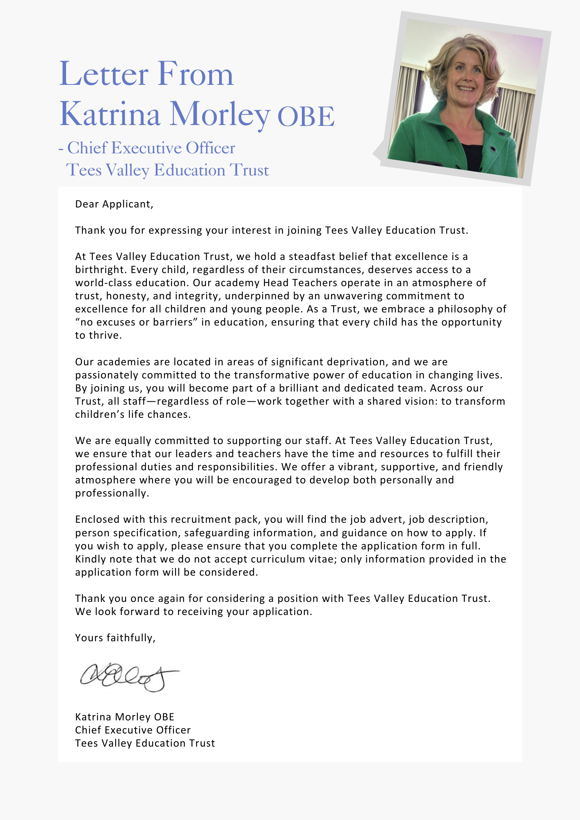

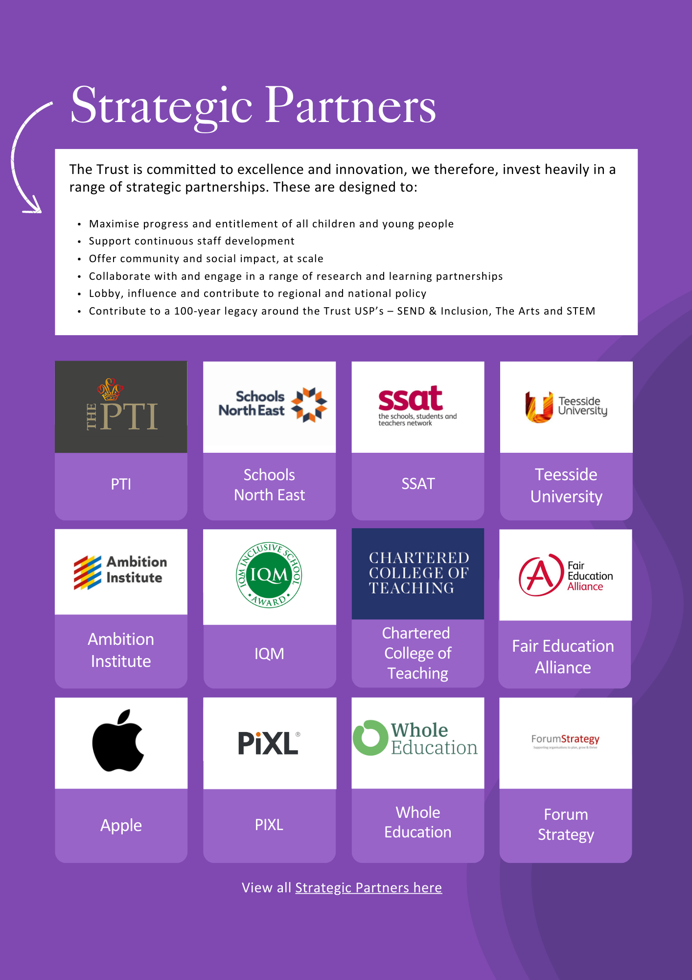



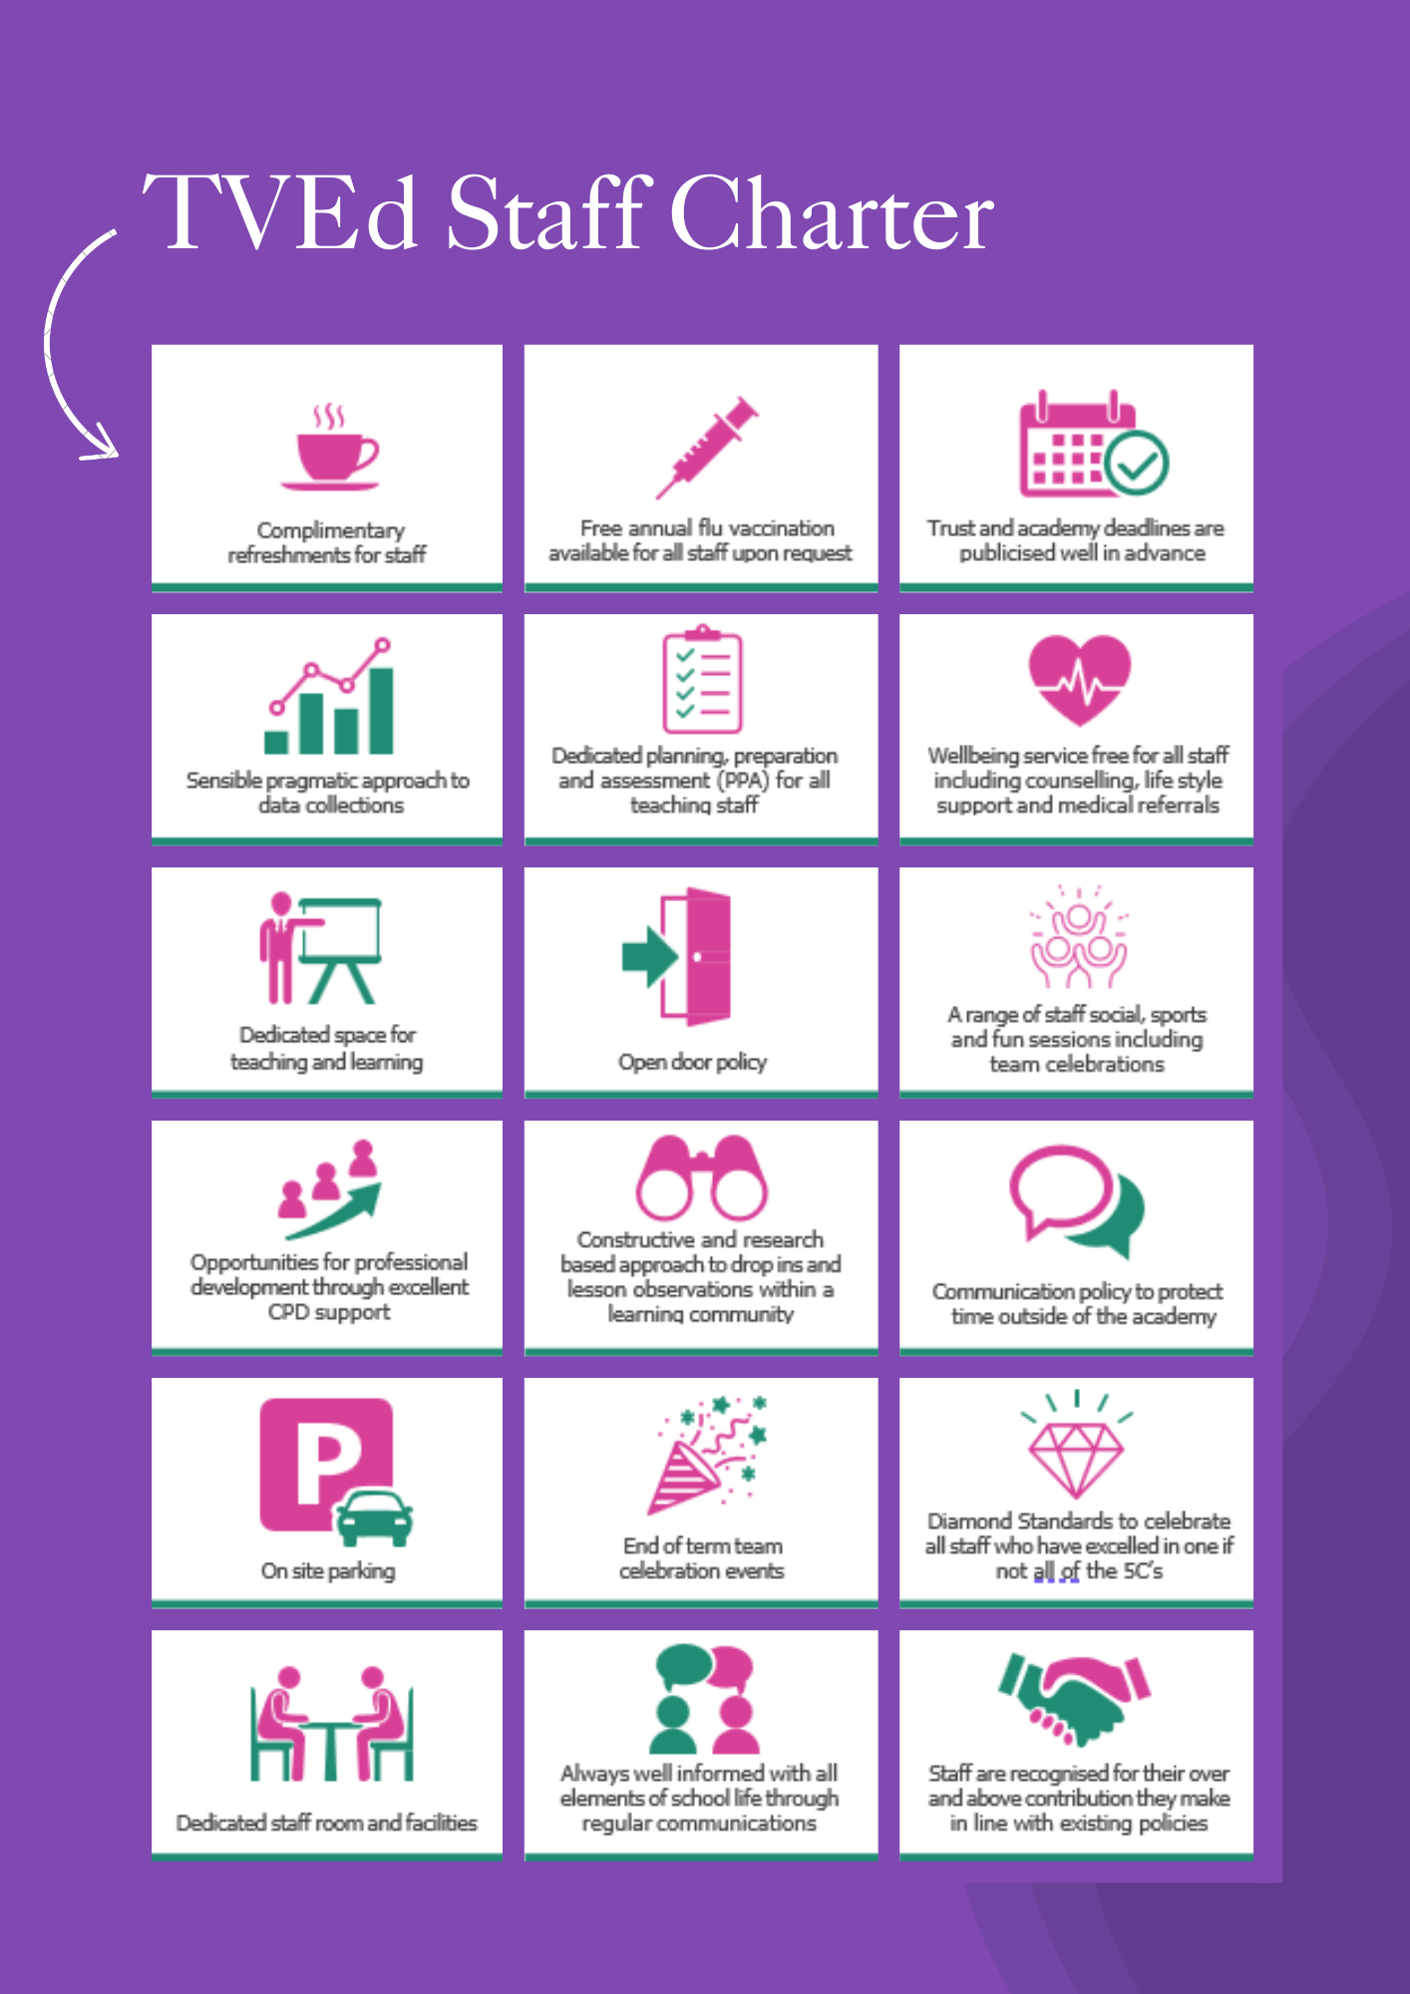

ADVERTISEMENT

SEND Case Officer x2
Status: Permanent, full time
Required: June 2026 (or as soon as possible thereafter)
Salary: NJC SCP 24 – 26 FTE £35,412 to £37,280 (pro rata £32,946 to £34,685)
Hours: 37 hours (Term Time Only with up to plus 4 weeks)
Reporting to: Deputy CEO for Inclusion, Standards and Sustainability
Academy: One post to work full time at Discovery Special Academy,
one post to work across Brambles, Dormanstown, Pennyman and Wilton Primary academies

Both posts will be located at Discovery Special Academy, Sandy Flatts Lane, Middlesbrough, TS5 7YN, as part of the wider SEND and Inclusion team, with time across academies as required.

About the Trust
The Trust was established in 2015 and provides education and enrichment activities to more than 1200 children across five Academies, located in Middlesbrough and Redcar and Cleveland local authority areas. Academies within the Trust are:
- Brambles Primary Academy (2 to 11 years),
- Discovery Special Academy (2 to 16 years),
- Dormanstown Primary Academy (2 to 11 years),
- Pennyman Primary Academy (2 to 11 years), and
- Wilton Primary Academy (3 to 11 years).

About the role we are looking to appoint:
As part of the Trust’s commitment to strengthening inclusion at every level, and in response to the national SEND and Inclusion reforms, the Trust has reviewed its structure. The SEND and inclusion team has been enhanced at academy level through the appointment of Deputy Headteachers with a lead for Pastoral and Inclusion and, at a Trust level, with the permanent appointment of a Deputy CEO for Inclusion, Standards and Sustainability. This structure is designed to deliver sustainable improvement and to continue to grow inclusive provision, underpinned by a culture of creativity, curiosity, care, courage and commitment.
Therefore, the trust is seeking to appoint two pro-active, enthusiastic, energetic and reliable SEND Case Officers to support the SEND and Inclusion Business Manager (new role), by ensuring effective and timely assessments, reviews, monitoring and access of children and young people aged 2–16 with Special Educational Needs and Disabilities (SEND) across the trust. This role will support with ensuring quality assurance across all processes and will represent the Trust on stakeholder groups to advocate for pupils’ needs and promote best practice.
The post holder will have operational responsibility for Education, Health and Care Plans (EHCPs) including referrals and coordinating the annual review process, preparing documentation, leading review meetings and liaising with professionals and teaching staff. This will involve working closely with the Senior Leadership Teams within academies on all referrals, in-year consultation response paperwork, supporting this preparation of tribunal paperwork and with High Needs Funding applications, administration and tracking individual pupil funding. Liaising with a range of partners, the SEND Case Officer will ensure that pupils with SEND receive appropriate and timely support and achieve the best possible outcomes. The post holders will report directly to the Deputy CEO for Inclusion, Standards and Sustainability and work closely with Trust SEND and Inclusion Business Manager and the wider trust SEND and Inclusion team.
What we are looking for:
We are seeking an experienced individual who has excellent communication skills and being able to build a rapport with parents, carers and their children. The post holder will have experience of working in a multi-agency context to drive and improve outcomes for children and young people. You are to be organised with the ability to manage a busy caseload and bring extensive relevant experience, along with the skills and qualifications needed to thrive in a dynamic, supportive environment.

What the Trust will provide the successful candidate with:
- A workplace where all staff are valued and treated with respect as outlined within the Trust’s Diamond Standards
- A passionate, enthusiastic and supportive Leadership Team
- A listening and learning organisation where all staff are encouraged to be curious and share ideas for the Trust/academies/team to improve
- Hard working, committed and dedicated staff who strive to gain the best outcomes for all children across the Trust’s academies
- Dedicated approach to children’s learning to encourage them all to be the best they can be
- Career enhancement opportunities within areas of interest as well as supporting ongoing professional development and training specific to job role
- Dedicated line manager to discuss work streams and capacity
- Free access to the Trust’s Wellbeing offer, which includes counselling, access to GP, Mindfulness and so much more.
- Free parking
- Enrolment into the local government pension scheme with employer contribution of 16%
- All support contracts are employed on National Joint Council (NJC) for local government services (also known as Green book)
- Benefits of the Trust’s Staff Charter which can be found at TVED Staff Charter.
Safeguarding requirements for the role:
Tees Valley Education Multi Academy Trust is committed to safeguarding and promoting the welfare of children. All appointments will be subject to a satisfactory enhanced DBS check.
This post is exempt from the Rehabilitation of Offenders Act 1974 and, therefore, all convictions, cautions and bind-overs, including those regarded as “spent” must be declared. The Trust’s Recruitment of Ex-Offender policy can be requested or visit the Trust’s website.
Applications are invited from prospective candidates who demonstrate that they can meet the essential criteria set out in the person specification and who have the vision, values and tenacity to join an outstanding team and help continue the journey towards excellence.

JOB DESCRIPTION
SEND Case Officer
To support high-quality inclusive practice across academies by working collaboratively with pupils, families, staff and external partners to ensure effective support for children and young people with special educational needs and disabilities (SEND). The postholder will be accountable for the operational coordination, quality assurance and statutory compliance of SEND processes.
EDUCATION, HEALTH AND CARE PLAN CO-ORDINATION AND QUALITY ASSURANCE
- Lead the preparation, coordination and review of Education, Health and Care Plans (EHCPs) in line with the SEND Code of Practice for children and young people aged 2–11.
- Coordinate and chair review meetings, ensuring documentation is accurate, timely and reflects the needs of the child or young person.
- Maintain oversight of EHCP caseloads at an academy level, ensuring reviews, amendments and statutory submissions are completed within required timelines.
- Liaise closely with the Local Authority regarding EHCP processes, consultations, amendments and placements.
- Quality assure EHCP documentation and Individual Support Plans to ensure clarity, accuracy and compliance with statutory expectations at an academy level and contribute to this within the Trust.
- Prepare and submit EHCP referral applications and supporting evidence to the Local Authority, leading Referral Planning meetings and ensuring all documentation is prepared to a high quality.
- Support with seeking legal advice and/or guidance as required at an academy level and/or trust.
INCLUSION AND SEND SUPPORT
- Keep up to date with all developments in SEND.
- Ensure knowledge of and compliance with relevant policies, guidance and procedures.
- Support improvements to working methods to enhance SEND service delivery.
- Contribute to continued professional development of academy and trust staff.
- Contribute to multi-agency groups as required.
- Be a part of the Trust SEND and Inclusion team, supporting quality assurance of EHCPs and Individual Support Plans.
- Support the DHoA for SEND and Inclusion to review and update key policies, including Accessibility Report, SEND Information Report.
- Support the delivery of identified opportunities to improve SEND systems, documentation and processes to enhance service delivery and efficiency
- Provide specialist guidance to staff to ensure appropriate procedures are followed in SEND referrals and statutory processes.
- Ensure equitable access to all pupils, with timely referrals for support where required.
- As a member of the Trust SEND and Inclusion team, support the implementation of SEND reforms, including access to specialist provision packages through high quality EHCPs and individual student support plans, that clearly evidence complexity of need.

SUPPORTING PUPILS AND FAMILIES
- Work in collaboration with children, young people, their families, education providers and other stakeholders to ensure the best possible outcomes for children and young people with SEND.
- Build partnerships and networks both internally and externally to ensure effective and improved service delivery for children and young people with SEND.
- Build and maintain strong partnerships with education providers, Local Authorities and external agencies to ensure effective collaboration in meeting the needs of pupils with SEND
- Offer specialist advice to academy staff, parents and other agencies on issues relating to SEND.
- Liaise with LA transport teams regarding referrals and transport arrangements for eligible pupils.
- Support pupils and families at transition points including school moves and transition to secondary ensuring information is shared effectively and appropriate place planning takes place.
- Professionally challenge via the SEND and Inclusion Business Manager if statutory processes are not being adhered too.
SEND CASE MANAGEMENT, FUNDING AND REPORTING
- Assist with documentation for in-year consultations, place planning and SEND Tribunal submissions, including preparation of reports and supporting evidence.
- Maintain accurate records and documentation relating to SEND processes and statutory casework.
- Monitor and manage High Needs Funding applications, ensuring accuracy, timely submission and effective tracking of funding allocations.
- Monitor SEND caseloads and maintain relevant data to support effective oversight of SEND processes.
- Support the SEND and Inclusion business Manager to produce reports and documentation as required to support senior leaders and the Trust SEND and Inclusion team.
- Assist with completion of paperwork for in-year consultations and place planning.
- Complete documentation for SEND Tribunal submissions and prepare associated reports.
- Support senior leaders in reviewing SEND resource use and identifying funding opportunities.
- Maintain oversight of SEND related documentation required for funding, inspections and audits.
SAFEGUARDING
All staff must adhere to the Trust’s safeguarding training (appropriate for job role) including policies, procedures, latest Keeping Children Safe in Education guidance and Working Together to Safeguard Children DfE 2018.
ADDITIONAL RESPONSIBILITIES
The job holder may be required to undertake additional duties as could be reasonably
required in exceptional or emergency situations. These may include:
- to work flexibly between the hours of 8am and 6pm.
- to work across the Trust if required.
- to undertake additional training, e.g. first aid.
This job description will be reviewed annually and may be subject to amendment or modification at any time after consultation with the post holder. It is not a comprehensive statement of procedures and tasks, but sets out the main expectations of the Trust in relation to the post holder’s professional responsibilities and duties.

Elements of this job description and changes to it may be negotiated at the request of either the line manager.

PERSON SPECIFICATION
QUALIFICATIONS
Professional qualification or relevant degree, plus substantial experience OR substantial vocational experience at a demonstrably professional level. | A, I, R | E1
Grade C/4 (or equivalent) in English and Mathematics | A, I, R | E2
Evidence of continued professional development, e.g. in SEND statutory processes. | A, I, R | E3
EXPERIENCE
Experience of using up to date and authoritative knowledge in a technical/ specialist area to support delivery of a complex operation, function or service. | A, I, R | D1
Experience of supporting activity across different services that includes working within a multi-agency environment and/or partnership working. | A, I, R | E4
Experience of working with children, young people, families and the public. | A,I,R | E5
Experience of supporting tribunal paperwork | A,I,R | D2
Experience of managing High Needs Funding applications and tracking, maintaining accurate data/records. | A,I,R | D3
KNOWLEDGE, ABILITIES AND SKILLS
Demonstrative knowledge of the application, principles, theory and practice of the specialist area of responsibility, including up to date knowledge of relevant legislation, statutory guidance and local authority SEND procedures and those required to safeguard and promote the welfare of the child. | A, I, R | E6
Knowledge of services relevant to children, young people, families and carers, groups and partner agencies. | A, I, R | D4
Demonstrated skill in successfully implementing complex and demanding solutions that align with current, emerging, or evolving policies and procedures. | A, I, R | E7
Proven technical ability in the interpretation of reports from a wide range of professionals and in exercising technical ability and judgement of these. | A, I, R | E8
Ability to produce high quality reports and documents that present complex information in a straightforward easy to read manner. | A, I, R | E9
Ability to apply technical/specialist judgement to ensure service area objectives are achieved. | A, I, R | D5
Ability to plan and organise a range of complex activities and priorities. | A, I, R | E10
Flexible and responsive approach to work supporting effective and creative problem solving. | A, I, R | E12
Comprehensive understanding of all existing policy and procedures and application in a changeable and challenging environment. | A, I, R | D6
Experience of working independently with relevant specialised systems, equipment and/or software to utilize ICT skills to support working practice. | A, I, R | E12
Ability to work in a team and develop and sustain partnership across teams and services. | A, I, R | E13
Ability to facilitate meetings with confidence including leading difficult conversations. | A, I, R | D7
Other
Commitment to equality and diversion. | A,I | E14
Commitment to health and safety. | A, I, R | E15
Demonstrate the Trust values and behaviours at all times and actively promote them in others. | A, I, R | E16
Essential car user | A, I, R | E17
AM (Assessment Method), A- Application Form, I – Interview, R – Reference, E – Essential, D - Desirable
Important: In the first instance, applications are assessed against the criteria listed above, in addition to overall presentation, use of standard English and grammatical accuracy.

Where applications do not meet the expected standard, they will be rejected before being matched to the person specification.

HOW TO APPLY AND EXPLANATORY NOTES OF THE PROCESS

An application form is attached. Application packs can be downloaded or printed directly from the Trust website www.teesvalleyeducation.co.uk or requested from the academy. Only applications via the Trust’s official application form will be accepted. Please do not submit a CV as substitute for part or full application form, the information will not be accepted or considered.
If you are submitting your completed application form by e-mail to recruitment@tved.org.uk - please be aware the academy cannot be responsible for any formatting anomalies when printing. If you are unable to submit an electronic application form, handwritten or electronic printed copies should be posted or hand delivered to the following address for the attention of Mrs Lucy Simpson

Tees Valley Education
c/o Pennyman Primary Academy
Fulbeck Road
Middlesbrough
TS3 0QS

Shortlisting Process
After the closing date, short listing will be conducted by a panel, who will match your skills/experience against the criteria in the Person Specification. You will be selected for interview entirely on the contents of your application form, so please read the Job Description and Person Specification carefully before you complete your form.
Shortlisted candidates will receive:
- Letter confirming interview details.
- Details of original ID documentation is required to confirm candidates. Photocopies or certified copies are not accepted.
- Criminal Record Self-Declaration Form, which must be brought on the day of the interview in the sealed envelope provided.

References for successful Candidate/s
We may seek references for shortlisted candidate/s and we may also approach previous employers for information to verify particular experience or qualifications before the interview. Any relevant issues arising from references will be taken up post interview.

Interview process
In addition to candidates’ ability to perform the duties of the post, the interview will also explore issues relating to safeguarding and promoting the welfare of children, including:
- Motivation to work with children and young people
- Ability to form and maintain appropriate relationships and personal boundaries with children and young people
- Emotional resilience in working with challenging behaviours
- Attitudes to use of authority and maintaining discipline

Conditional Offer: Pre-Employment Checks
Any offer to a successful candidate will be conditional upon:
- Verification of right to work in the UK
- Receipt of at least two satisfactory references (if these have not already been received)
- Verification of identity checks and qualifications
- Satisfactory enhanced DBS check
- Verification of professional status such e.g. QTS Status, NPQH (where required)
- Satisfactory completion of a Health Assessment
- Satisfactory completion of the probationary period (where relevant)
- Where the successful candidate has worked or been resident overseas in the previous five years, such checks and confirmations as may be required in accordance with statutory guidance.

Please contact Miss Jennifer Duncan, Deputy CEO and Executive Headteacher on 01642 248333 to arrange a discussion/visit.
For your information, the recruitment timetable is detailed below:

Closing date: Thursday 14th May 2026 at 9:00am
Shortlisting date: Thursday 14th May2 026
Interview date: Tuesday 19th May 2026
UK General Data Protection Regulation
Refer to our privacy policy on how we will process your personal data including how you can request to access your personal data via Tees Valley Education website: http://www.teesvalleyeducation.co.uk.

EQUALITIES INFORMATION AND OBJECTIVES STATEMENT

As an academy we ensure that our vision, values and ethos meet the expectations of the equality and diversity guidelines and legislation set out by the Equality and Human Rights Commission. This includes the following 9 protected characteristics:
- Age
- Disability
- Gender Reassignment
- Marriage and Civil Partnerships
- Pregnancy and Maternity
- Race
- Religion or belief
- Sex
- Sexual Orientation

Objectives Statement
- To support children’s sensory, academic and communication skills to enable them to develop holistically.
- To ensure high expectations across all aspects of the academy (as outlined in objective 1) to ensure children make the best progress according to their individual starting points.
- To continue to monitor attendance of all groups of children in the academy.
- To review levels of parental and pupil engagement in learning and academy life, across all activities and ensure equality and fairness in access and engagement.
- To ensure the academy environment is as accessible as possible to pupils, staff and visitors.



