

March 2026

Dear Applicant
Teacher of Modern Foreign Languages
Thank you for your interest in the above position which is a permanent post, full time, commencing 1 September 2026. Part time applicants are welcomed as job share would be considered.

Marden High School is highly successful, with examination results well in excess of national standards.

If after reading the attached material you would like to apply for the post please complete the application form and submit it, together with a letter of application, outlining how well you meet the person specification, the qualities you will bring to this position and your thoughts on how students gain from excellent Modern Foreign Languages teaching. Your letter should be no longer than 2 sides of A4. Applications can be emailed to e.scott@mardenhigh.net

If you would like an informal chat about this opportunity, do not hesitate to contact me.

The closing date for applications is Wednesday 22 April 2026. Interviews will take place on Tuesday 28 April 2026.
Yours faithfully
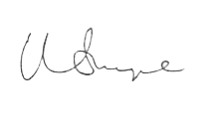

Mr Matt Snape
Headteacher

