

Staff Well Being Policy

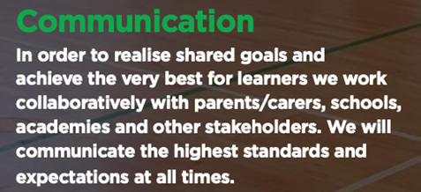
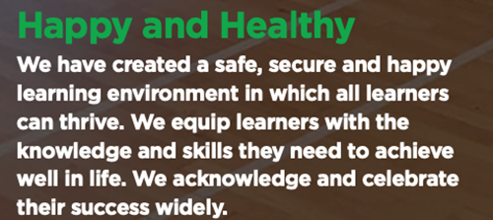

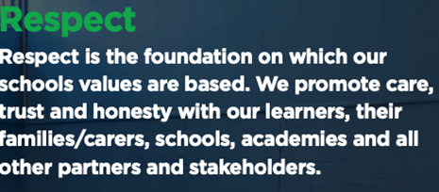

Date: | September 2025
Date approved by Management Committee:
Signature of Chair of Management Committee:
To be reviewed: | September 2026

Aims
At The Link School, we aim to ensure that emotional well-being is at the heart and ethos of the school, to promote emotional health and well-being in staff, as well as children. Through our REACH Ethos, we want to ensure all of our staff are happy and healthy.
At our school we recognise that staff are the most important resource and are to be valued, supported, challenged and encouraged to develop personally and professionally, within a learning and caring community. We aim to create a supportive working environment, where staff feel they are listened to and valued.
This policy will:
- Support the wellbeing of all staff to promote positive mental and physical health
- Promote a supportive working environment for all staff
- Acknowledge the needs of staff, and how these change over time
- Support staff to balance their working lives with their personal needs and responsibilities
- Support staff with any specific wellbeing issues they experience
- Ensure that staff understand their role in working towards the above aims

Promoting wellbeing at all times
As part of The Link School’s Ethos, we are proud that we:
- Develop a healthy, motivated workforce
- Provide effective and appropriate support for all staff
- Recognise the importance of a work-life balance for all staff and help each other to achieve this
- Monitor workloads and provide support to reduce any excessive demands on staff
- Minimise the harmful effects of stress.
- Respect confidentiality
- Create a positive attitude towards each other, to promote positive personal qualities
- Develop positive, supportive relationships
- Build trust, confidence and reliability

Role of all staff
All staff are expected to:
- Treat each other with empathy and respect
- Keep in mind the workload and wellbeing of other members of staff
- Support other members of staff if they become stressed, such as by providing practical assistance or emotional reassurance
- Report honestly about their wellbeing and let other members of staff know when they need support
- Follow the school’s policy on out-of-school hours working, including guidance on when it is and isn’t reasonable to respond to communications
- Contribute positively towards morale and team spirit
- Use shared areas respectfully, such as the staff room or offices
- Take part in training opportunities that promote their wellbeing
Role of line managers
Line managers are expected to:
- Maintain positive relationships with their staff and value them for their skills, not their working pattern
- Provide a non-judgemental and confidential support system to their staff
- Take any complaints or concerns seriously and deal with them appropriately using the school’s policies
- Monitor workloads and be alert to signs of stress, and regularly talk to staff about their work/life balance
- Make sure new staff are properly and thoroughly inducted and feel able to ask for help
- Understand that personal issues and pressures at work may have a temporary effect on work performance, and take that into account during any appraisal or capability procedures
- Promote information about, and access to, external support services
- Help to arrange personal and professional development training where appropriate
- Keep in touch with staff if they’re absent for long periods
- Monitor staff sickness absence, and have support meetings with them if any patterns emerge
- Conduct return to work interviews to support staff back into work
- Conduct exit interviews with resigning staff to help identify any wellbeing issues that led to their resignation
Role of senior staff
Dave Bromby is our Senior Leader Mental Health Lead. Dave also leads the Emotional Well-Being Ambassador Group.
Senior staff are expected to:
- Lead in setting standards for conduct, including how they treat other members of staff and adhering to agreed working hours
- Manage a non-judgemental and confidential support system for staff
- Monitor the wellbeing of staff through regular surveys and structured conversations
- Make sure accountability systems are based on trust and professional dialogue, with proportionate amounts of direct monitoring
- Regularly review the demands on staff, such as the time spent on paperwork, and seek alternative solutions wherever possible
- Make sure job descriptions are kept up to date, with clearly identified responsibilities and staff being consulted before any changes are made
- Listen to the views of staff and involve them in decision-making processes, including allowing them to consider any workload implications of new initiatives
- Communicate new initiatives effectively with all members of staff to ensure they feel included and aware of any changes occurring at the school
- Establish a clear policy on out-of-school hours working, including on when it is and isn’t reasonable for staff to respond to communications, and provide clear guidance to all stakeholders
- Make sure that the efforts and successes of staff are recognised and celebrated
- Produce calendars of meetings, deadlines and events so that staff can plan ahead and manage their workload
- Provide resources to promote staff wellbeing, such as training opportunities
- Promote information about, and access to, external support services, and make sure that there are clear routes in place to escalate a concern in order to access further support
- Organise extra support during times of stress, such as Ofsted Inspections

Role of the Management Committee
The Management Committee is expected to:
- Make sure the school is fulfilling its duty of care as an employer by ensuring staff have a reasonable workload and by creating a supportive working environment
- Monitor and support the wellbeing of the Headteacher
- Ensure that resources and support services are in place to promote staff wellbeing
- Make decisions and review policies with staff wellbeing in mind, particularly in regards to workload
- Be reasonable about the format and quantity of information asked for from staff as part of monitoring work
- Ensure that staff are clear about the purpose of any monitoring visits and what information will be required from the
As a school we have agreed to promote Staff Well-Being:
- Provide opportunities to nurture all staff across the school
- Recognise strengths and qualities in each other
- Give compliments and recognise each other’s strengths
- Be respectful to each other at all times
- Identify ways to provide support to each other
- Provide time for mindfulness
- Ensure opportunities for pastoral support
- Emotional Well-being Twilights
- Provide regular, planned 1:1 meeting times to discuss work related progress/issues - professional supervision for all staff
- Offer access to pastoral support to discuss personal worries and issues
- Ensure opportunities to debrief at the end of the school day
- Be sensitive & kind to each other
- Build in tasks and activities to promote relaxation and physical activities
- Consistency in high quality staffing and teamwork
- Support each other’s practices
- Maintain an open-door policy for all staff
- Clinical supervision for Safeguarding Advisor.

Managing specific wellbeing issues
The school will support and discuss options with any staff that raise wellbeing issues, such as if they are experiencing significant stress at school or in their personal lives.
Where possible, support will be given by line managers or senior staff. This could be through:
- Giving staff time off to deal with a personal crisis
- Arranging external support, such as counselling or occupational health services. The Link School has arranged Counselling Provision with Breakfree Counselling, up to 12 sessions will be paid for by the Link School.


- Completing a risk assessment where necessary and following through with any actions identified
- Reassessing their workload and deciding what tasks to prioritise
- Providing staff the opportunity to be part of the emotional well-being group.
- Provide half termly Emotional Well-being Twilights for all staff, utilising the feedback and expertise from the Emotional Well-being Ambassador Group.
- Providing staff with the opportunities to feedback on emotional well-being issues through staff well-being surveys.
- Providing opportunities to Celebrate Staff’s Successes.
- Having policies and procedures to deal with bullying, harassment and issues of personal safety
- At all times, the confidentiality and dignity of staff will be maintained.
- If staff are unhappy with anything in their Professional Supervision Session, staff should communicate this with the Senior Mental Health Lead. However, if staff feel they cannot then staff must inform their concern directly to the Headteacher.
Monitoring arrangements
This policy will be reviewed annually by the Senior Mental Health Lead. At every review, it will be approved by Management Committee.
Links with other policies
This policy is linked to our:
- Appraisal policy
- Behaviour policy
- Capability procedure
- Staff code of conduct
- Staff Benefits policy
- Practical Guide to Effective Supervision

