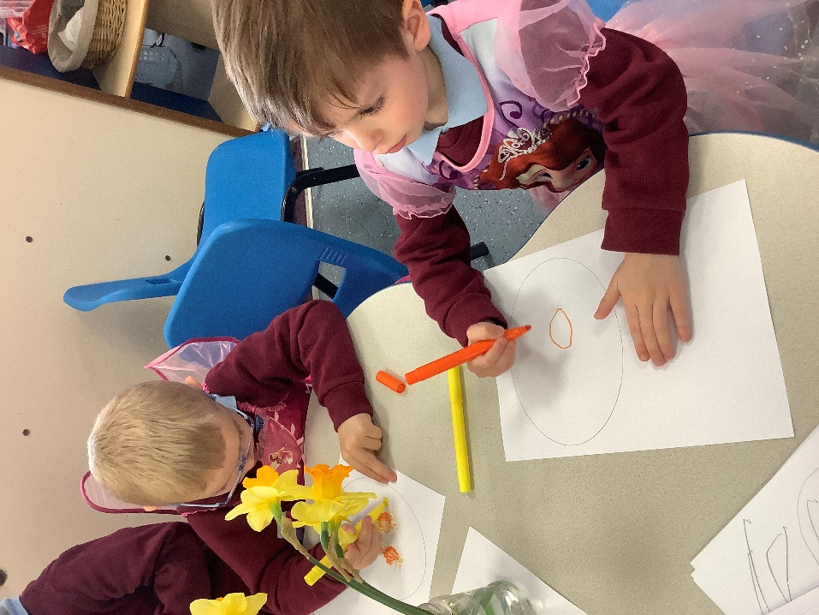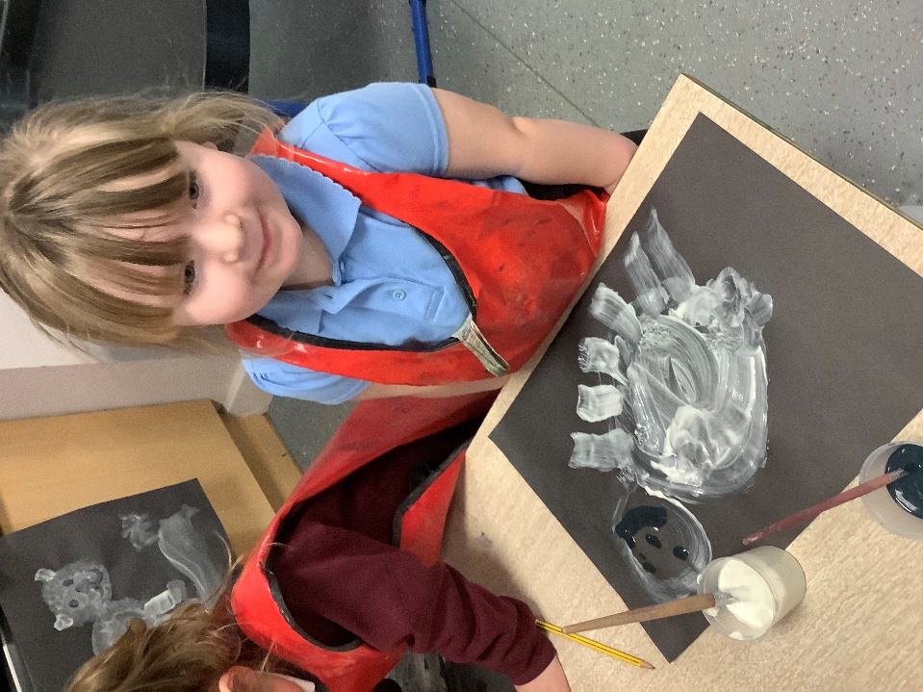

Lunchtime Supervisor

Errington Primary School



Lunchtime Supervisor, 5 hours per week, TTO | 

Atomix Educational Trust is a dynamic, forward-thinking multi-academy trust delivering exceptional education across our family of schools whilst providing comprehensive corporate training solutions. We foster academic excellence and professional development, creating an environment where innovation meets tradition in both educational and corporate settings.

Errington Primary school is an average sized primary school based in Marske who is proud to be part of the Tees Valley Collaborative Trust. We pride ourselves on inclusion and provide vibrant learning experiences for all our pupils.

The Trust and Governors are seeking to appoint a Lunchtime Supervisor who will be part of a team that is responsible for supervising pupils and the school's premises during the midday break to ensure that the break runs effectively and that the safety and welfare of pupils is maintained.

If you would like to look around school or require any additional information please contact the School Office on 01642 482002. We warmly welcome visits to out setting, please contact school to arrange a visit.

Start Date: 2nd March 2026

Salary and Benefits Information

Salary: LA Support Staff Salary Spine, Point 2 (FTE £24,413 per annum)
Actual Salary: £2,802.21 per annum, including holiday pay

Employee Benefits include:

- Membership of the Local Government Pension Scheme for all our support staff
- Opportunities for training and professional development
- Childcare Vouchers
- Cycle Scheme
- Free on-site parking
- Discounted nursery provision on the Prior Pursglove College site (available to all Trust employees)

Application Details

Closing Date: noon on Tuesday 3rd February

Interview Date: w/c 9th February

An application pack can be downloaded from https://www.atomix.ac.uk/careers/. Please contact the HR Department at HR@atomix.ac.uk for any further information.

All applications must be submitted on a Trust application form and CVs will not be accepted.

We are an inclusive employer and we actively encourage applications from people from diverse and underrepresented backgrounds. If you need any assistance with your application in terms of reasonable adjustments, please let us know.

Safer Recruitment

Atomix Educational Trust is committed to safeguarding and promoting the welfare of children and young people and expects all staff and volunteers to share this commitment

As this post involves direct contact with, or unsupervised responsibility for, children or vulnerable adults the successful candidate will be required to undertake a Disclosure and Barring Service check before taking up the position. Additional checks will include; identity checks, qualification checks and employment checks, including the investigation of any gaps between jobs and two satisfactory references.

ATOMIX EDUCATIONAL TRUST
Church Walk
Guisborough
TS14 6BU
Tel: 01287 280800
Email: HR@atomix.ac.uk

Job Description – Lunchtime Supervisor

Reporting to the Head Teacher

Location: Errington Primary School
Hours: 5 hours per week, term time only (not including PD Days)
Grade: LA Support Staff Pay Spine point 2

Job Purpose
A midday supervisor will be part of a team that is responsible for supervising pupils and the school's premises during the midday break to ensure that the break runs effectively and that the safety and welfare of pupils is maintained.

Supervision
- Supervise pupils in the lunch area, playground, and classrooms (for wet play)
- Encourage pupils to eat their lunch and monitor those who don't, reporting any concerns to the class teacher.
- Monitor pupils that aren't engaging in play and feedback any concerns to class teachers.
- Interaction/organize games etc.

Organisation
- Clean tables between classes
- Manage pupils' entrance and exit from the lunch area in an orderly manner.
- Clean up food and water spillages.
- Encourage good table manners.

Health and safety
- Observe pupils and the environment and take action to minimise any identified health and safety risks.
- Report all accidents to a qualified first aider. Inform class teacher of any accidents.
- Record details of incidents in line with the school's reporting procedures
- Be aware of and support pupils with medical/dietary needs.
- Promote the school's policy around healthy eating to pupils.
- Feedback concerns relating to pupils' health and safety to or a senior member of staff.

Behaviour
- Report any incidents of serious misbehavior to the relevant staff member, in line with the school's behaviour policy.
- Take necessary action to minimise disruption and harm to pupils, in line with the school's behaviour policy.
- Make sure children tidy up after themselves in the lunch area and when using play resources/equipment.
- Follow any directions from class teachers on supporting specific pupils with challenging behaviour.

Play
- Organise play activities to encourage pupils to play and make use of play equipment.
- Offer educational instruction where needed to help pupils to share play equipment.
- Help to resolve issues between pupils during play activities.

Safeguarding
- Make sure pupils remain on the school premises during the midday break.
- Look out for any unidentified visitors approaching the school and follow the school's procedures for approaching/reporting individuals.
- Ensure that all gates are securely locked on the playgrounds.
- Other areas of responsibility
- Read and follow the relevant school policies (Keeping Children Safe in Education)
- Undertake training required to develop in the role.

Please note: this is illustrative of the general nature and level of responsibility of the role. It is not a comprehensive list of all tasks that a midday supervisor will carry out. The postholder may be required to do other duties appropriate to the level of the role.

Person Specification – Lunchtime Supervisor

criteria | qualities
Qualifications  and training | - First aid training (or willingness to complete it)
Experience | - Working with children or young people  - Working and collaborating within a team
Skills and knowledge | - Ability to respond quickly and effectively to issues that arise.  - Ability to use own initiative and take action accordingly.  - Effective communication with adults and children  - Ability to follow instructions from senior team members.  - Ability to have a firm but fair approach to handling behaviour issues in line with the school's policies.  - • Ability to build effective working relationships with colleagues
Personal qualities | - Commitment to supporting and understanding pupil needs.  - Uphold and promote the ethos and values of the school.  - Maintain confidentiality at all times.  - Commitment to safeguarding, equality, diversity, and inclusion

