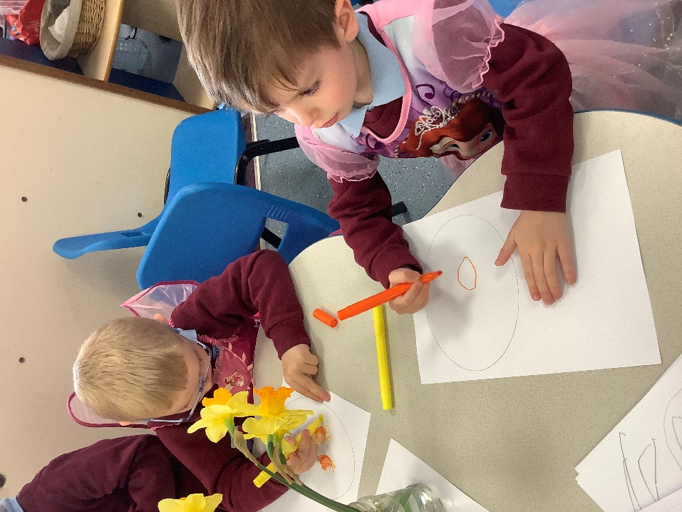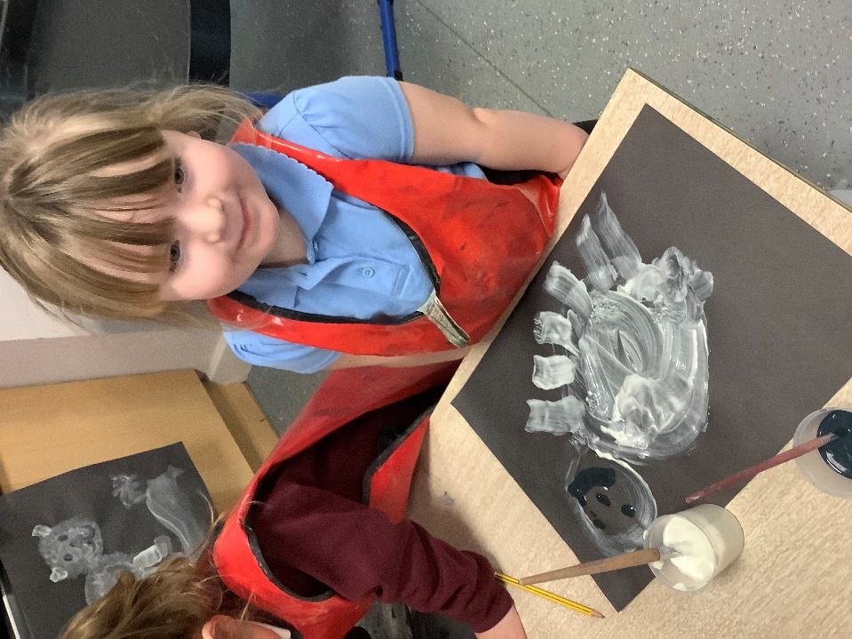

1:1 Teaching Assistant (Level 2)

Errington Primary School



Level 2 Teaching Assistant (with 1:1 responsibility for a child with additional needs), 32.5 hours per week, term time only (including PD Days), fixed term until 31st August 2026 | 

Atomix Educational Trust is a dynamic, forward-thinking multi-academy trust delivering exceptional education across our family of schools whilst providing comprehensive corporate training solutions. We foster academic excellence and professional development, creating an environment where innovation meets tradition in both educational and corporate settings.

At Errington Primary School, we are seeking a highly motivated and committed Level 2 Teaching Assistant with experience of working within Early Years and a firm understanding of SEND specifically autism.

The successful candidate will be working alongside our Early Years team to support 3 children with autism. We seek a highly committed and creative professional who embodies are inclusive and inquisitive ethos, supporting the individual to fully meet their full potential. We require flexibility, working on your own initiative and having a fun and child centred outlook in all that you do.

You must be Level 2 qualified and experience of working with children with SEND and Early Years. Experience of working in a Thrive background would also be desirable.

Hours of work are 8.30am until 3.30pm Monday to Friday term time only.

If you would like to look around school or require any additional information please contact the School Office on 01642 482002. We warmly welcome visits to our setting.

Start Date: Immediate start available

Salary and Benefits Information

Salary: Scale 6 - 7 of the Local Government Support Staff Salary Spine (FTE £25,989 - £26,403 per annum)
Actual Starting Salary: £19,898.04 per annum (based on an FTE of £25,989 per annum)

Employee Benefits include:

- Membership of the Local Government Pension Scheme for all our support staff
- Opportunities for training and professional development
- Childcare Vouchers
- Cycle Scheme
- On-site canteen for both staff and students
- Free on-site parking
- Discounted nursery provision on the Prior Pursglove College site (available to all Trust employees)

Application Details

Closing Date: noon on Tuesday 6th January

Interview Date: w/c 12th January

An application pack can be downloaded from https://www.atomix.ac.uk/careers/. Please contact the HR Department at HR@atomix.ac.uk for any further information.

All applications must be submitted on a Trust application form and CVs will not be accepted.

We are an inclusive employer and we actively encourage applications from people from diverse and underrepresented backgrounds. If you need any assistance with your application in terms of reasonable adjustments, please let us know.

Safer Recruitment

Atomix Educational Trust is committed to safeguarding and promoting the welfare of children and young people and expects all staff and volunteers to share this commitment

As this post involves direct contact with, or unsupervised responsibility for, children or vulnerable adults the successful candidate will be required to undertake a Disclosure and Barring Service check before taking up the position. Additional checks will include; identity checks, qualification checks and employment checks, including the investigation of any gaps between jobs and two satisfactory references.

ATOMIX EDUCATIONAL TRUST
Church Walk
Guisborough
TS14 6BU
Tel: 01287 280800
Email: HR@atomix.ac.uk

Job Description – Level 2 Teaching Assistant (with 1:1 responsibility for a child with additional needs)

Reporting to the Head Teacher

School Errington Primary Schoot

Hours: 32.5 hours a week, term time only (including PD Days)
Grade: LA Support Staff Pay Scale 6 - 7

Main Purpose:

To work under the guidance of teaching/senior staff to supervise children, implementing schemes of work with individuals/groups, in or out of the classroom. This could include those requiring detailed and specialist knowledge in particular areas and will involve assisting the teacher in the whole planning and assessment cycle and the management/preparation of resources. This may include providing support in addressing the needs of pupils who need particular help in overcoming barriers to learning. Staff may also supervise whole classes occasionally during the short-term absence of teachers. The primary focus will be to maintain classroom management, nurturing pupils and building positive relationships with pupils and staff members alike. When working within a 1:1 pupil, a sound understanding of sensory diets, intervention, breaking down tasks whilst supporting the child holistically will be required.

…………………………………………………………………………………………………………………
Responsibilities and duties:

Support for the Pupil:
- Use specialist (curricular/learning) skills/training/experience to support pupils
- Assist with the development and implementation of Individual Support/ Behaviour Plans
- Establish nurturing working relationships with pupils, acting as a role model and setting high expectations
- Promote the inclusion of all pupils within the classroom
- Support pupils consistently whilst recognising and responding to their individual needs
- Encourage pupils to interact and work co-operatively with others and engage all pupils in activities
- Promote independence and employ strategies to recognise and reward achievements, give encouragement and praise.
- Provide feedback to pupils in relation to progress and achievement
- Work with the SENCo and LA to provide any specialist support needed for a 1:1 pupil to allow them to access the curriculum and wider offer that the school plans and delivers.
- To understand the Thrive programme and support it implementation.
- To understand attachment, trauma and relationship difficulties.

Support for the Teacher:
- Work with the teacher to establish an engaging learning environment
- Work with the teacher in lesson planning, evaluating and adjusting lessons/work plans as appropriate
- Monitor and evaluate pupils’ responses to learning activities through observation and planned recording of achievement against pre-determined learning objectives
- Provide objective and accurate feedback as required, to the teacher on pupil achievement, progress and other matters, ensuring the availability of appropriate evidence
- Undertake marking of pupils work and accurately record achievement/progress
- Promote positive values, attitudes and good pupil behaviour, dealing promptly with issues and incidents in line with established policy and encourage pupils to take responsibility for their own behaviour
- Liaise sensitively and effectively with parents/carers as agreed with the teacher within your role/responsibility and participate in feedback sessions/meetings with parents, or as directed
- Provide general administrative support e.g. produce worksheets for agreed activities, laminating etc

Support for the Curriculum:
- Implement agreed learning activities/teaching programmes, adjusting activities according to pupil responses/needs
- Implement local and national learning strategies e.g. literacy, numeracy, Early Years and make effective use of opportunities provided by other learning activities to support the development of relevant skills
- Support the use of ICT in learning activities and develop pupils’ competence and independence in its use
- Help pupils to access learning activities through specialist support
- Determine the need for, prepare and maintain general and specialist equipment and resources
- Be proactive in curriculum review and give feedback about learning sequences and recall.

Support for the School:
- Be aware of and comply with policies and procedures relating to Child Protection, health, safety and security, confidentiality and data protection, reporting all concerns to an appropriate person
- Be aware of and support difference and ensure all pupils have equal access to opportunities to learn and develop
- Contribute to the overall ethos/work/aims of the school
- Establish constructive relationships and communicate with other agencies/professionals, in liaison with the teacher, to support achievement and progress of pupils
- Attend and participate in regular meetings
- Recognise own strengths and areas of expertise and use these to advise and support others
- Provide appropriate guidance and supervision and assist in the training and development of staff as appropriate
- Supervise pupils on out of school activities as required
- Accompany teaching staff and pupils on visits and trips as required with appropriate responsibility
- Participate in training and other learning activities and performance development as required
- Show a duty of care and take appropriate action to comply with Health & Safety requirements at all time
- Demonstrate and promote commitment to Equal Opportunities and to the elimination of behaviour and practices that could be discriminatory.

Safeguarding – Promoting the Welfare of Children and Young People
- To demonstrate a commitment to safeguarding and promoting the welfare of children and young people, staff and volunteers.
- To demonstrate a thorough understanding of safeguarding and safer recruitment policies and procedures, and their application within an educational setting/environment.

This job description sets out the main responsibilities for the postholder but is not intended to be an exhaustive list. Specific duties may change from time to time without changing the general nature of the post and the postholder is expected to be flexible in the range of responsibilities they undertake commensurate with the responsibility and salary

Person Specification – Level 2 Teaching Assistant (with 1:1 responsibility for a child with additional needs)

 | Essential | Desirable
QUALIFICATIONS/  TRAINING: | - Willingness to participate in relevant training and development opportunities  - NVQ Level 2 or equivalent qualification in relevant discipline OR appropriate experience, preferably as a Teaching Assistant | - First Aid training or willingness to undertake appointed person certificate in First Aid  - Child Protection training  - Training in Special Educational Needs strategies  - Qualifications at GCSE level or equivalent in Maths and English  - Thrive training for inclusion
EXPERIENCE: | - Recent and relevant experience of working with children within an education setting, within Early Years  - Working as a 1:1 to support a child with additional needs. | - Experience of working in a school environment  - Working with the Thrive programme.  - Experience of attachment and trauma.
SKILLS/  KNOWLEDGE: | - Ability to relate well to children and adults  - Ability to work effectively within a team environment, understanding classroom roles and responsibilities  - Ability to build effective working relationships with all pupils and colleagues  - Ability to promote a positive ethos and role model positive attributes  - Ability to work with children at all levels regardless of specific individual need and identify learning styles as appropriate  - Ability to adapt own approach in accordance with pupils needs  - Understanding of national curriculum and other basic learning Programmes/techniques (within specified age range/subject area) e.g. knowledge of core subjects  - Understanding of principles of child development, learning styles and independent learning  - Experience of resources preparation to support learning programmes  - Effective use of ICT to support learning  - Experience of resources preparation to support learning programmes  - Excellent communication skills  - Excellent numeracy and literacy skills  - Be able to maintain confidentiality  - Excellent listening skills  - The ability to manage behaviour of children in a positive and supportive manner  - General awareness of inclusion, especially within a school setting | - Relevant knowledge of First Aid  - Knowledge of Child Protection  - Equal Opportunities and recognising the nature of the diverse school community  - Understanding of basic technology – computer, video, photocopier etc  - Working knowledge of relevant policies/codes of practice/legislation
PERSONAL AND PROFESSIONAL ATTRIBUTES: | - Friendly, approachable and professional manner  - Calm approach  - A commitment to working as part of the whole school team and supporting the vision and aims of the school  - High expectations of all pupils  - Ability to build and maintain successful relationships with pupils.  - Demonstrate and promote the positive value, attitudes and behaviour they expect from the pupils with whom they work  - Ability to liaise sensitively and effectively with parent and carers, recognising their role in pupils learning



