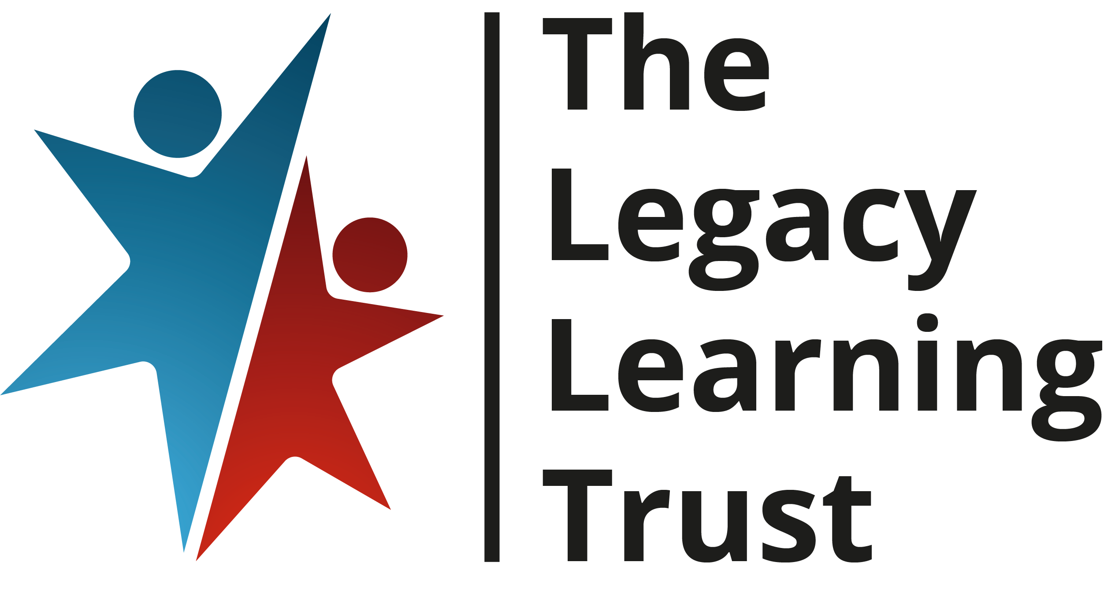
Equal Opportunities Monitoring Form

In accordance with our policy on equal opportunities in employment, The Legacy Learning Trust will provide equal opportunities to any employee or job applicant and will not discriminate either directly or indirectly because of race, sex, sexual orientation, gender reassignment, religion or belief, marital or civil partnership status, age, disability, or pregnancy and maternity.

In order to assess how successful this policy is we have set up a system of monitoring all job applications. We also monitor equality data in relation to our employees.

The completion of this form and questionnaire is entirely voluntary. However it will assist the Trust in carrying out this monitoring. We would therefore be grateful if you would complete the questions on this form.

We have asked for your name to enable us to monitor applications at shortlisting and appointment stage. If you are appointed to a role in the Trust we will retain this information, again for monitoring purposes.

All information will be treated in confidence and will not be seen by staff directly involved in the appointment. The questionnaire will be detached from your application form, stored separately and used only to provide statistics for monitoring purposes.

Thank you for your assistance
Please complete ALL sections as requested.
PERSONAL DETAILS
POST APPLIED FOR:
Last Name:
First name(s)

1 Ethnicity

How would you describe yourself?
Choose ONE section from A to G, and then tick the appropriate box
A Asian or Asian British
Bangladeshi
Indian
Pakistani
Any other Asian background, please write ………………………………………….
B Black/African/Caribbean or Black British
African
Caribbean
Any other Black background, please write …………………………………………
C Mixed/Multiple Ethnic Groups
White and Asian
White and Black African
White and Black Caribbean
Any other Mixed background, please write …………………………………..
D Other Ethnic Group
Arab
Any other Ethnic Group, please write ……………………….........................
E Chinese and other ethnic groups
Chinese
Any other, please write.................................................................................
F White
British/ English/Northern Irish/Scottish/ Welsh
Gypsy or Irish Traveller
Irish
Any other White background, please write …………………………………...

G Prefer not to say

2 Disability
To make positive changes, The Legacy Learning Trust wants to address the different barriers faced by disabled people.
What do we mean when we say disability?
- Do you have a physical or mental impairment?
- Is it long term?
- Does this make it difficult for you to do the things that most people do on a fairly regular and frequent basis?

Do you consider yourself to have a disability or a long-term health condition?
Yes No

What is the effect or impact of your disability or health condition?

Prefer not to say

If you would like to discuss your response, or are unsure of the types of reasonable adjustment that might be possible, please contact your manager who is trained to help and support you.
3 Gender

Which of the following best describes your gender?
Male Female Prefer not to say Own term: ………………………..

4 Gender identity

Do you identify as transgender/transsexual?
Yes No Prefer not to say Own term: …………………………………………..

5 Sexual Orientation
Monitoring sexual orientation in our staff and in our recruits is a significant step towards acknowledging gay, lesbian and bi sexual staff within [insert school/academy name].
We seek to become an exemplar employer and make sure our processes and practices are fair to all staff. However, we recognise you may not wish to provide this information.

Which of the following best describes your sexual orientation?
Bi / bisexual
Gay / Lesbian
Heterosexual / Straight
Other ……………………………………
Prefer not to say

6 Age monitoring
What is your Date of Birth?

7 Religion and belief
Below is a list of religions that are the most commonly found in Britain. They are listed in alphabetical order.

Please tick the box that best describes you:
Buddhist
Christian (including Church of England, Catholic, Protestant and all other Christian denominations)
Hindu
Jewish
Muslim
Sikh
Other Religion or Belief (please state) ………………………………………..
No Religion
Prefer not to say

8 Legal, Marital or Same Sex Status?
Single
Married
Married, same-sex partner
Civil partnership
Other (please state) …………………………………………….
Prefer not to say

I hereby give my consent to The Legacy Learning Trust processing the special categories of data supplied in this form for the purposes of monitoring data and diversity statistics, recruitment and selection, and as set out in the Workforce Privacy Notice.
Applicant’s signature
Date

