07/

Play Facilitator Dormanstown Primary Academy

DPA341

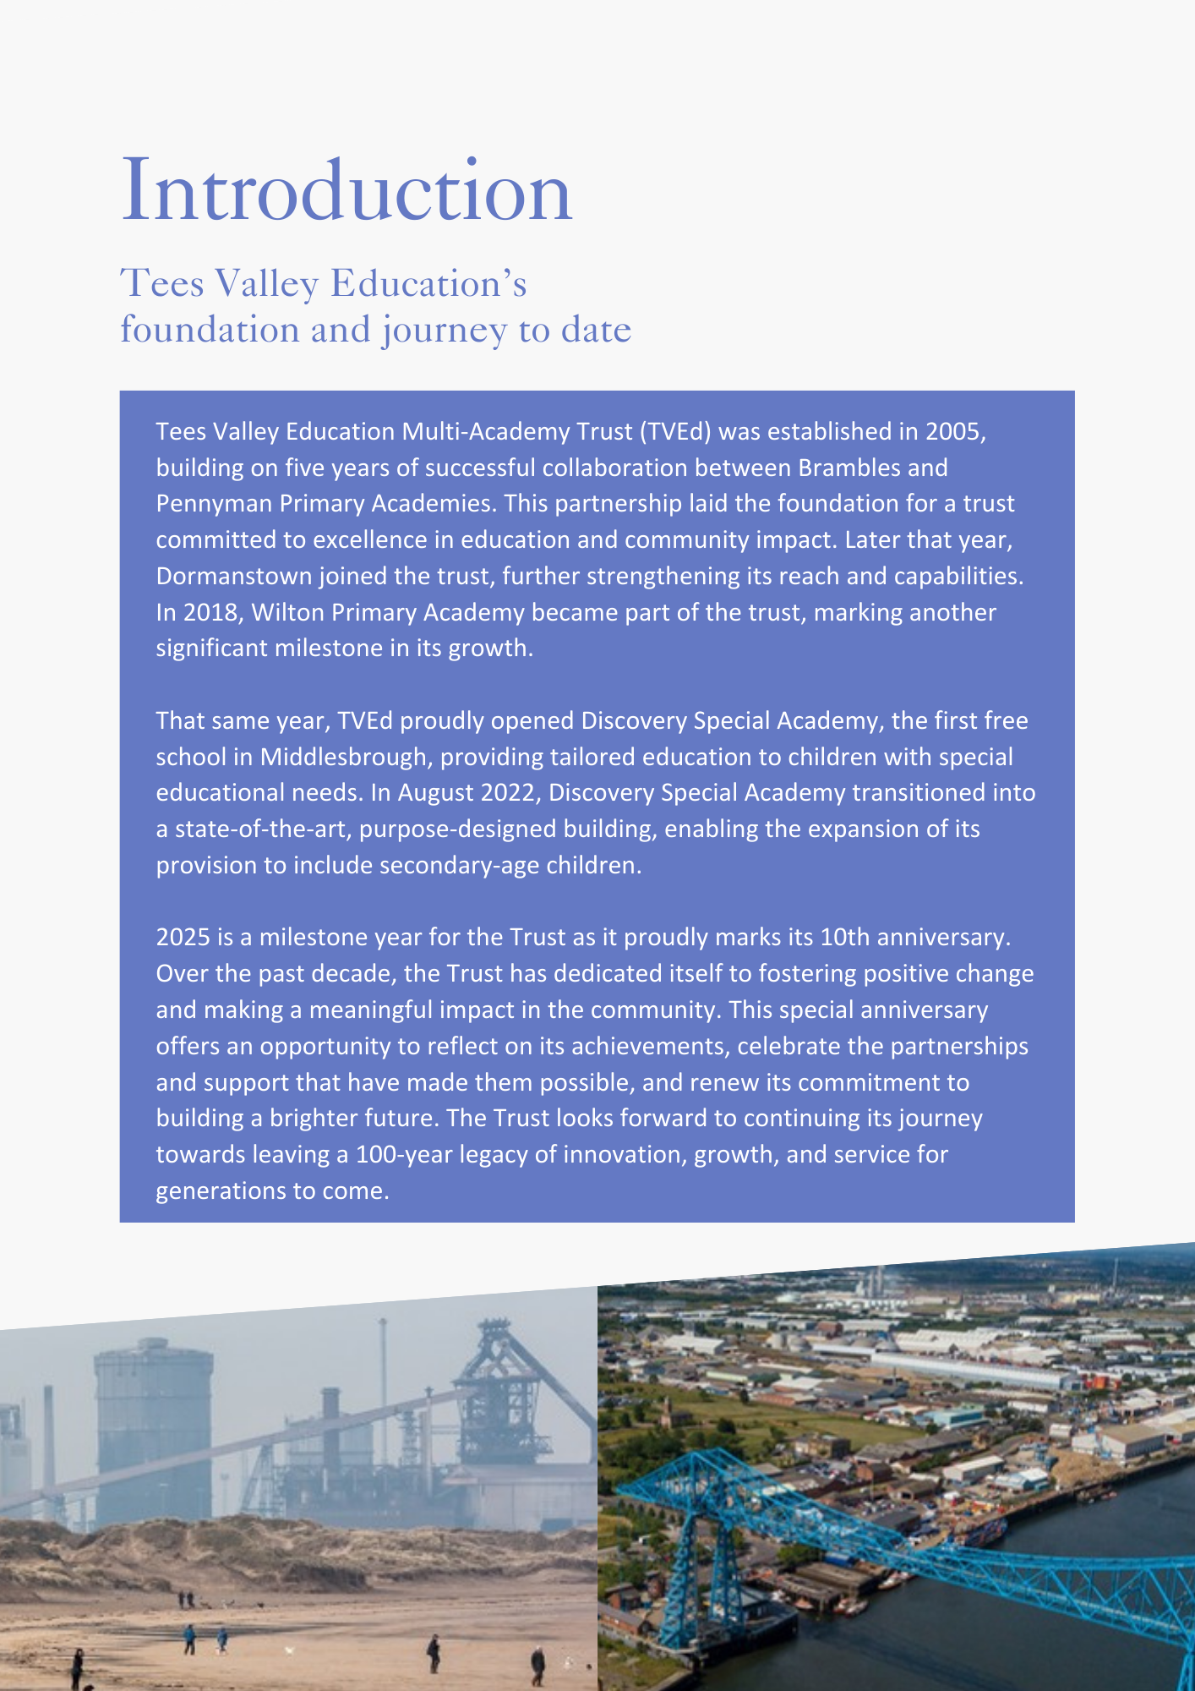

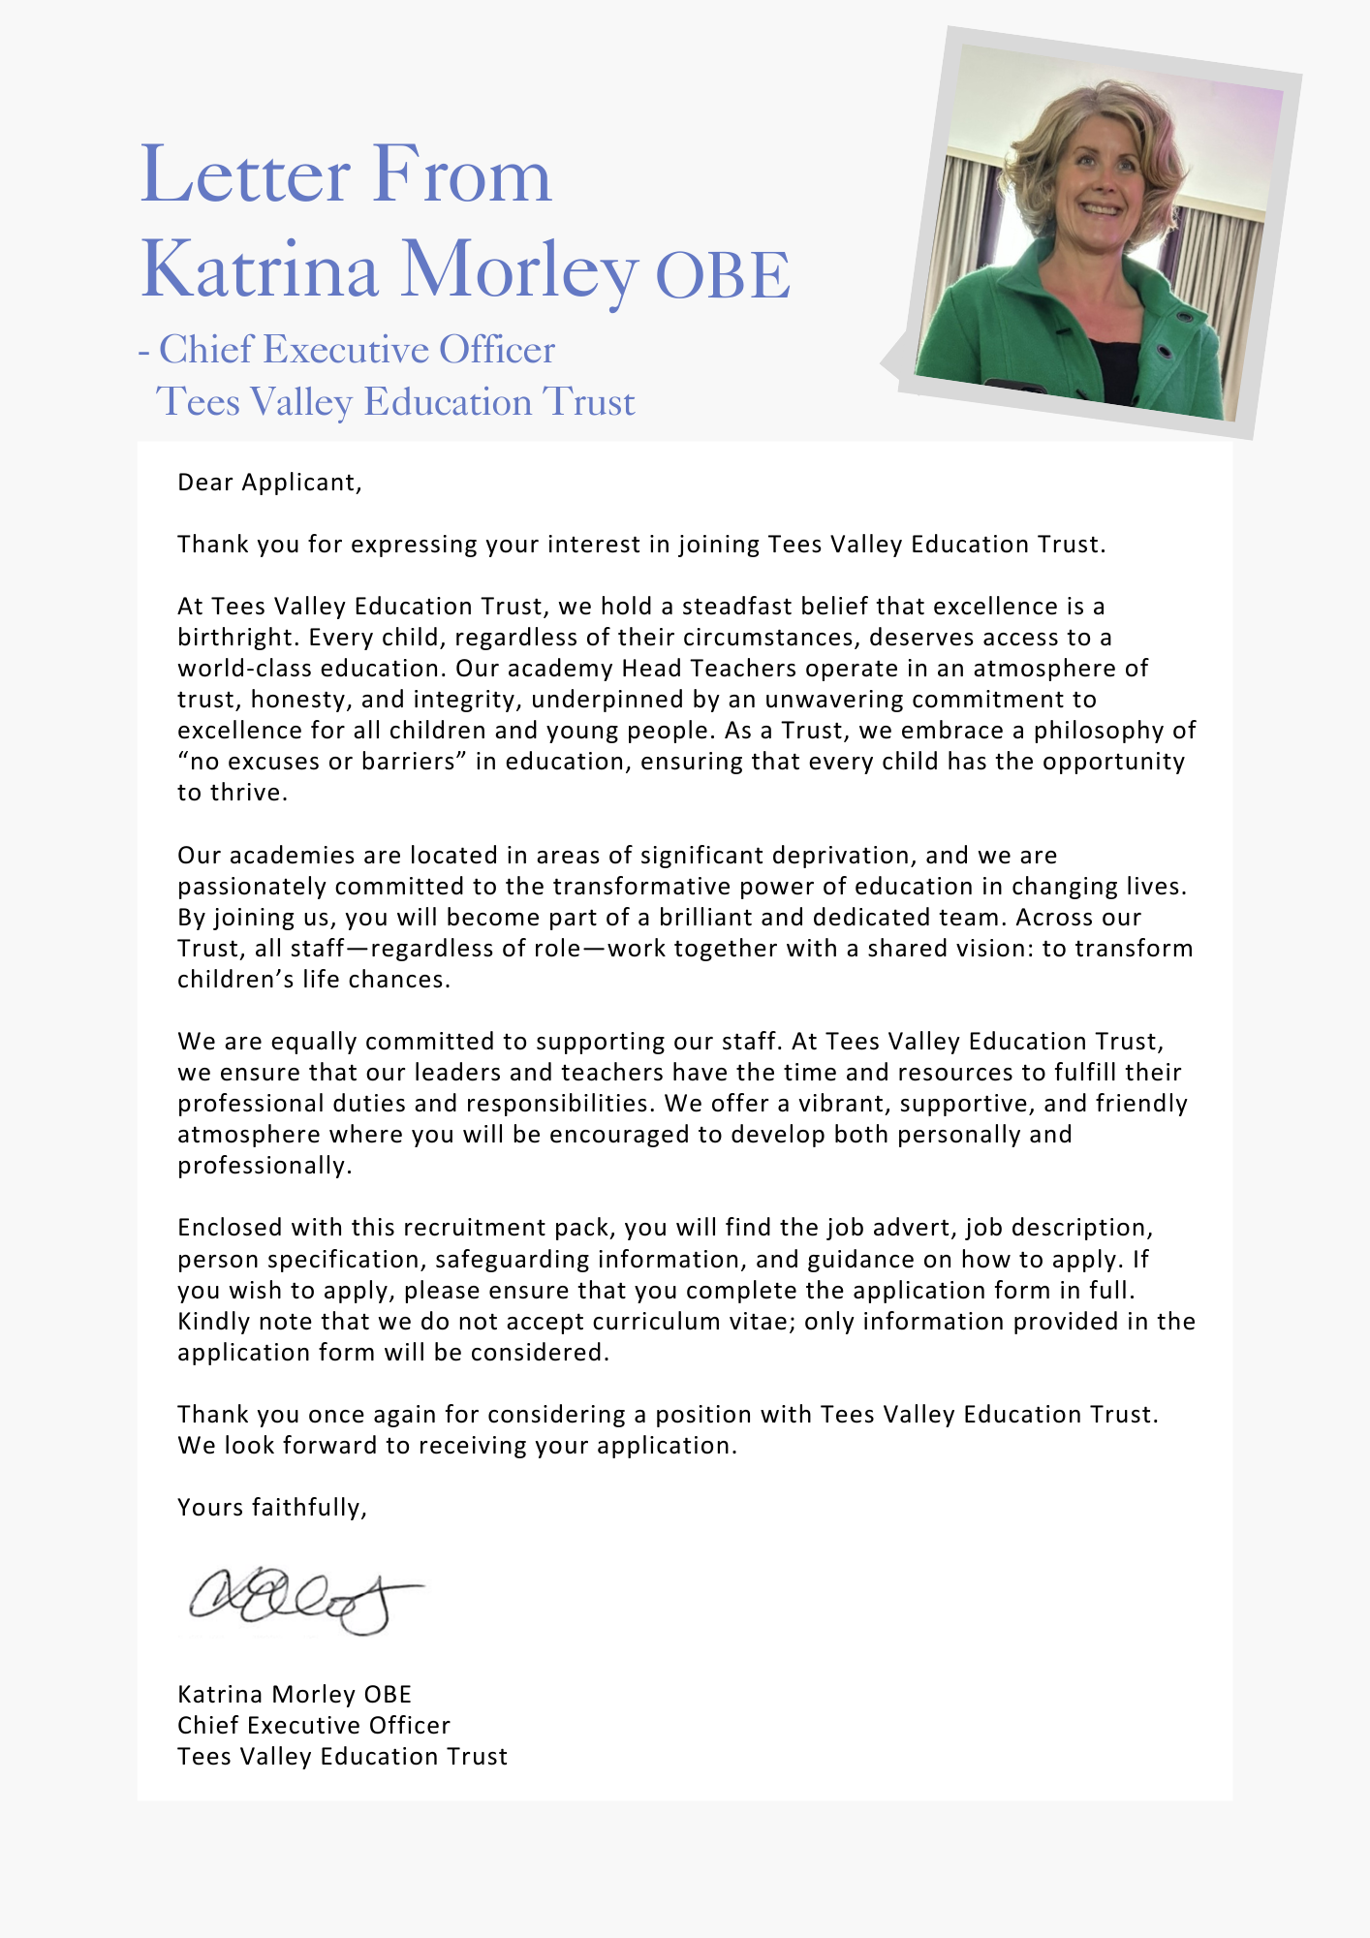





|  |
| --- |
| **ADVERTISEMENT** |

#### **Play Facilitator**

**Status:** Permanent

**Required:** 01.09.2025

**Salary:** Real Living Wage £12.60 per hour, £4,147.60 annual salary

**Hours:** 7.5 hours, term time only (TTO).

**Reporting to:** Pastoral Lead

**Academy:** Dormanstown Primary Academy

### About the Trust

The Trust was established in 2015 and provides education and enrichment activities to more than 1100 children across five Academies, located in Middlesbrough and Redcar and Cleveland local authority areas. Academies within the Trust are:

* Brambles Primary Academy (3 to 11 years),
* Discovery Special Academy (2 to 16 years),
* Dormanstown Primary Academy (2 to 11 years),
* Pennyman Primary Academy (3 to 11 years), and
* Wilton Primary Academy (3 to 11 years).

About the role we are looking to appoint:

Tees Valley Education wish to appoint enthusiastic, experienced and committed play facilitators. This position would be to work with children across the primary age ranges. The post will be situated at Dormanstown Primary Academy, South Avenue, Redcar, TS10 5LY.

Duties will include supervising children, both in the dining hall and playground, leading play activities and ensuring the safety, wellbeing, and good behaviour of all our children. Ideally, the successful candidates will have experience of working with children and young people.

In return, we can offer you the opportunity to join a successful academy within a well-established trust. Both the trust and academy have a strong inclusive ethos and an inherent drive for quality. Dormanstown Primary Academy is dedicated to delivering outstanding inclusive practice through a culture of co-production, experiential learning and growth, where parents and professionals work together to support the holistic development of the child. Our children are proud academy citizens, care for each other, are focused on learning and enjoy coming to school. We have an incredibly strong team and thrive on working together to improve access to education and outcomes for our children

### What the Trust will provide the successful candidate with:

* A workplace where all staff are valued and treated with respect as outlined within the Trust’s Diamond Standards
* A passionate, enthusiastic and supportive Leadership Team
* A listening and learning organisation where all staff are encouraged to be curious and share ideas for the Trust/academies/team to improve
* Hard working, committed and dedicated staff who strive to gain the best outcomes for all children across the Trust’s academies
* Dedicated approach to children’s learning to encourage them all to be the best they can be
* Career enhancement opportunities within areas of interest as well as supporting ongoing professional development and training specific to job role
* Dedicated line manager to discuss work streams and capacity
* Free access to the Trust’s Wellbeing offer, which includes counselling, access to GP and Mindfulness.
* Benefits of the Trust’s Staff Charter which can be found at [TVED Staff Charter](https://www.teesvalleyeducation.co.uk/wp-content/uploads/2022/01/STAFF-CHARTER_FINALISED.pdf).

Safeguarding requirements for the role:

Tees Valley Education Multi Academy Trust is committed to safeguarding and promoting the welfare of children. All appointments will be subject to a satisfactory enhanced DBS check.

This post is exempt from the Rehabilitation of Offenders Act 1974 and, therefore, all convictions, cautions and bind-overs, including those regarded as “spent” must be declared. The Trust’s Recruitment of Ex-Offender policy can be requested or visit the Trust’s website.

Applications are invited from prospective candidates who demonstrate that they are able to meet the essential criteria set out in the person specification and who have the vision, values and tenacity to join an outstanding team and help continue the journey towards excellence.

|  |  |
| --- | --- |
| **JOB DESCRIPTION**  Play Facilitator | |
| Job Title | Play Facilitator |
| Salary | £4,147.60 p.a. |
| Hours of work: | 7.50 hours |
| Reporting to | Pastoral Lead |
| **JOB PURPOSE** | |
| Applicants should be able to competently undertake the care, physical support, and supervision of children aged between 2 and 11 years old | |
| **Lunch Hall Responsibilities** | |
| * Ensuring good behaviour and calm atmosphere * Support pupils, as appropriate, while they are eating their lunch. * Being aware of pupils on special or restricted diets for medical reasons * Being aware of children with SEND * Assisting pupils with cutting up food, pouring liquids etc. where necessary * Encouraging social skills and good table manners, ensuring safety with knives and forks * Ensuring pupils tidy/clear up in a satisfactory manner * Cleaning up spillages * Supporting children with intimate care if needed | |
| **Outdoor Play** | |
| * Ensure pupils are adequately dressed for the weather conditions i.e have coats on when cold * To supervise children playing outside in all weathers * Direction of pupils to the playground and engage them in activities, ensuring their safety and wellbeing, providing emotional support where necessary * Ensuring safe play in line with the academy policy by engaging in, and modelling, a range of play activities to motivate and enthuse pupils during their lunchtime. * Being proactive to prevent behaviour issues, being aware of changes in friendships, encouraging socialising, play etc. * Supporting pupils inside the premises when they are not allowed outside due to bad weather * Provide support to pupils in designated areas of the school (including playground or external spaces) during lunchtime and to ensure their safety, welfare and general conduct through appropriate application of the school’s policies and procedures. * Take any immediate action to attend to sickness or accidents by carrying out minor first aid and asking for assistance. * Ensure resources are stored appropriately. * Check the quality and condition of resources and repair or remove any resources that are not in a suitable condition for continued use. * Facilitate peer-led play opportunities. * Ensure a rich and varied set of play opportunities is available for all children to engage in. * Provide engaging playwork interventions where pupils who find positive behaviour choices challenging. | |
| **Ancillary** | |
| * Supporting the academy with cleaning before and after lunchtime * Ensuring that any pupils who suffer accident or injury are dealt with appropriately in accordance with the Academy’s agreed procedure. * Report any major accidents or bumped heads to the class teacher and record in the accident book * Complete any relevant documentation required by the school in relation to incidents occurring during the lunchtime break period and to participate in review/medical meetings, as required. * Be aware of any special medical conditions * Liaising with staff to share any incidents to allow them to be logged on CPOMs | |
| **Safeguarding Children** | |
| * Tees Valley Education is committed to safeguarding and promoting the welfare of children and young people. We expect all staff to share this commitment and to undergo appropriate checks, including enhanced DBS checks * To follow the child protection procedures adopted by the academy | |
| **Personal skills and attributes** | |
| * Excellent interpersonal skills * Can communicate effectively with both adults and children. * Successfully supervise pupils, both in the dining hall and whilst playing on the yard. * Have a good understanding of how to care for children. * Demonstrate a proven track record of working successfully as part of a team. * Flexible and adaptable, even under challenging situations * Actively promote the ethos of the academy | |
| **General responsibilities** | |
| As a member of staff within the Trust, you are also expected to:   * Undertake any additional duties as could be reasonably required. * Undertake additional training and other learning activities and performance development as required * Develop familiarity with relevant legislation such as UK General Data Protection Regulation (UK GDPR) and Health and Safety at Work etc. Act 1974 to ensure the Trust is fully protected at all times. | |

|  |
| --- |
| **Important:** In the first instance, applications are assessed against the criteria listed above, in addition to overall presentation, use of standard English and grammatical accuracy.  Where applications do not meet the expected standard, they will be rejected before being matched to the person specification. |

|  |
| --- |
| **HOW TO APPLY AND EXPLANATORY NOTES OF THE PROCESS** |

An application form is attached below. Application packs can be downloaded or printed directly from the Trust website **www.teesvalleyeducation.co.uk** or requested from the academy. Only applications via the Trust’s official application form will be accepted. Please do not submit a CV as substitute for part or full application form, the information will not be accepted or considered.

If you are submitting your completed application form by e-mail to **Dormanstown@tved.org.uk** - please be aware the academy cannot be responsible for any formatting anomalies when printing. If you are unable to submit an electronic application form, handwritten or electronic printed copies should be posted or hand delivered to the following address for the attention of Mrs Antje Kell.

Dormanstown Primary Academy

South Avenue

Redcar

TS10 5LY

##### Shortlisting Process

After the closing date, short listing will be conducted by a panel, who will match your skills/experience against the criteria in the Job Description. You will be selected for interview entirely on the contents of your application form, so please read the Job Description carefully before you complete your form.

Shortlisted candidates will receive:

* Letter confirming interview details.
* Details of original ID documentation is required to confirm candidates. Photocopies or certified copies are not accepted.
* Criminal Record Self-Declaration Form, which must be brought on the day of the interview in the sealed envelope provided.

References for successful Candidate/s

We may seek references for shortlisted candidate/s and we may also approach previous employers for information to verify particular experience or qualifications before the interview. Any relevant issues arising from references will be taken up post interview.

Interview process

In addition to candidates’ ability to perform the duties of the post, the interview will also explore issues relating to safeguarding and promoting the welfare of children, including:

* Motivation to work with children and young people
* Ability to form and maintain appropriate relationships and personal boundaries with children and young people
* Emotional resilience in working with challenging behaviours
* Attitudes to use of authority and maintaining discipline

##### Conditional Offer: Pre-Employment Checks

Any offer to a successful candidate will be conditional upon:

* Verification of right to work in the UK
* Receipt of at least two satisfactory references (if these have not already been received)
* Verification of identity checks and qualifications
* Satisfactory enhanced DBS check
* Verification of professional status such e.g. QTS Status, NPQH (where required)
* Satisfactory completion of a Health Assessment
* Satisfactory completion of the probationary period (where relevant)
* Where the successful candidate has worked or been resident overseas in the previous five years, such checks and confirmations as may be required in accordance with statutory guidance.

**Please contact the academy office on 01642 483696 for more details on the role. Once your application has been received, and if successful, we will contact you with an interview date.**

For your information, the recruitment timetable is detailed below:

**Closing date: Monday 7th July 2025 at 12 noon**

**Shortlisting date: Monday 7th July 2025 PM**

**Interview date: Thursday 10th July 2025 AM**

|  |
| --- |
| **EQUALITIES INFORMATION AND OBJECTIVES STATEMENT** |

As an academy we ensure that our vision, values and ethos meet the expectations of the equality and diversity guidelines and legislation set out by the Equality and Human Rights Commission. This includes the following 9 protected characteristics:

1. Age
2. Disability
3. Gender Reassignment
4. Marriage and Civil Partnerships
5. Pregnancy and Maternity
6. Race
7. Religion or belief
8. Sex
9. Sexual Orientation

**Objectives Statement**

1. To support children’s sensory, academic and communication skills to enable them to develop holistically.
2. To ensure high expectations across all aspects of the academy (as outlined in objective 1) to ensure children make the best progress according to their individual starting points.
3. To continue to monitor attendance of all groups of children in the academy.
4. To review levels of parental and pupil engagement in learning and academy life, across all activities and ensure equality and fairness in access and engagement.
5. To ensure the academy environment is as accessible as possible to pupils, staff and visitors.

