EYFS 2-year-old Level 4 Room Leader

Dormanstown Primary Academy

DPA338

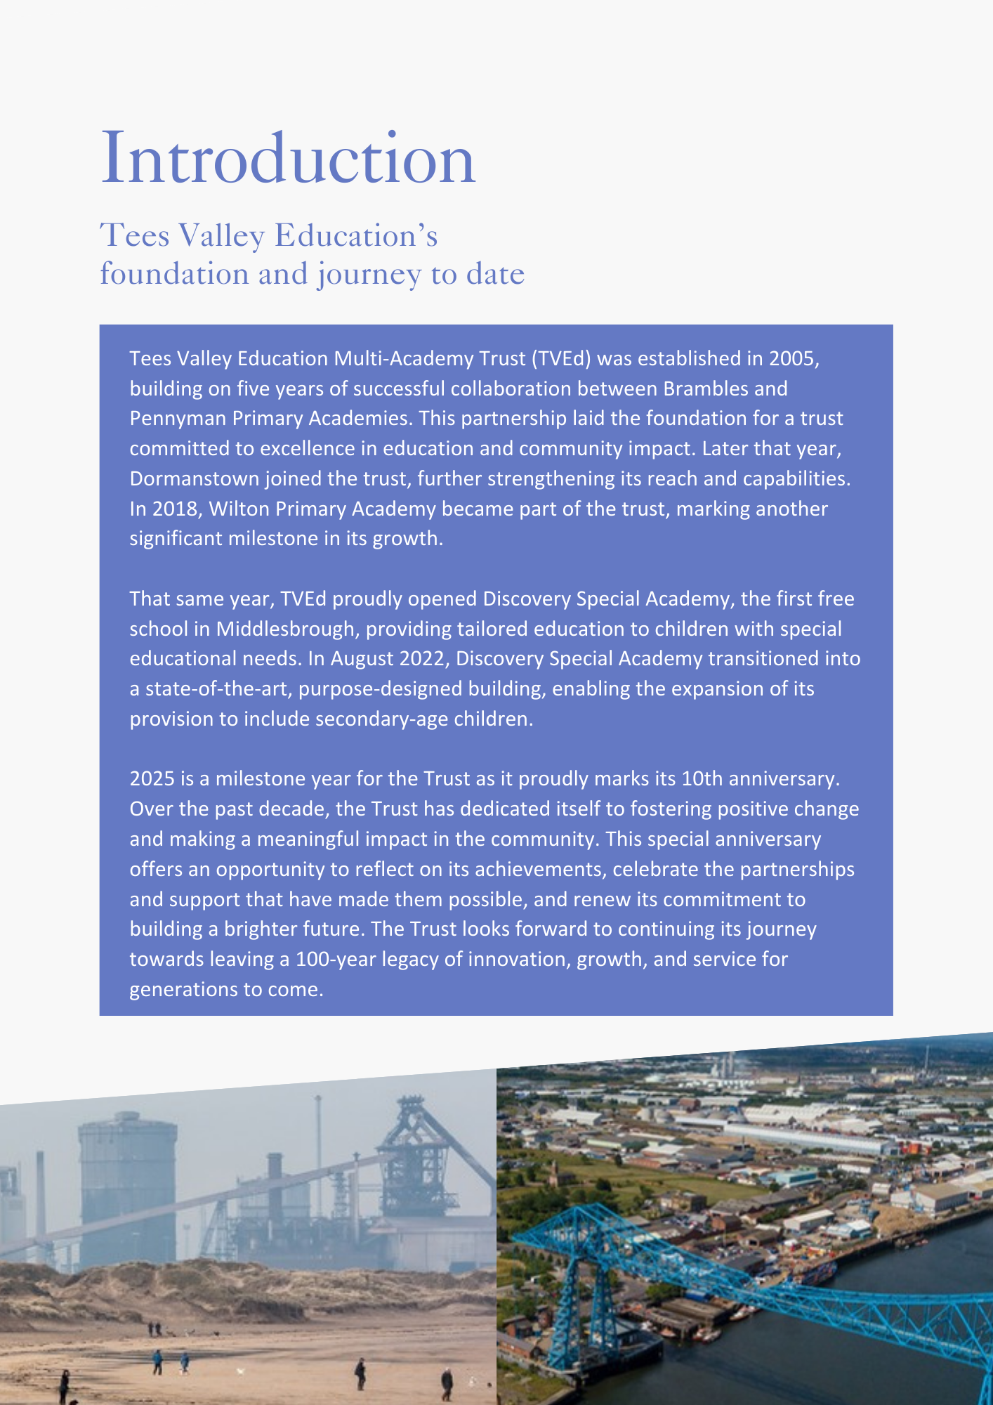

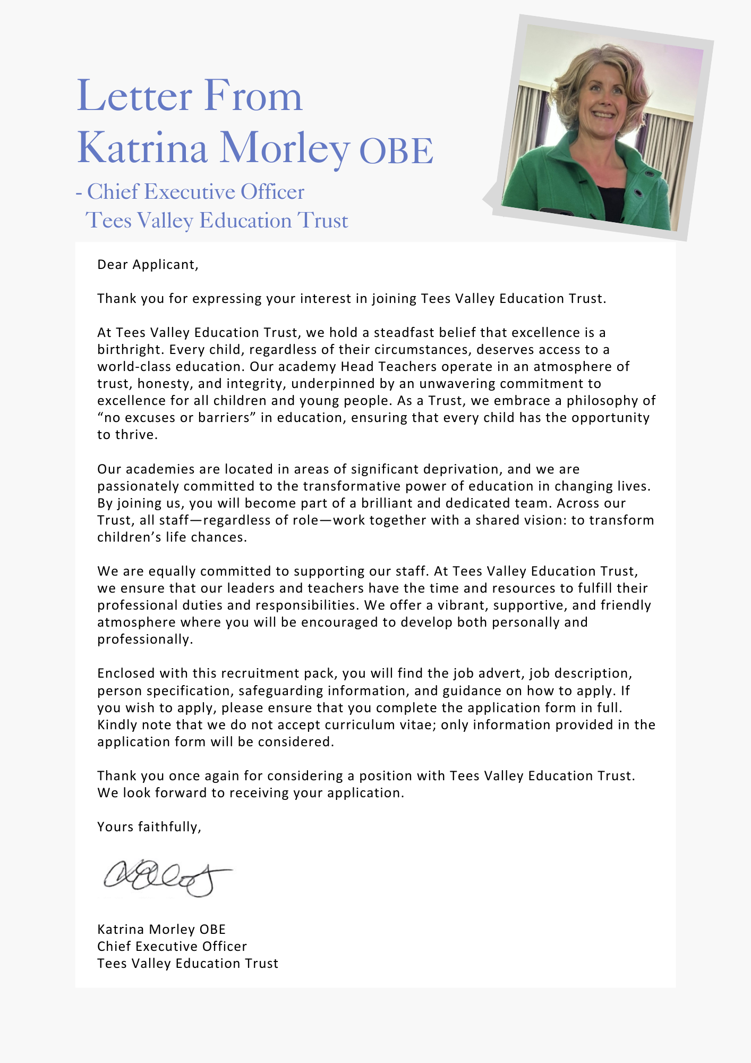

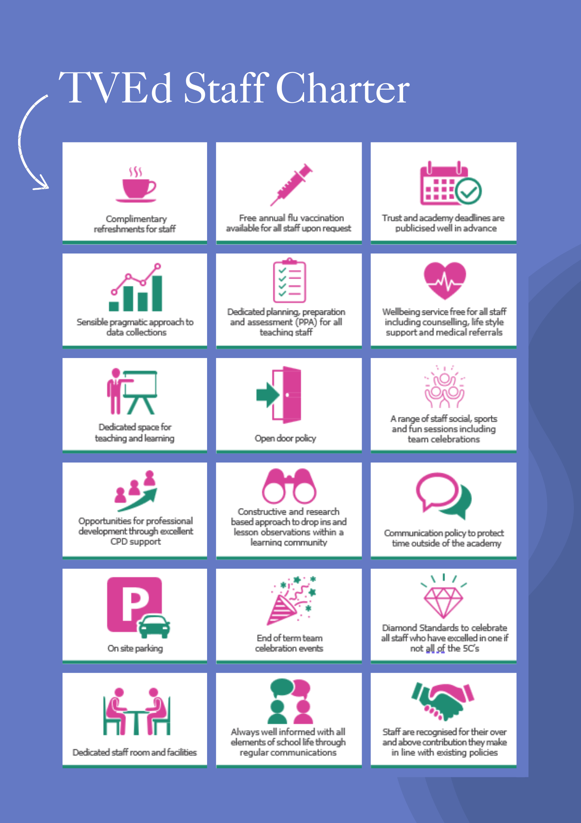



|  |
| --- |
| **ADVERTISEMENT** |

**Learning Assistant – Level 4**

**Dormanstown Primary Academy**

**Status: Permanent**

**Required: September 2025**

**Salary: NJC SCP 12 -15 £28,598 to £30,024 (pro rated £14,959 to £15,705)**

**Hours: 22.5 hours term time only plus 1 week**

**Reporting to: Executive Head Teacher**

### **About the Trust**

The Trust was established in 2015 and provides education and enrichment activities to more than 1200 children across five Academies, located in Middlesbrough and Redcar and Cleveland local authority areas. Academies within the Trust are:

* Brambles Primary Academy (2 to 11 years),
* Discovery Special Academy (2 to 16 years),
* Dormanstown Primary Academy (2 to 11 years),
* Pennyman Primary Academy (2 to 11 years), and
* Wilton Primary Academy (3 to 11 years).

**About the role we are looking to appoint:**

Dormanstown Primary Academy is a thriving learning community of 270 pupils aged 2-11 years consisting of a mainstream setting and a smaller unit provision. The academy is committed to developing each child’s unique potential within an environment where all pupils can thrive and not only reach their best academically, but also develop a thirst for knowledge, a love of learning and be well prepared for their future lives. Our learning environment is integral in promoting key learning dispositions and values and fulfilling the ‘inspiration, aspiration, collaboration and celebration’ embodied in our school logo. Through the provision of a range of educational experiences, we aim to increase confidence, broaden horizons and increase pupils’ cultural capital through our new ‘activities passport’. We define progress as the widening and deepening of key knowledge, skills and understanding, which together with the development of key values and learning dispositions leads to success both now and in the future. The provision at Dormanstown Primary ensures pupils have the essential knowledge, learning dispositions and key values to embrace the opportunities and challenges they encounter to go out into the world and make a difference to their own lives and that of others.

Dormanstown Primary Academy is seeking to appoint a Room Leader for our brand new 2-year-old provision. This will be closely linked to our existing nursery provision. The Room Leader for our 2-year-old provision will share the same enthusiasm and dedication to childrens’ learning that all our staff have and will need to work well within a team, as well as provide leadership for this new opportunity.

The prospective candidate will be an excellent EYFS practitioner who is passionate about driving forward this exciting opportunity for the children of Dormanstown. They will also be good role model, set high expectations and have an excellent understanding of the EYFS phase.

We believe that every child deserves the best possible start in life. Our team is nurturing, enthusiastic, and committed to early intervention and inclusive practice. If you are passionate about early years education and ready to make a difference, we’d love to hear from you.

We have a committed and hardworking staff team who play an active role in driving school improvement and ensuring our children enjoy the best of what we have to offer. You will be able to make a valuable contribution by participating in the team-working ethos of the academy within our team of staff and across the Redcar and Cleveland partnership of Dormanstown and Wilton under the executive leadership of both academies.

**Dormanstown Primary Academy can offer you:**

* an excellent learning environment
* dedicated pupils who love coming to the academy and are encouraged to be the best they can be
* a forward-thinking approach to education
* a passionate and high performing team of professionals within the academy and across the Trust to learn from and contribute to
* an enthusiastic and supportive Executive Head Teacher and Head of Academy who put the interests of the children first and are committed to the continual improvement of the academy
* an opportunity to be part of working parties across the Redcar and Cleveland academies of Dormanstown and Wilton and the Trust within your areas of interest
* career enhancement opportunities within areas of interest

### **What the Trust will provide the successful candidate with:**

* A workplace where all staff are valued and treated with respect as outlined within the Trust’s Diamond Standards
* A passionate, enthusiastic and supportive Leadership Team
* A listening and learning organisation where all staff are encouraged to be curious and share ideas for the Trust/academies/team to improve
* Hard working, committed and dedicated staff who strive to gain the best outcomes for all children across the Trust’s academies
* Dedicated approach to children’s learning to encourage them all to be the best they can be
* Career enhancement opportunities within areas of interest as well as supporting ongoing professional development and training specific to job role
* Dedicated line manager to discuss work streams and capacity
* Free access to the Trust’s Wellbeing offer, which includes counselling, access to GP, Mindfulness and so much more.
* Auto Enrolment into the Local Government Pensions Scheme, employer contributing 17.50%
* Benefits of the Trust’s Staff Charter which can be found at [TVED Staff Charter](https://www.teesvalleyeducation.co.uk/wp-content/uploads/2022/01/STAFF-CHARTER_FINALISED.pdf).

**Safeguarding requirements for the role:**

Tees Valley Education Trust is committed to safeguarding and promoting the welfare of children. All appointments will be subject to a satisfactory enhanced DBS check.

This post is exempt from the Rehabilitation of Offenders Act 1974 and, therefore, all convictions, cautions and bind-overs, including those regarded as “spent” must be declared. The Trust’s Recruitment of Ex-Offender policy can be requested or visit the Trust’s website.

Applications are invited from prospective candidates who demonstrate that they are able to meet the essential criteria set out in the person specification and who have the vision, values and tenacity to join an outstanding team and help continue the journey towards excellence.

|  |
| --- |
| **JOB DESCRIPTION** |
|  |
| **MAIN DUTIES AND RESPONSIBILITES** |
| The Room Leader is expected to lead the provision of a high quality, vibrant learning environment, ensuring that children are stimulated by an exciting range of experiences, offering the best possible academic and pastoral care.   * Ensure that room staff and resources are effectively managed * Establish an appropriate, rich learning environment * Be responsible for high quality teaching and learning * Ensure records are properly maintained e.g attendance register, accident records, learning journeys, reports, SEND plans * Liaise with the SENCO and other professionals as necessary * Work closely with the DSL over any concerns over a child * Ensure the room is a safe environment for children, staff and others * Use skills/training/experience to support all pupils * Promote the inclusion and acceptance of all pupils * Work with classes, small groups and individuals to support them by accessing learning across the EYFS curriculum * Encourage pupils to interact with others and engage in activities * Support pupils in their own personal development to be successful through promoting excellent attitudes towards learning and behaviour * Supervise and provide support for pupils, including those with special needs, ensuring their safety and access to learning activities * Establish constructive relationships with pupils and interact with them according to individual needs * Supervise pupils who may be working outside normal timetables or who need 1:1 support outside the classroom * Provide feedback to parents/carers in relation to progress and achievement * Supervise pupils and ensure they are happy and safe at playtimes and lunchtimes * Support pupils with personal hygiene and toileting needs, whilst respecting their dignity and promoting independence * Encourage the development of communication and language for all children |
|  |
| * Promote positive values, attitudes and good pupil behaviour, dealing promptly with conflict and incidents in line with established policy * Liaise sensitively and effectively with parents/carers and participate in feedback sessions/meetings with parents/carers * Conduct paired home visits before a pupil starts in the provision * Ensure the team works flexibly and takes shared responsibility so that adult:child rations are always maintained, highlighting to the EYFS leader where cover is required * Keep up to date with good practice * Manage teaching assistants/ apprentices/ students as required * Undertake recruitment/ induction/ appraisal/ training/ mentoring for other Level 3 teaching assistants in the 2-year-old room |
| **SUPPORT FOR THE CURRICULUM** |
| * Plan and evaluate the agreed learning activities/teaching programmes, adjusting activities according to pupil responses/needs * Implement agreed learning strategies/curriculum activities and make effective use of opportunities to support the development of relevant knowledge and skills * Help pupils to access learning activities through targeted support * Determine the need for, prepare and maintain general and specialist equipment and resources * Select and prepare resources necessary to lead learning activities, taking account of pupils’ interests and language and cultural backgrounds |
| **SUPPORT FOR THE ACADEMY** |
| * Be aware of and comply with policies and procedures relating to child protection, health, safety and security, confidentiality and data protection, reporting all concerns to an appropriate person * Understand and fully implement the academy’s positive behaviour management strategies * Be aware of and support differences and ensure all pupils have equal access to opportunities to learn and develop * Contribute to the overall ethos/work/aims of the academy * Establish constructive relationships and communicate with other agencies/professionals to support the achievement and progress of pupils * Attend and participate in regular meetings, including staff meetings, as and when necessary * Participate in training and other learning activities as required |
| The job holder may be required to undertake additional duties as could be reasonably required in exceptional or emergency situations.  The job holder may be required to work flexibly between the hours of 8.30am – 12.30am and 8.30-3.30 on Wednesdays  The job holder may be required to work across the academy group.  The job holder may be required to undertake additional training e.g. first aid, Positive Handling. |

**Important:** In the first instance, applications are assessed against the following criteria:

*overall presentation *use of standard English *grammatical accuracy

Where applications do not meet the expected standard, they will be discarded before being matched to the person specification.

|  |  |
| --- | --- |
| **PERSON SPECIFICATION** | |
| **QUALIFICATIONS** | **E/D** |
| GCSE grade C or above in English and Mathematics (equivalent qualifications considered) | E |
| CACHE Level 4 qualification for Advanced Practitioner (Early Years) (or equivalent) or Level 3 Early Years Educator and a willingness to work towards CAHCE Level 4 | E |
| Current Paediatric First Aid (or willingness to train) | E |
| Safeguarding training (or willingness to undertake) | E |
| Positive handling training | D |
| **EXPERIENCE** |  |
| Experience of working with 2-year-olds in a nursery or school setting | E |
| Experience of leading and delivery of learning tasks to groups of pupils | E |
| Experience of supporting pupils with academic and pastoral development | E |
| Send experience or training | D |
| **KNOWLEDGE, ABILITIES AND SKILLS** |  |
| Ability to form warm, responsive relationships with young children | E |
| Working knowledge of implementing the EYFS curriculum and other relevant learning programmes/strategies | E |
| Good understanding of child development and learning | E |
| Ability to support the provision of a stimulating, organised and educationally rich learning environment | E |
| Ability to supervise and assist groups and individuals to support their learning | E |
| Ability to observe and track progress of pupils | E |
| Full working knowledge of relevant polices/codes of practice/legislation | E |
| Have a working knowledge of how technology can be used to support learning | E |
| Ability to work as part of a team, following instructions and on own initiative | E |
| Strong communication skills, including the use of standard English | E |
| Ability to use time effectively to enable work to be prioritised and for deadlines to be met | E |
| Ability to relate well to parents/carers | E |
| Knowledge of the concept of confidentiality and its importance | E |
| Commitment to safeguarding and protecting the welfare of children and young people | E |
| Evidence of adaptability and ability to use own initiative |  |
| Be able to plan and deliver structured learning and after school activities successfully for individuals and groups of children | D |
| Experience of delivering interventions and being able to provide feedback on progress | D |

|  |
| --- |
| **SAFEGUARDING** |
| * All staff must adhere to the Trust’s safeguarding training (appropriate for job role) including policies, procedures, latest Keeping Children Safe in Education guidance and Working Together to Safeguard Children DfE 2023. |
| This job description will be reviewed annually and may be subject to amendment or modification at any time after consultation with the post holder. It is not a comprehensive statement of procedures and tasks, but sets out the main expectations of the Trust in relation to the post holder’s professional responsibilities and duties.  Elements of this job description and changes to it may be negotiated at the request of either the line manager or executive headteacher. |

E – Essential D – Desirable

|  |
| --- |
| **HOW TO APPLY AND EXPLANATORY NOTES OF THE PROCESS** |

An application form is attached. Application packs can be downloaded or printed directly from the Trust website www.teesvalleyeducation.co.uk or requested from the Academy. Only applications on the Trust’s official application form will be accepted. Please do not submit a CV as substitute for part or full application form, the information will not be accepted or considered.

If you are submitting your completed application form by e-mail to dormanstown@tved.org.uk - please be aware that the academy cannot be responsible for any formatting anomalies when printing. Please add Dormanstown Learning Assistant as the subject. If you are unable to submit an electronic application form, hand written or electronic printed copies should be posted or hand delivered to the following address for the attention of Mrs A Kell, Executive Headteacher.

Dormanstown Primary Academy

South Avenue

Dormanstown

Redcar and Cleveland

TS10 5LY

Shortlisting Process

After the closing date, shortlisting will be conducted by a panel, who will match your skills/experience against the criteria in the Person Specification. You will be selected for interview entirely on the contents of your application form, so please read the Job Description and Person Specification carefully before you complete your form.

Shortlisted candidates will receive:

• Letter confirming interview details.

• Details of original ID documentation is required to confirm candidates. Photocopies or certified copies are not accepted.

• Criminal Record Self-Declaration Form, which must be brought on the day of the interview in the sealed envelope provided.

The Trust may undertake social media searches in accordance with keeping children safe in education guidance.

References for successful Candidate/s

We may seek references for shortlisted candidate/s, we may also approach previous employers for information to verify particular experience or qualifications before the interview. Finally, we may also undertake a social media search in accordance with Keeping Children Safe in Education guidance. Any relevant issues arising from references will be taken up post interview.

Interview Process

In addition to candidates’ ability to perform the duties of the post, the interview will also explore issues relating to safeguarding and promoting the welfare of children, including:

• Motivation to work with children and young people

• Ability to form and maintain appropriate relationships and personal boundaries with children and young people

• Emotional resilience in working with challenging behaviours

• Attitudes to use of authority and maintaining discipline

Conditional offer: Pre-Employment Checks

Any offer to a successful candidate will be conditional upon:

• Verification of right to work in the UK

• Receipt of at least two satisfactory references (if these have not already been received)

• Verification of identity checks and qualifications

• Satisfactory enhanced DBS check

• Verification of professional status such as e.g. QTS Status, NPQH (where required)

• Satisfactory completion of a Health Assessment

• Satisfactory completion of the probationary period (where relevant)

• Where the successful candidate has worked or been resident overseas in the previous five years, such checks and confirmations as may be required in accordance with statutory guidance.

Visits to the academy are actively encouraged and should be arranged by contacting the academy office on 01642 483696.

Visit dates are:

* Friday 13th June at 4pm
* Wednesday 18th June at 1pm
* Thursday 19th June at 9am
* Monday 23rd June at 3.30pm

For your information, the recruitment timetable is detailed below:

**Closing Date:** Thursday 26th June at 4pm

**Shortlisting Date:** Friday 27th June

**Interviews:** Monday 30th June 2025.