

**TEACHER OF MUSIC**

**Part Time 0.6FTE, Permanent**

**About Our School**

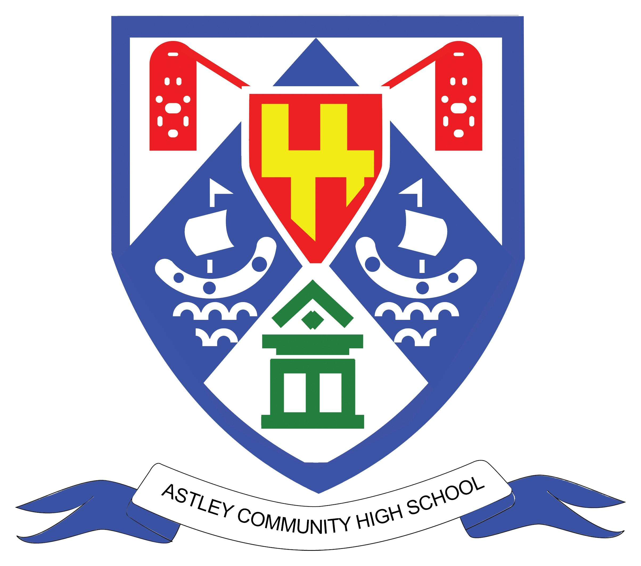

**Small enough to care,   
big enough to deliver a positive impact**

**Executive Headteacher’s Welcome**

**Thank you for your interest in the opportunity to join Astley Community High School at this exciting time in the school's journey as we are about to enter a new era in the school's history as we move into a new school building in September 2025. This candidate information pack provides more details about our school.**

Astley Community High School and Whytrig Middle School, currently co-located on Elsdon Avenue in Seaton Delaval, together form the Seaton Valley Federation of Schools, alongside Seaton Sluice Middle School. The three schools share a single governing body.

As the Executive Headteacher of all three schools, I am immensely proud of the work we do. We strive for excellence in the education we offer our students and are a focal point within the local community. Astley Community High School is rated ‘Good’ by Ofsted.

I firmly believe that the smaller size of our schools provides an excellent environment to know our students well, enabling us to understand and respond to their individual needs and support their success.

We have a fantastic staff team, people who are passionate about achieving the best outcomes for our students, while also considering their unique needs. The majority of our staff tend to spend a large part of their career with us. We are committed to continuous learning and have fostered strong relationships with other schools across the North-East to ensure our teachers benefit from an outstanding Continuous Professional Development (CPD) program. Building the skills and capacity of our support staff is also a top priority.

We hope the information in this pack inspires you to apply for this exciting opportunity. If you would like an informal discussion about the position, please feel free to contact Richard Goodman, Head of School ACHS on 0191 2371505.



**John Barnes  
Executive Headteacher – Seaton Valley Federation of Schools**

**Our Ethos and Values**

We have three main themes to our ethos:

* To know every child academically and pastorally as a complete young person.
* To treat everyone and everything with respect.
* To strive for everyone to be as good as they can be and to be proud of doing   
   well.

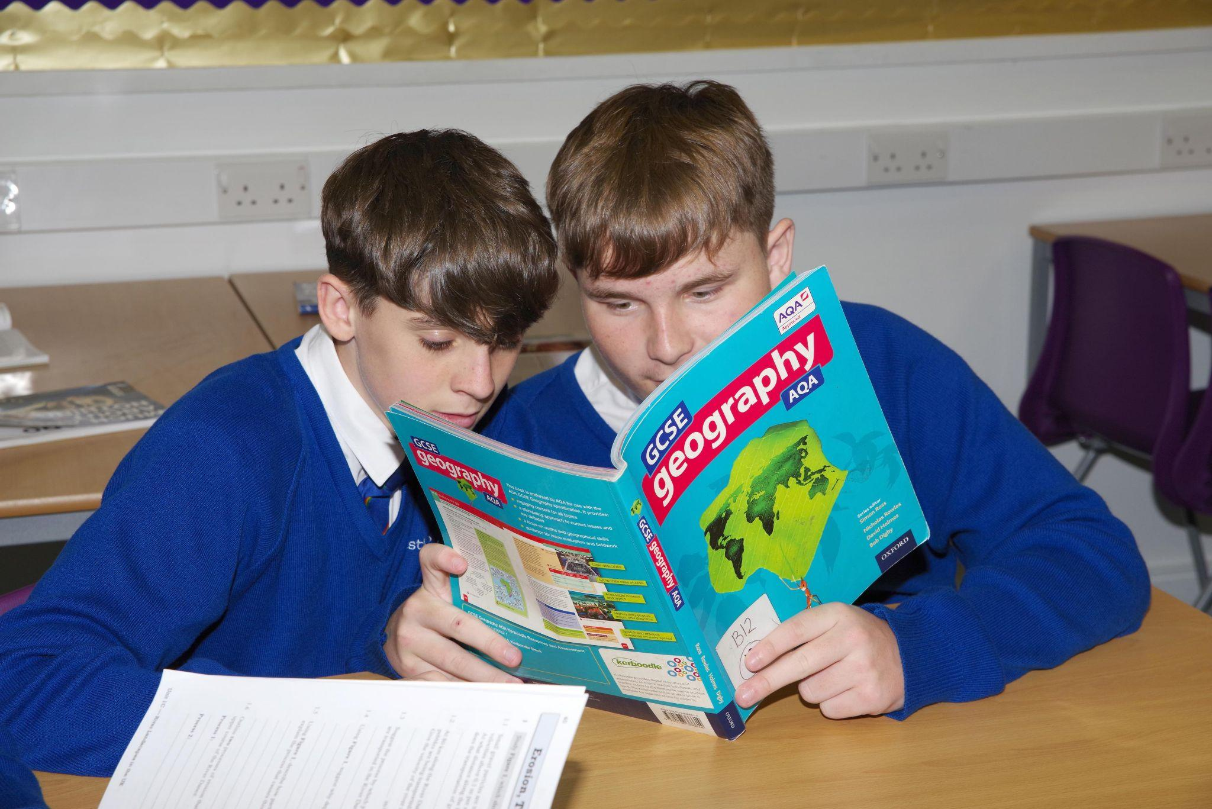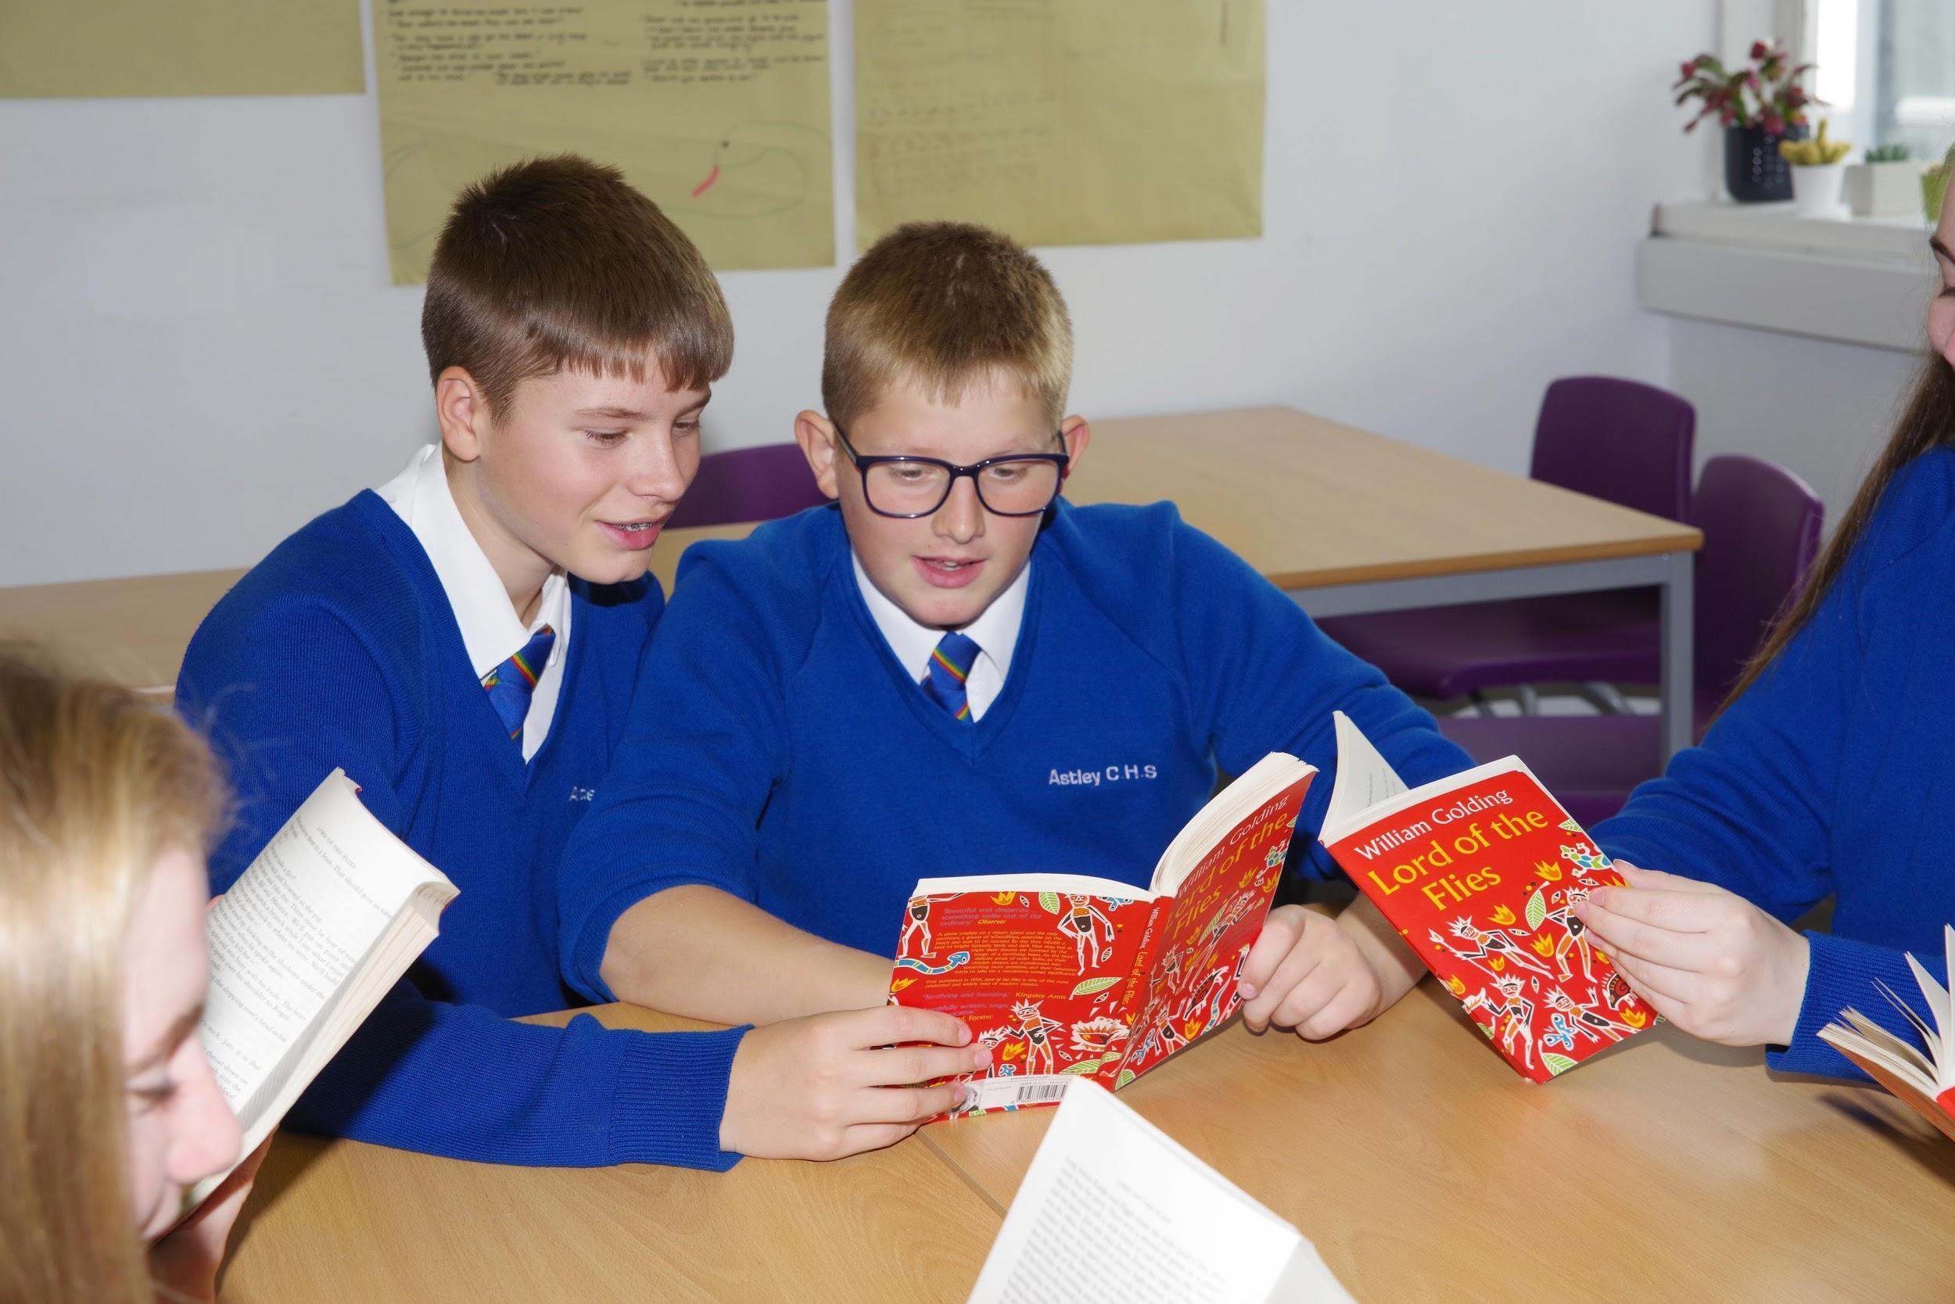

All three schools in the Seaton Valley Federation share a set of core values. We expect that all members of our school community will:

* develop their self-knowledge, self-esteem and self-confidence
* respect the laws of England and will know right from wrong and ensure their   
   actions reflect this
* accept responsibility for their behaviour
* show initiative and contribute in a positive way to the school community, the   
   local community and society in general
* show respect for each other and all other people
* show tolerance and respect for different cultures and traditions and will never   
   act in such a way that these cultures or traditions are abused or attacked
* show respect for the rule of democracy and respect for the democratic  
   principles of England.

**Our New Building**

September 2025 brings a new era for Astley Community High School and   
Whytrig Middle School, as we move into our new multi-million pound campus, featuring fantastic facilities for our students, staff and community, including a fitness studio, swimming pool and 3G pitch, transforming the learning environment for students.

The name for Astley Community High School will be changing to Seaton Valley High School in September 2025.

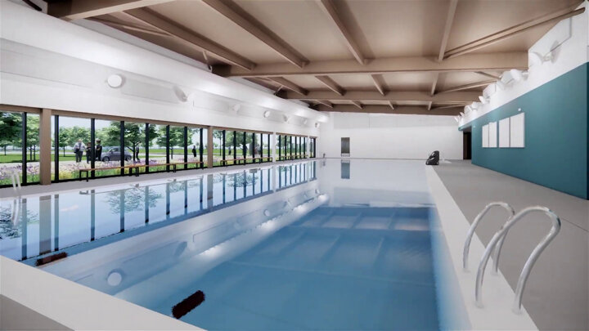

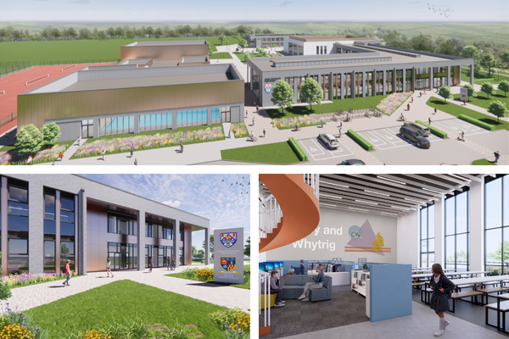

[**https://youtu.be/OLSDluhzoqc**](https://youtu.be/OLSDluhzoqc)

**About our Schools**

|  | **Age Range** | **Total Number of Pupils** | **Number in Sixth Form** |
| --- | --- | --- | --- |
| Astley Community High School | 13 to 18 years | 630 | 181 |
| Seaton Sluice Middle School | 9 to 13 years | 334 | N/A |
| Whytrig Middle School | 9 to 13 years | 326 | N/A |

Astley Community High School attracts students from outside the Seaton Valley area   
due to the inclusive nature of our school environment. Many students who have faced challenges elsewhere come to our school and thrive. Our dedicated staff are both caring and nurturing, ensuring that every child is given the support and opportunities needed to succeed.

We focus on positive relationships between all members of the school community. We aim to help develop our students’ understanding of what positive relationships and behaviour look like and we strive to support those students who struggle with this, providing support for students wellbeing though our pastoral and counselling services.

We strive to support all students to achieve their full potential. This starts first through quality first teaching in each classroom – teachers knowing the students in front of them and adapting their teaching to suit the individual needs. Wraparound support is also put in place for those students who need it, especially from a pastoral and SEN perspective.

We also have a strong sixth form and we typically retain 75% of our Year 11 students for further study. This year we are launching our Sports Academy in Sixth Form, with the fantastic new sporting facilities available to us, including a 25 metre swimming pool, dance studio, sports hall, 3G and grass pitches.

More information about sixth form including our prospectus is available from: [www.svf.org.uk/sixthform](http://www.svf.org.uk/sixthform)

**About our Structure and Teams**

The Senior Leadership team across our schools are lead by the Executive   
Headteacher, John Barnes, there is a Head of School in each school along with the Business Director.

| Executive Headteacher  **John Barnes** | | | |
| --- | --- | --- | --- |
| Head of School  Astley Community High School  **Richard Goodman** | Head of School  Whytrig Middle School  **Jon Souter** | Head of School  Seaton Sluice Middle School  **Karen McSparron** | Business Director  **Ben Watson** |

In each school there is an individual Leadership Team, the SLT meet in their school base  
but we often meet as a wider SLT to share practice across the federation.

| Head of School  Astley Community High School  **Richard Goodman** | | | | |
| --- | --- | --- | --- | --- |
| Assistant Headteacher  SEND & Disadvantaged  **Kath Lennon** | Assistant Headteacher Curriculum  **Lou Power** | Assistant Headteacher  6th Form  **Adam Ironside** | Assistant Headteacher  Attendance & Pastoral  **Stephen Wood** | Business Manager  **Janet Das** |
| Associate SLT  School Counsellor  **Jonathan Collins** | | Associate SLT  Student Progress Leader  **Steven Henderson** | | |

Each member of the Senior Leadership line manages a faculty / department within the school, each faculty has a Head of Faculty.

The Support Staff team is headed up by the Business Director, supported by three   
Business Managers with responsibilities for Data and Curriculum, ICT and site, HR, Administration, partnerships, marketing and governance.

**About our Performance and Ofsted**

We are proud of our Ofsted reports, we are rated as Good schools   
across the federation

|  | **Overall Effectiveness** | **Last Ofsted Inspection** |
| --- | --- | --- |
| **Astley Community High School** | **Good** | **December 2024** |
| ‘Astley Community High School is a close-knit community where pupils are safe and happy. Pupils are proud to attend the school and enjoy positive relationships with staff. The school has high expectations for pupils. Staff know pupils well. Pupils are regarded as individuals. Pastoral care is strong. Pupils conduct themselves well. They greet visitors warmly and demonstrate excellent manners. The school is calm and orderly. In lessons, pupils work hard and listen carefully to their teachers. At social times, pupils mix well together. Sixth-form students are positive role models for younger pupils.’ | | |
| **Seaton Sluice Middle School** | **Good** | **September 2023** |
| ‘Pupils at Seaton Sluice Middle School are proud of their school community. They say that everyone is welcome and that teachers will always help them do their best. Inspectors agree. Pupils are polite and confident when speaking to staff, visitors and each another. They are keen to make the most of their time at school.Bullying at the school is rare. If pupils are unkind in their words or actions, staff deal with this immediately. Pupils tell an adult if something is worrying them. The school counsellor provides additional support for vulnerable pupils. This helps pupils to become confident and resilient young adults. The school’s approach to promoting and supporting the mental health and well-being of pupils and staff is a strength of the school’ | | |
| **Whytrig Middle School** | **Good** | **December 2021** |
| ‘This school is an inclusive environment where pupils value each other. They respect and celebrate difference. There is a strong sense of community and pupils feel responsible for each other. Pupils spoken to would all challenge bullying if they saw it. Parents and carers and pupils agree that if bullying does occur, it is dealt with effectively by staff. Pupils feel safe and happy here. They are rightly proud of their school. Behaviour is exemplary. Pupils who have previously found school difficult thrive and flourish here.’ | | |

For full reportsvisit [**https://reports.ofsted.gov.uk**](https://reports.ofsted.gov.uk)

**Our Commitment to Safeguarding**

Keeping our children and young people safe and secure is crucially important.   
We are committed to safeguarding and promoting the welfare of children and young people and we expect all staff and volunteers to share this commitment.

It is important during the recruitment process that we ensure candidates support this commitment. We will ask all applicants to tell us in confidence about any criminal convictions they have and the successful candidate will also need to obtain an enhanced certificate from the Disclosure and Barring Service (DBS). This does not mean that you cannot work here if you have a criminal conviction as we will take into account factors such as the age of the conviction, its relevance to the job and any mitigating factors before making a decision.

However we are aware that not everyone who is a risk to children will have a criminal conviction and therefore you should expect at interview that we will explore any gaps in your employment record, your motivations for working with children and young people and your ability to keep them safe from harm. We will also check this information in any references we receive, one of which must be from your current or last employer.

As part of our pre-employment checks, we will complete an online search of candidates.

| **How To Apply**  All of our job vacancies are advertised on our website [www.svf.org.uk/vacancies,](http://www.svf.org.uk/vacancies) along with the job advert, a job description and this About Our School  Please read through all of the information on the role and click on the link to apply, this will take you to mynewterm, our application portal, where you will be able to complete an application form online.  Please note that we do not accept CVs. |
| --- |

**What We Offer and Staff Benefits**

We offer staff benefits

Competitive Salary

Cycle To work Scheme

Onsite Parking

Onsite Gym at Astley and Whytrig

Teachers Pension Scheme

Tyne & Wear Tyne Pension Scheme for support staff

NHS Fleet solutions for support staff

Generous Annual Leave Allowance

Learning and Development

Salary Sacrifice

Occupational Health

Mental Health support



**Contact Us**

Seaton Valley Federation of Schools  
Astley Community High School

Elsdon Avenue  
Seaton Delaval   
NE25 0BP   
0191 2371505

vacancies@svf.org.uk

[www.svf.org.uk](http://www.svf.org.uk)