

**LEARNING SUPPORT ASSISTANT Band 2**

**Part Time, Permanent**

**About Our School**

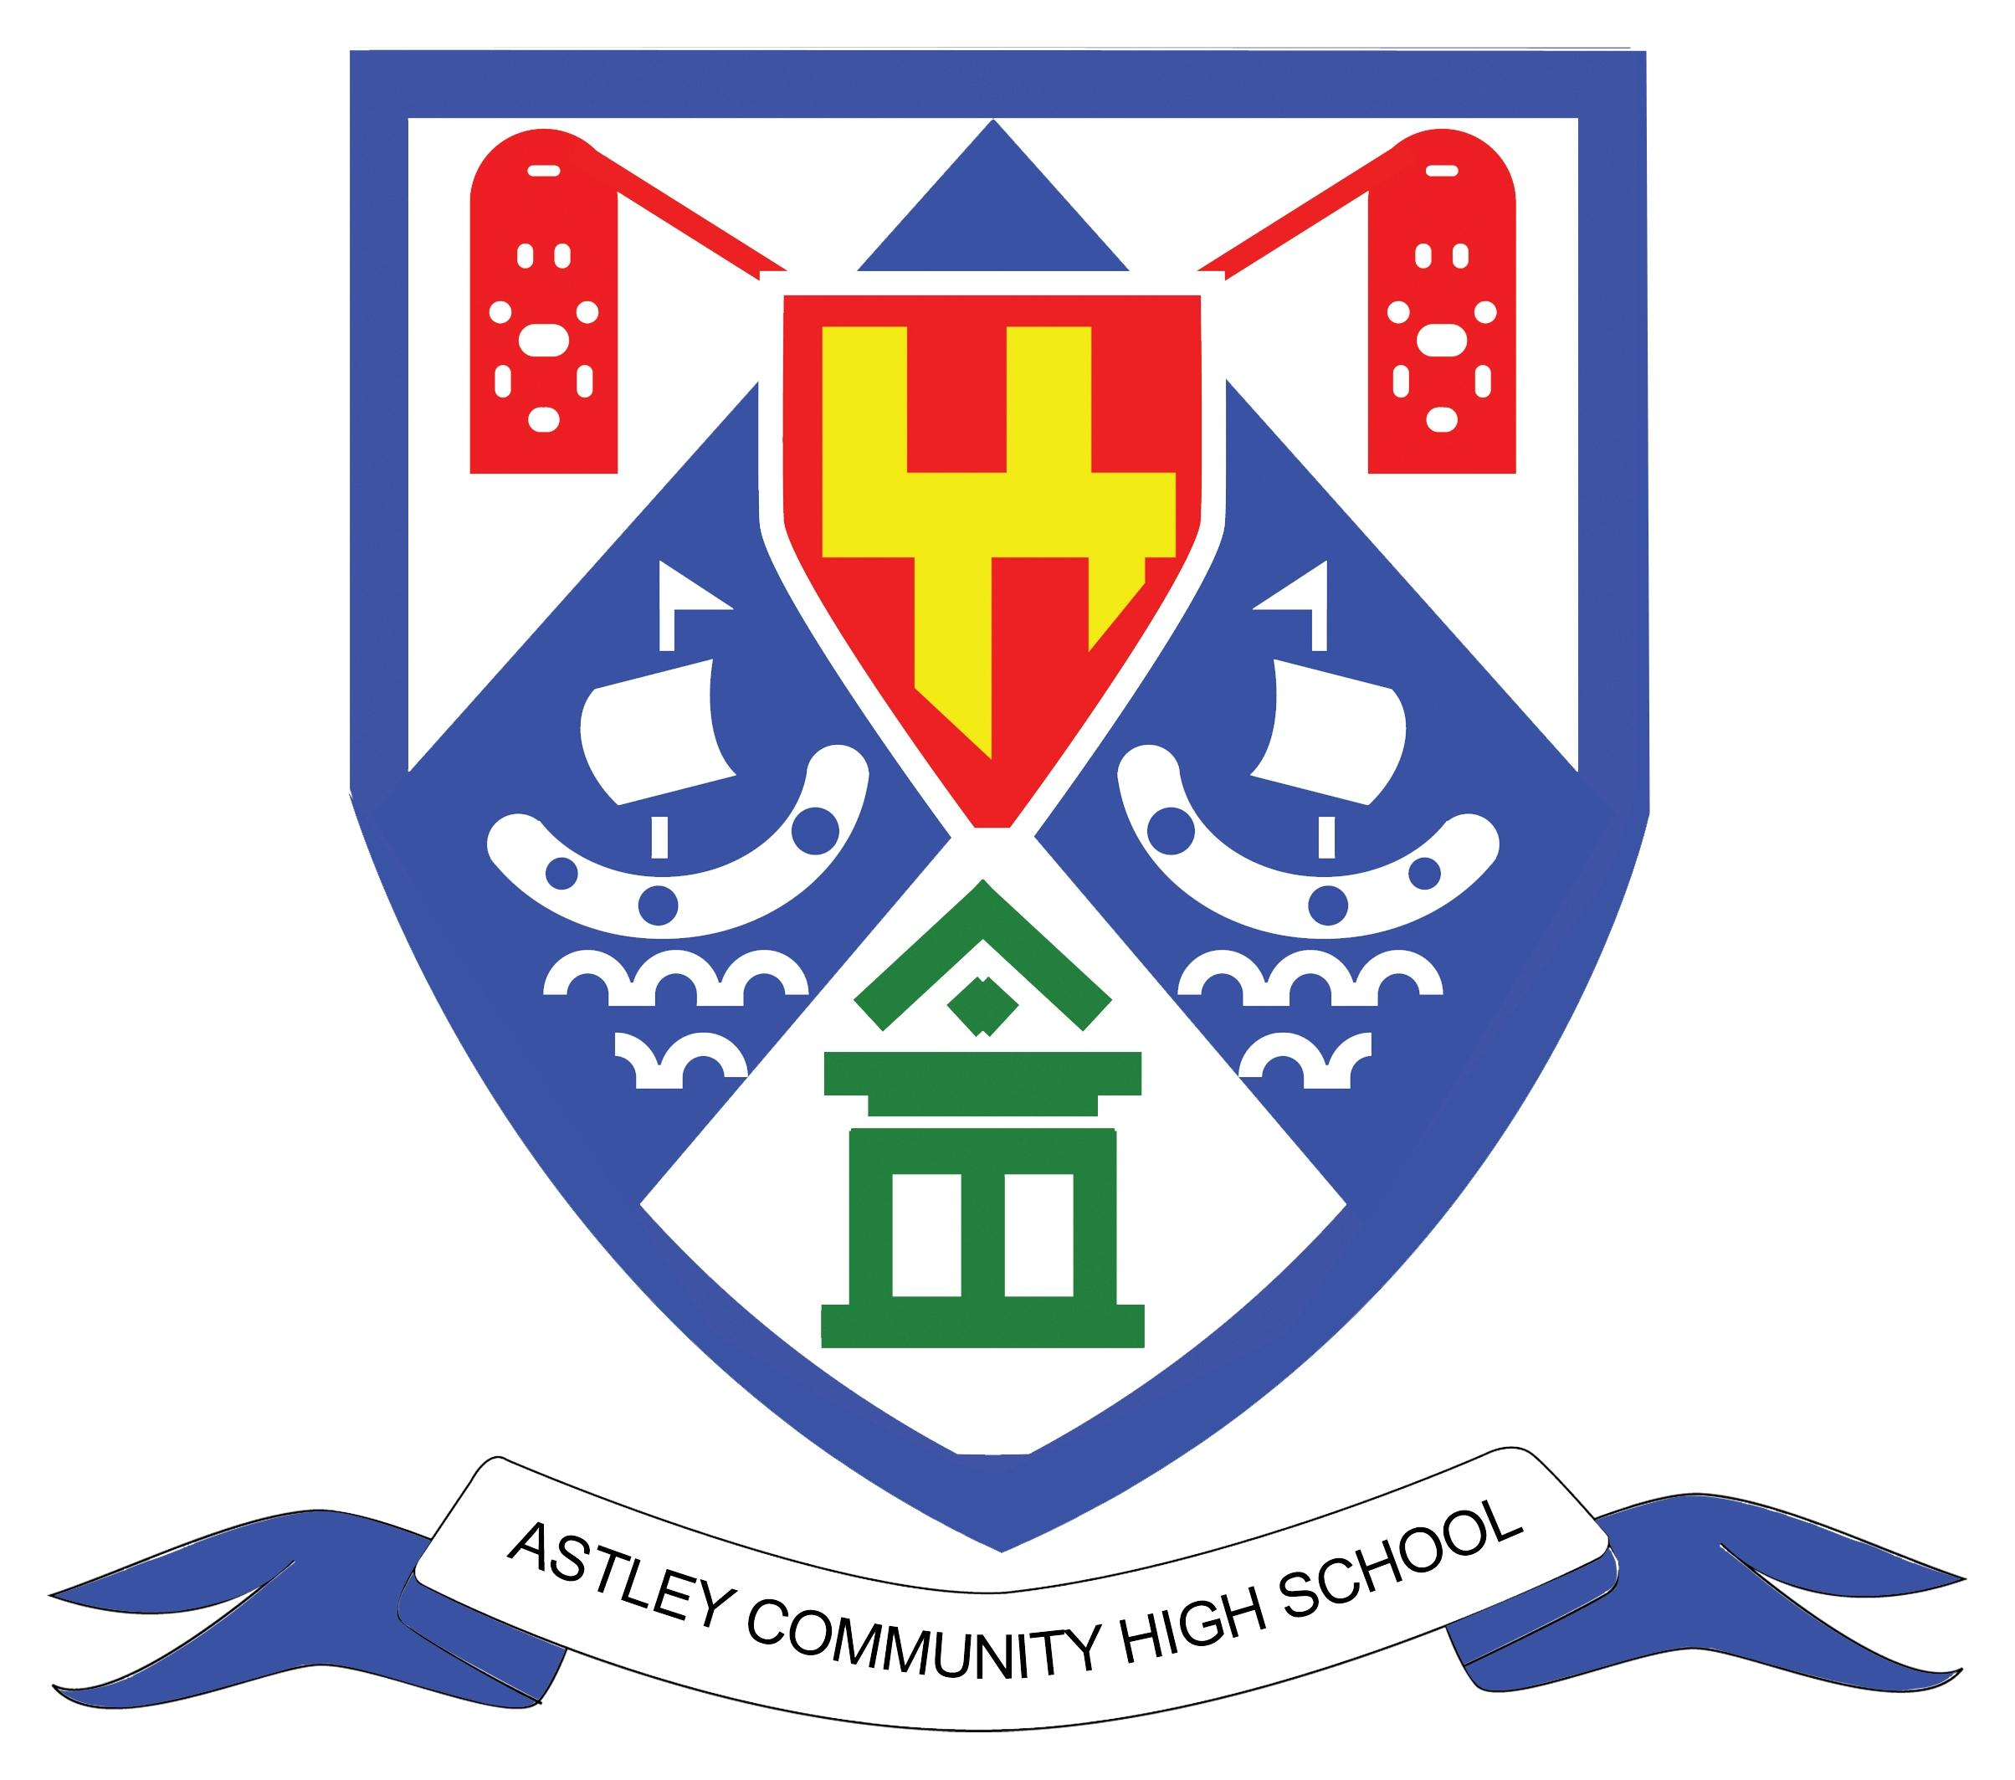

**Small enough to care,   
big enough to deliver a positive impact**

**Executive Headteacher’s Welcome**

**Thank you for your interest in the opportunity to join Astley Community High School at this exciting time in the school's journey. We are about to enter a significant new chapter in our history as we prepare to move into a brand-new school building in September 2025. This information pack provides more details about our school.**

Astley Community High School and Whytrig Middle School are currently co-located on Elsdon Avenue in Seaton Delaval. Together with Seaton Sluice Middle School, we form the **Seaton Valley Federation of Schools**, overseen by a single governing body

As the **Executive Headteacher** of all three schools, I am immensely proud of the work we do. We are deeply committed to delivering an excellent education to our students and take pride in being a central part of the local community. Astley Community High School is rated ‘**Good**’ by Ofsted, a reflection of our strong educational provision.

One of our key strengths is the relatively small size of our schools, which enables us to get to know our students well. This allows us to understand and respond effectively to their individual needs and support them in achieving success.

We are fortunate to have a **dedicated and passionate team of staff** who strive to achieve the best possible outcomes for our students. Many of our colleagues choose to build long-term careers with us, which speaks to the supportive and inclusive culture we foster. We are also strongly committed to **continuous professional development (CPD)**. Through robust partnerships with other schools across the North East, we ensure that our staff—both teaching and support—have access to high-quality CPD opportunities that develop their skills and build our collective capacity.

We hope the information in this pack inspires you to apply for this exciting opportunity. If you would like an informal discussion about the position, please feel free to contact us at 0191 2371505.



**John Barnes  
Executive Headteacher – Seaton Valley Federation of School**

**Our Ethos and Values**

We have three main themes to our ethos:

* To know every child academically and pastorally as a complete young person.
* To treat everyone and everything with respect.
* To strive for everyone to be as good as they can be and to be proud of   
   doing well.

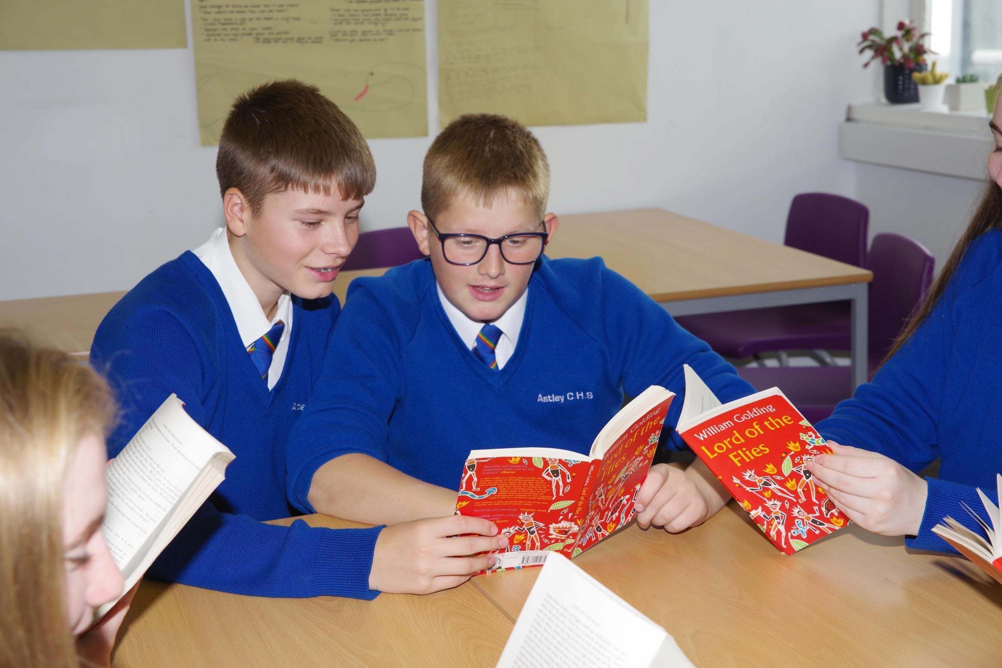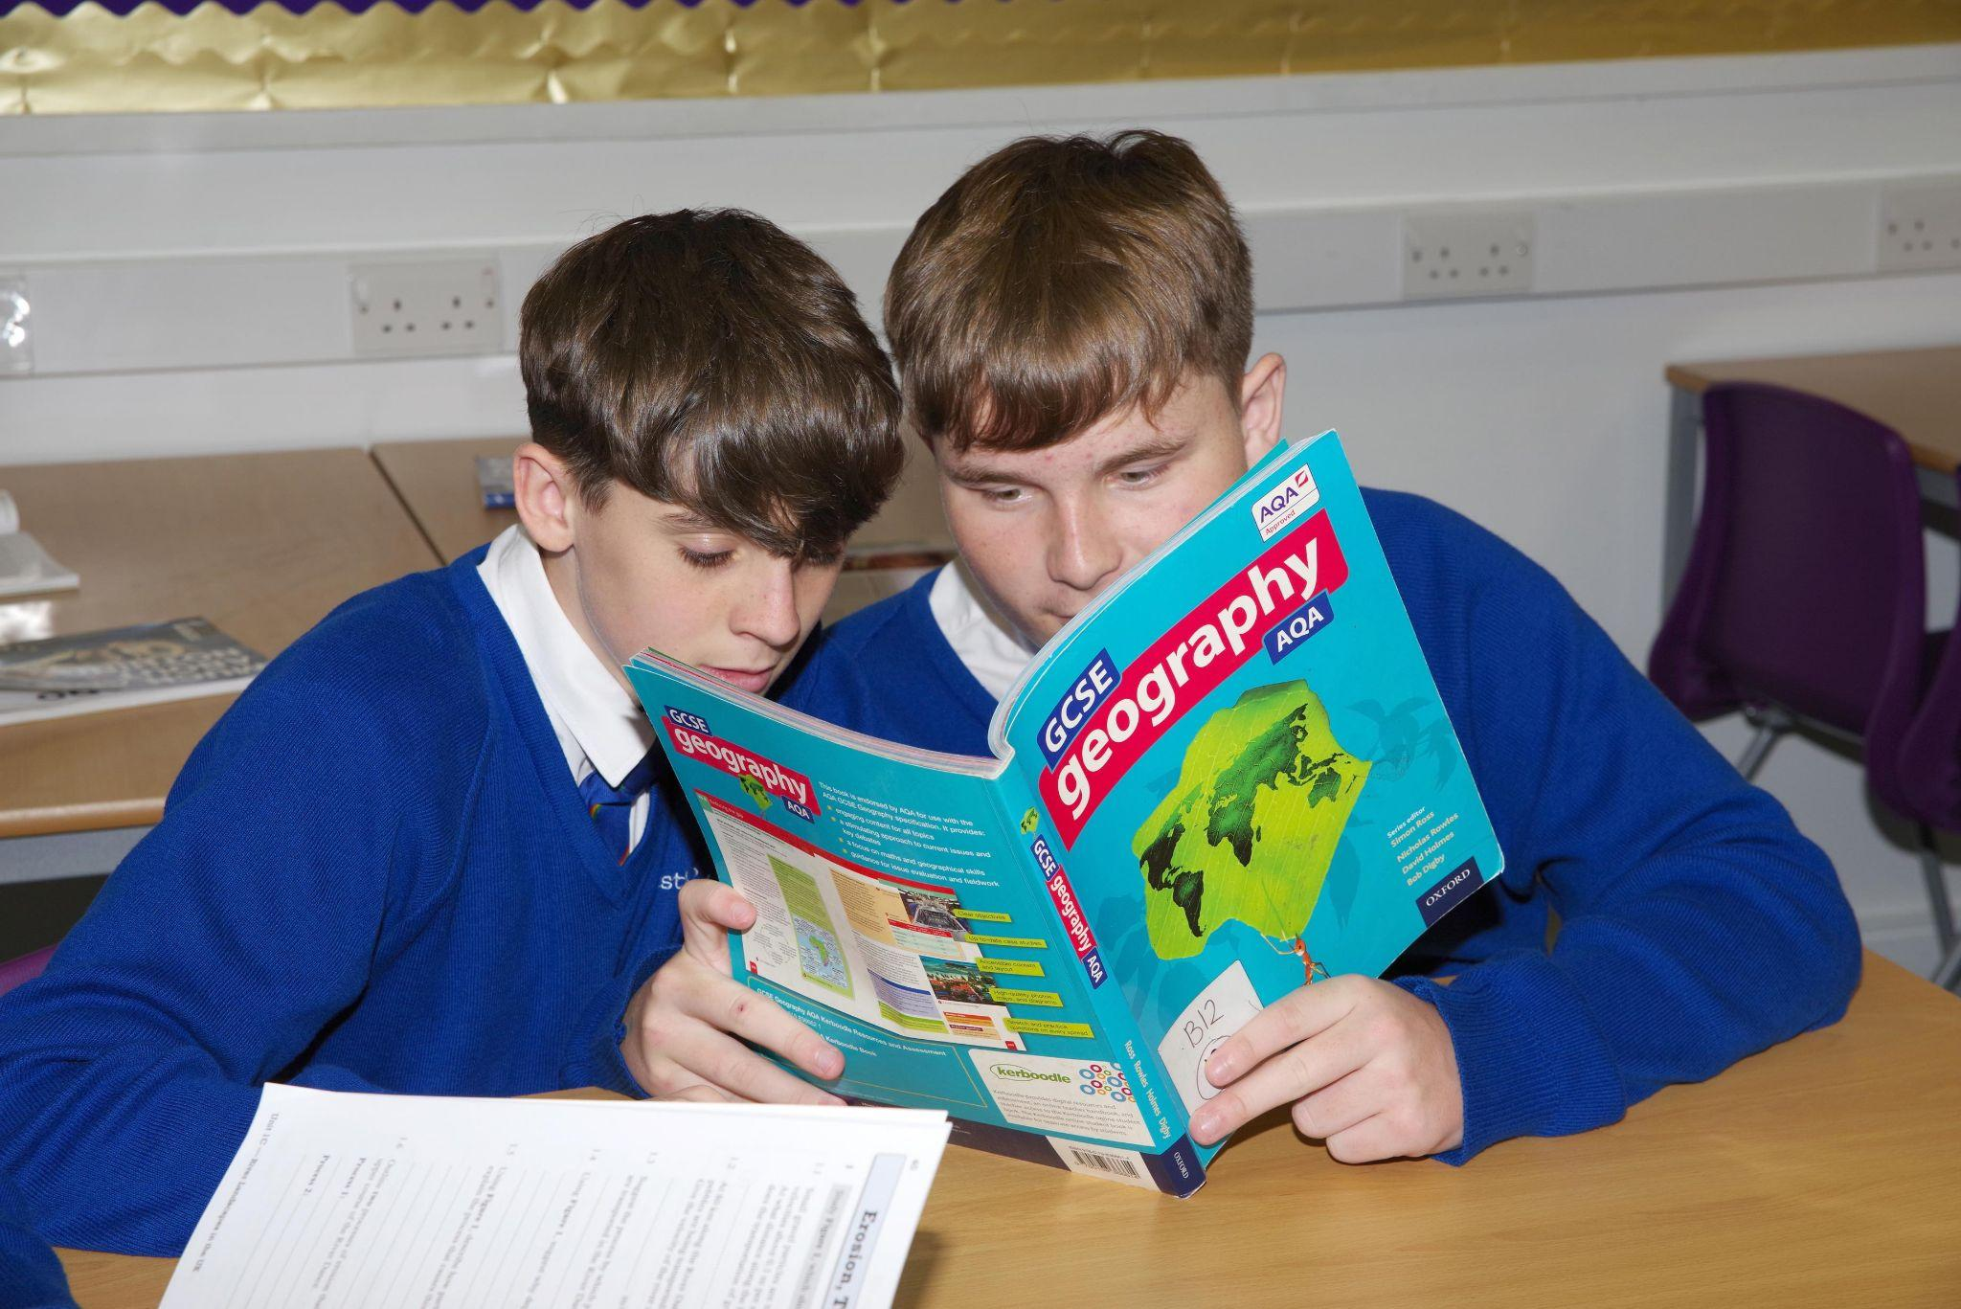

All three schools in the Seaton Valley Federation share a set of core values. We expect that all members of our school community will:

* develop their self-knowledge, self-esteem and self-confidence
* respect the laws of England and will know right from wrong and ensure their   
   actions reflect this
* accept responsibility for their behaviour
* show initiative and contribute in a positive way to the school community, the   
   local community and society in general
* show respect for each other and all other people
* show tolerance and respect for different cultures and traditions and will never   
   act in such a way that these cultures or traditions are abused or attacked
* show respect for the rule of democracy and respect for the democratic  
   principles of England.

**Our New Building**

September 2025 marks a new ear for Astley Community High School and   
Whytrig Middle School, as we move into our brand new multi-million pound campus. This state-of-the-art facility will offer outstanding resources for our students, staff, and the wider community, including fitness studio, swimming pool, 3G pitch and transforming the learning environment for students.   
  
This investment will significantly enhance the educational experience for our students and reflect our ambition to provide the very best for the communities we serve.  
  
As part of this exciting transformation, **Astley Community High School will be renamed *Seaton Valley High School* from September 2025**. This name change marks a fresh identity, while maintaining the values and commitment that have always defined our school.

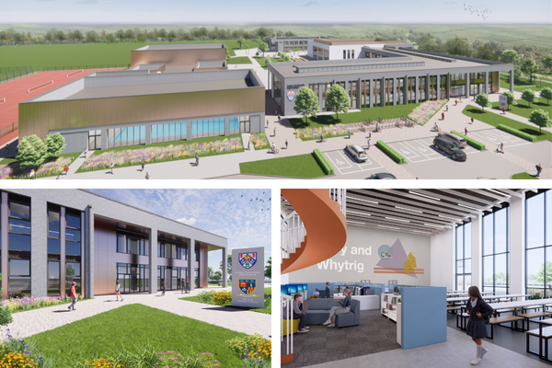

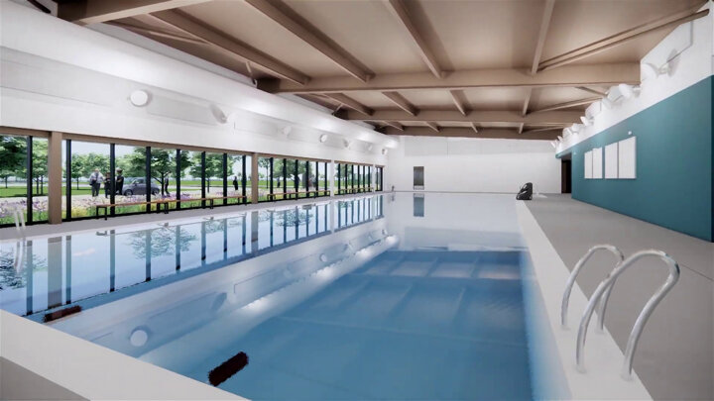

[**https://youtu.be/OLSDluhzoqc**](https://youtu.be/OLSDluhzoqc)

**About our Schools**

|  | **Age Range** | **Total Number of Pupils** | **Number in sixth Form** |
| --- | --- | --- | --- |
| Astley Community High School | 13 to 18 years | 630 | 181 |
| Seaton Sluice Middle School | 9 to 13 years | 334 | N/A |
| Whytrig Middle School | 9 to 13 years | 326 | N/A |

Astley Community High School & Whytrig Middle School attracts students from beyond the Seaton Valley area, thanks to the inclusive and welcoming nature of our school environment. Many students who have faced challenges in other settings come to us and thrive. Our dedicated staff are both caring and nurturing, ensuring that every child is given the support and opportunities needed to succeed.

We place a strong emphasis on **positive relationships** between all members of our school community. We work to help students understand what respectful, healthy relationships and positive behaviours look like, and we offer targeted support for those who may find this challenging. Our **pastoral and counselling services** play a key role in supporting student wellbeing.

Our aim is to help every student reach their full potential. This begins with **high-quality teaching** in every classroom—our teachers take the time to know their students and adapt their approaches to meet individual needs. For students requiring additional support, we provide robust **support**, especially in relation to **pastoral care** and **special educational needs (SEN)**.

We are also proud of our **strong Sixth Form**, which retains around 75% of our Year 11 students each year. In 2025, we are excited to launch our brand-new **Sports Academy**, which will take full advantage of our exceptional new facilities, including a 25-metre swimming pool, dance studio, sports hall, 3G pitch, and grass pitches.

More information about sixth form including our prospectus is available from: [www.svf.org.uk/sixthform](http://www.svf.org.uk/sixthform)

**About our Structure and Teams**

The Senior Leadership team across are schools are lead by the Executive Headteacher, John Barnes, there is a Head of School in each school along with the Business   
Director.

| Executive Headteacher  **John Barnes** | | | |
| --- | --- | --- | --- |
| Head of School  Astley Community High School  **Richard Goodman** | Head of School  Whytrig Middle School  **Jon Souter** | Head of School  Seaton Sluice Middle School  **Karen McSparron** | Business Director  **Ben Watson** |

In each school there is an individual Leadership Team, the SLT meet in their school base  
but we often meet as a wider SLT to share practice across the federation.

| Head of School  Astley Community High School  **Richard Goodman** | | | | |
| --- | --- | --- | --- | --- |
| Assistant Headteacher  SEND & Disadvantaged  **Kath Lennon** | Assistant Headteacher Curriculum  **Lou Power** | Assistant Headteacher  6th Form  **Adam Ironside** | Assistant Headteacher  Attendance & Pastoral  **Stephen Wood** | Business Manager  **Janet Das** |
| Associate SLT  School Counsellor  **Jonathan Collins** | | Associate SLT  Student Progress Leader  **Steven Henderson** | | |

Each member of the Senior Leadership line manage a faculty / department within the school, each faculty has a Head of Faculty. The Support staff team is headed up by the Business Director, supported by three Business Managers with responsibilities for Data   
and Curriculum, ICT and site, HR, Administration, partnerships, marketing and   
governance.

**About our Performance and Ofsted**

We are proud of our ofsted reports, we are rated as good schools   
across the federation

|  | **Overall Effectiveness** | **Last Ofsted Inspection** |
| --- | --- | --- |
| **Astley Community High School** | **Good** | **December 2024** |
| ‘Astley Community High School is a close-knit community where pupils are safe and happy. Pupils are proud to attend the school and enjoy positive relationships with staff. The school has high expectations for pupils. Staff know pupils well. Pupils are regarded as individuals. Pastoral care is strong. Pupils conduct themselves well. They greet visitors warmly and demonstrate excellent manners. The school is calm and orderly. In lessons, pupils work hard and listen carefully to their teachers. At social times, pupils mix well together. Sixth-form students are positive role models for younger pupils.’ | | |
| **Seaton Sluice Middle School** | **Good** | **September 2023** |
| ‘Pupils at Seaton Sluice Middle School are proud of their school community. They say that everyone is welcome and that teachers will always help them do their best. Inspectors agree. Pupils are polite and confident when speaking to staff, visitors and each another. They are keen to make the most of their time at school.Bullying at the school is rare. If pupils are unkind in their words or actions, staff deal with this immediately. Pupils tell an adult if something is worrying them. The school counsellor provides additional support for vulnerable pupils. This helps pupils to become confident and resilient young adults. The school’s approach to promoting and supporting the mental health and well-being of pupils and staff is a strength of the school’ | | |
| **Whytrig Middle School** | **Good** | **December 2021** |
| ‘This school is an inclusive environment where pupils value each other. They respect and celebrate difference. There is a strong sense of community and pupils feel responsible for each other. Pupils spoken to would all challenge bullying if they saw it. Parents and carers and pupils agree that if bullying does occur, it is dealt with effectively by staff. Pupils feel safe and happy here. They are rightly proud of their school. Behaviour is exemplary. Pupils who have previously found school difficult thrive and flourish here.’ | | |

For full reportsvisit [**https://reports.ofsted.gov.uk**](https://reports.ofsted.gov.uk)

**Our Commitment to safeguarding**

Keeping our children and young people safe and secure is crucially important.   
We are committed to safeguarding and promoting the welfare of children and young people and we expect all staff and volunteers to share this commitment.

It is important during the recruitment process that we ensure candidates support this commitment. We will ask all applicants to tell us in confidence about any criminal convictions they have and the successful candidate will also need to obtain an enhanced certificate from the Disclosure and Barring Service (DBS). This does not mean that you cannot work here if you have a criminal conviction as we will take into account factors such as the age of the conviction, its relevance to the job and any mitigating factors before making a decision.

However we are aware that not everyone who is a risk to children will have a criminal conviction and therefore you should expect at interview that we will explore any gaps in your employment record, your motivations for working with children and young people and your ability to keep them safe from harm. We will also check this information in any references we receive, one of which must be from your current or last employer.

As part of our pre-employment checks, we will complete an online search of candidates.

| **How To Apply**  All of our job vacancies are advertised on our website [www.svf.org.uk/vacancies,](http://www.svf.org.uk/vacancies) along with the job advert, a job description and a candidate information pack.  Please read through all of the information on the role and click on the link to apply, this will take you to mynewterm, our application portal, where you will be able to complete an application form online.  Please note that we do not accept CVs. |
| --- |

**What We Offer and Staff Benefits**

We offer staff benefits

Competitive Salary

Cycle To work Scheme

Onsite Parking

Onsite Gym at Astley and Whytrig

Teachers Pension Scheme

Tyne & Wear Tyne Pension Scheme for support staff

NHS Fleet solutions for support staff

Generous Annual Leave Allowance

Learning and Development

Salary Sacrifice

Occupational Health

Mental Health support



**Contact Us**

Seaton Valley Federation of Schools  
Astley Community High School

Elsdon Avenue  
Seaton Delaval   
NE25 0BP   
0191 2371505

vacancies@svf.org.uk

[www.svf.org.uk](http://www.svf.org.uk)