

April 2025

Dear Applicant

**Pastoral Support Manager**

Thank you for your interest in the above position which is a full time, permanent post commencing 1 September 2025.

Marden High School is highly successful, with examination results well in excess of national standards.

If after reading the attached material you would like to apply for the post please complete the application form and submit it, together with a letter of application, outlining how well you meet the person specification and the qualities you will bring to this position. Your letter should be no longer than 2 sides of A4. Applications can be emailed to e.scott@mardenhigh.net

If you would like an informal chat about this opportunity, do not hesitate to contact me.

The closing date for applications is Tuesday 13 May 2025. Interviews will take place on Tuesday 20 May 2025.

Yours faithfully

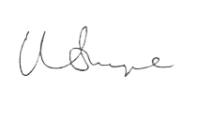

Mr Matt Snape  
**Headteacher**