

February 2025

Dear Applicant

**Teacher of Art and Technology**

Thank you for your interest in the above position which is a full time, permanent position, commencing 1 September 2025. Job share will be considered.

Marden High School is highly successful, with examination results well in excess of national standards.

If after reading the attached material you would like to apply for the post please complete the application form and submit it, together with a letter of application, outlining how well you meet the person specification, the qualities you will bring to this position and your thoughts on how students gain from excellent Art and Technology teaching. Your letter should be no longer than 2 sides of A4.   Applications can be emailed to e.scott@mardenhigh.net

The closing date for applications is Friday 21 March 2025. Interviews will take place on Monday 31 March 2025.

Yours faithfully

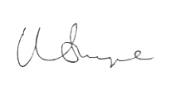

Mr Matt Snape  
**Headteacher**