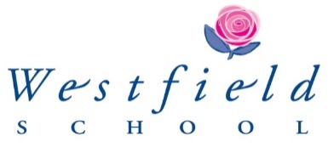

***PART TIME TEACHER OF MATHEMATICS***

***0.6-0.8 FTE***

We require from January 2025, or possibly earlier, a well-qualified and enthusiastic teacher of Mathematics to teach the subject up to and including A level.  Experience of teaching Edexcel A level and Further Maths A level would be beneficial but not essential, as would the ability to teach Science at Key Stage 3.

We are a small Maths Team that form part of a thriving STEM faculty alongside the Science and Psychology departments. As a faculty we are passionate about encouraging our girl’s interest in everything STEM related. We regularly run challenge days and extra-curricular clubs, we promote STEM careers, as a non-selective school we believe there is a career in STEM for everyone who is interested no matter what their academic ability. Our outreach programme includes running ‘Girls in STEM’ days for Year 5 and 6 pupils from local primary schools and teaching Further Maths GCSE to pupils from secondary schools in the North East.

Our year groups are set in 2 Maths classes, our top set GCSE class will follow the Higher Edexcel GCSE course. Our second set follow a course that is appropriate to the pupils in front of us, this may be foundation from the onset completing the OCR papers, or a hybrid of higher/foundation allowing some of our pupils to gain a grade 6. We offer AQA Level 2 Certificate in Further Maths (an IGCSE qualification) to our brightest GCSE Maths students. In the Sixth Form, the Department follows the Edexcel AS/A level course.   We also offer Further Maths AS level in Year 13.

Our aim is to give the girls confidence and to create competent Mathematicians and problem solvers with every girl achieving the best GCSE grade possible for them. We are seeking individuals who can communicate their enthusiasm for Mathematics in the classroom and can help develop the girls’ higher order mathematical skills, someone who shares the same enthusiasm for STEM as the rest of the faculty and who is happy to fully immerse themselves in the wider school activities and ethos.

July 2024