

May 2024

Dear Applicant

**Teacher of English**

Thank you for your interest in the above position which is a part time, permanent position, commencing 1 September 2024.

Marden High School is highly successful, with examination results well in excess of national standards.

If after reading the attached material you would like to apply for the post please complete the application form and submit it, together with a letter of application, outlining how well you meet the person specification, the qualities you will bring to this position and your thoughts on how students gain from excellent English teaching. Your letter should be no longer than 2 sides of A4.   Applications can be emailed to e.scott@mardenhigh.net

If you would like an informal chat about this opportunity, do not hesitate to contact me.

The closing date for applications is 9.00am on Thursday 20 June 2024. Interviews will take place on Monday 24 June 2024.

Yours faithfully

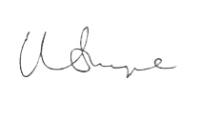

Mr Matt Snape  
**Headteacher**