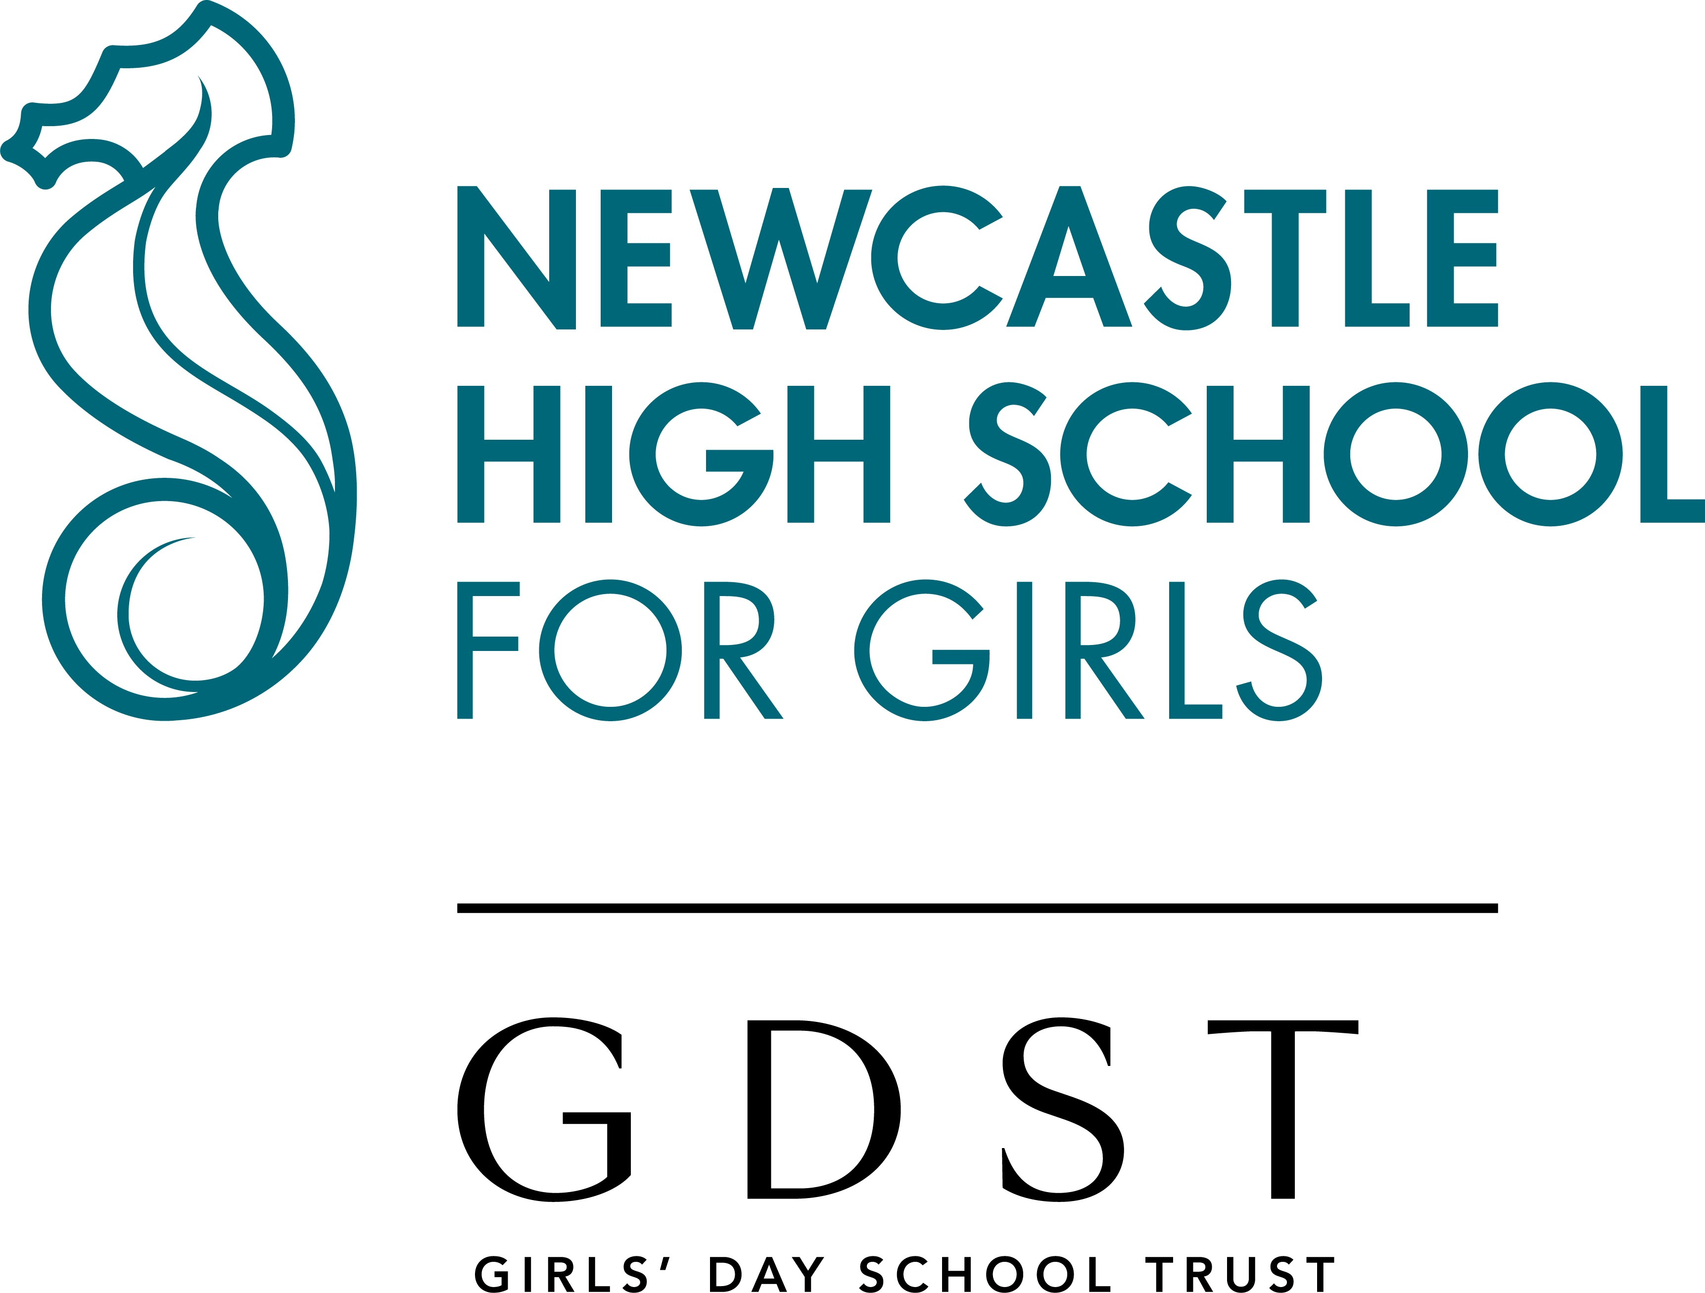

Dear Applicant

Thank you for requesting details of the post of Junior School Teacher at Newcastle High School for Girls. I hope that the enclosed information will encourage you to apply for a job in our successful and happy school. You will also find the School offers a very pleasant and supportive atmosphere in which to work.

I regard every member of staff as extremely important. It is essential that anyone joining Newcastle High School for Girls has the ability and drive to help us improve further by participating wholeheartedly in all aspects of school life and promoting our ethos.
We are all committed to helping every individual in the School, both staff and pupils, achieve their full potential. We have a thorough Induction Programme for all staff and the Staff Room is lively and welcoming.

Extensive building and refurbishment programmes in recent years mean that both our Senior and Junior School sites have some of the most impressive school facilities in the region and, indeed, the UK.

I do hope that you will apply for this post. Newcastle High School for Girls is a wonderful School in which to work, and this is an exciting opportunity. I look forward to hearing from you.

Yours sincerely



Mrs A Hardie
Head



About the School

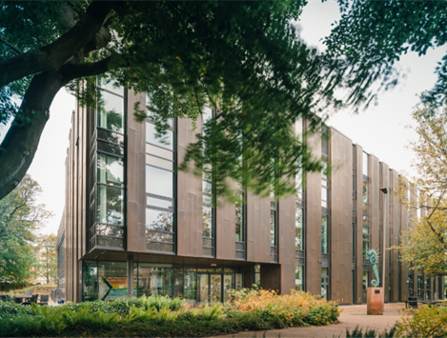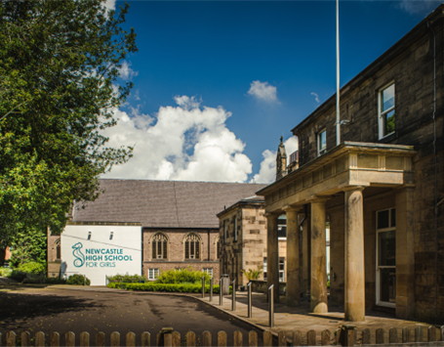

Newcastle High School for Girls is the North East’s leading independent girls’ day school. Founded in 2014, following the merger of two very long-standing predecessor schools, NHSG is a state-of-the-art, modern school with a tradition and history stemming back almost 150 years.

We are an all-through school (ages 3-18) with around 250 girls in the Junior School and 450 in the Senior School, including over 100 in the Sixth Form, who, together with around 150 staff, make up a friendly and welcoming community.

The Junior and Senior Schools occupy their own separate campuses around a mile apart and this role is based at the Junior School site. Our two campuses are situated within the suburban, leafy areas of Jesmond and Sandyford, both with excellent transport links to the Tyne & Wear Metro and bus services from across the region.

Our School is a very popular choice at all ages, with girls joining us from most parts of the Tyne & Wear metropolitan area, as well as areas further afield in Durham, Northumberland, the Tyne Valley, the Borders and Teesside.

Girls who attend NHSG are bright, enthusiastic, eager to learn and have high aspirations. Our public examination results are consistently outstanding, and girls go on to study a wide range of subjects at prestigious universities in the UK and abroad. NHSG is highly regarded for the way it achieves its outstanding outcomes within a particularly warm and supportive environment, with pastoral care and achieving the best for every girl at the heart of everything we do.

Our Junior School – an overview and the role

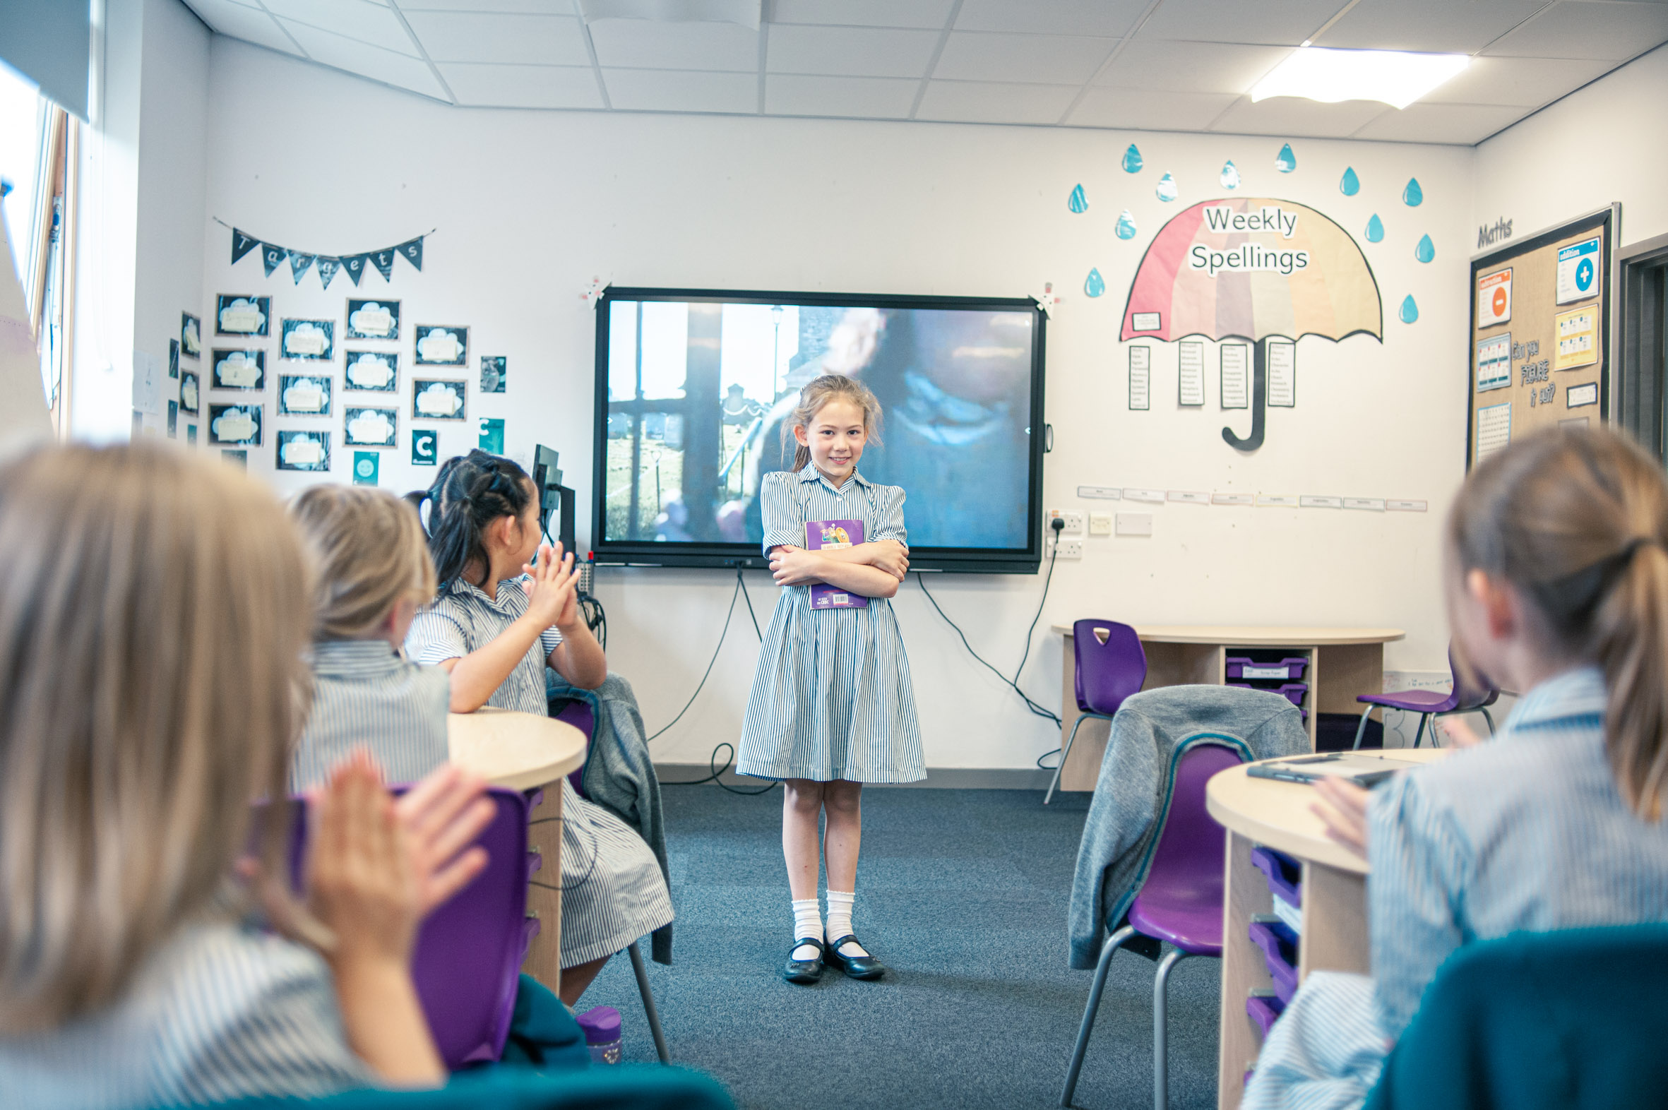

A teacher in the Junior School will have the opportunity to be part of a dynamic team, fully committed to providing the very best level of education and pastoral care for the pupils. The Junior Teacher is expected to work closely within a specific Phase and to collaborate with other Primary Phases during the school year. There will also be the opportunity to lead a curriculum subject across the Junior School.

The role is an exciting opportunity for a teacher to work in a well-resourced and calm learning environment where pupil and staff wellbeing are firmly embedded across the school. Teachers work closely together in year groups to plan lively and ambitious lessons, ensuring the requirements of the National Curriculum are met.

The cocurricular programme is a strength of the school and teachers are an integral part of the programme, offering a range of activities and interests to the programme within the after-school co-curricular provision.

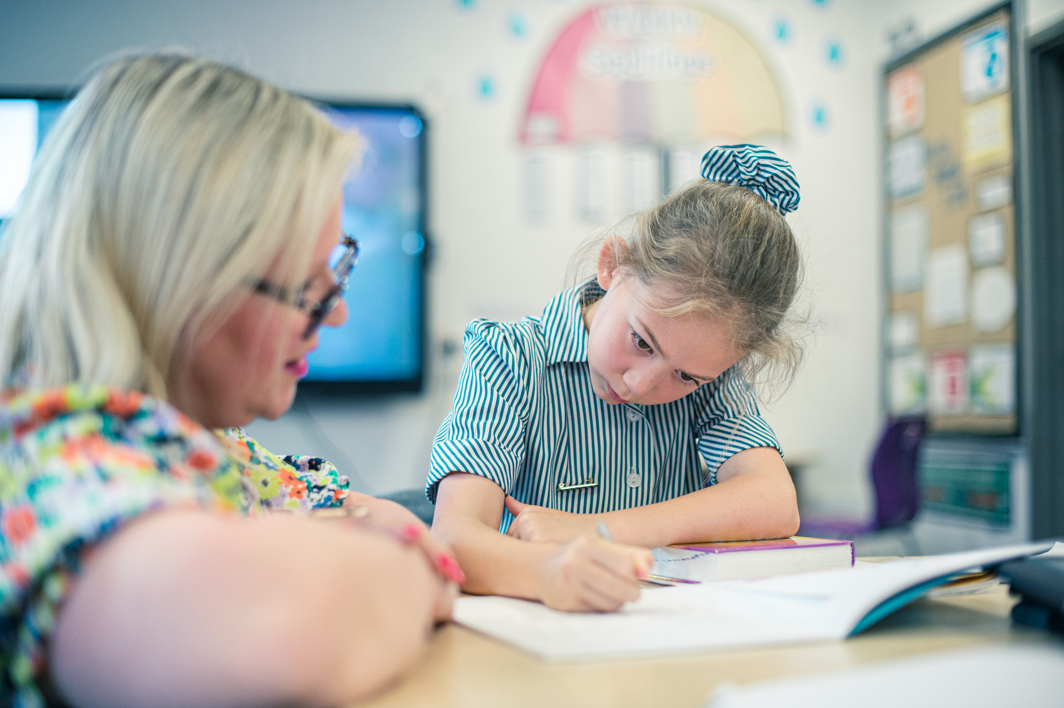

About the Girls’ Day School Trust

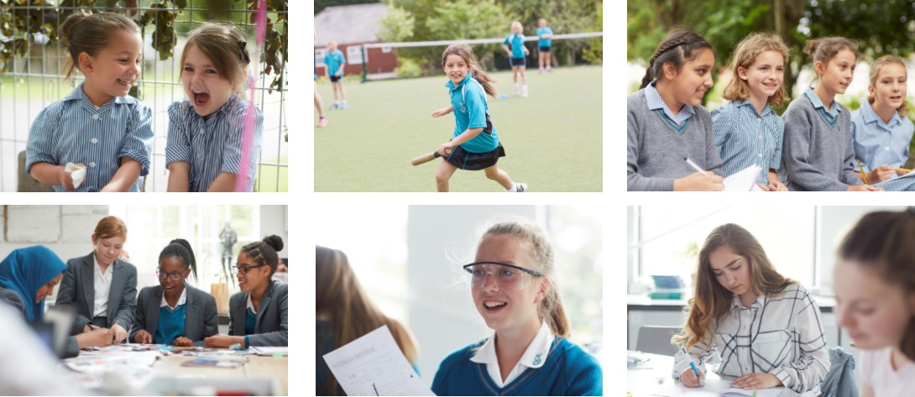

The Girls’ Day School Trust is the UK’s leading group of independent girls’ schools, with 23 schools and two academies throughout England and Wales. The GDST educates 20,000 students and employs 4,000 staff.

The GDST Family has four core values:
- We always put girls first.
- We are fearless, never afraid to think differently.
- We are forward-thinking, embracing change.
- We are a family, collaborative and supportive in pursuit of our missions.

GDST schools are global leaders in girls’ education, backed by the expertise and resources of the Trust, with decades of experience.

We bring teachers the latest ideas, innovations, and insights in education. We invest in new facilities, and we encourage collaboration between schools, so that everyone benefits from each other’s insights.

We nurture a culture of diversity and inclusion where every person is valued and supported. We are a family of schools where everyone feels that they belong.

With a team of central experts, we also help schools with finance, fees, governance, HR, legal, marketing and maintenance.

If you would like more information on the GDST’s difference, please visit:

https://www.gdst.net/

