
Park View School

Headteacher’s Welcome

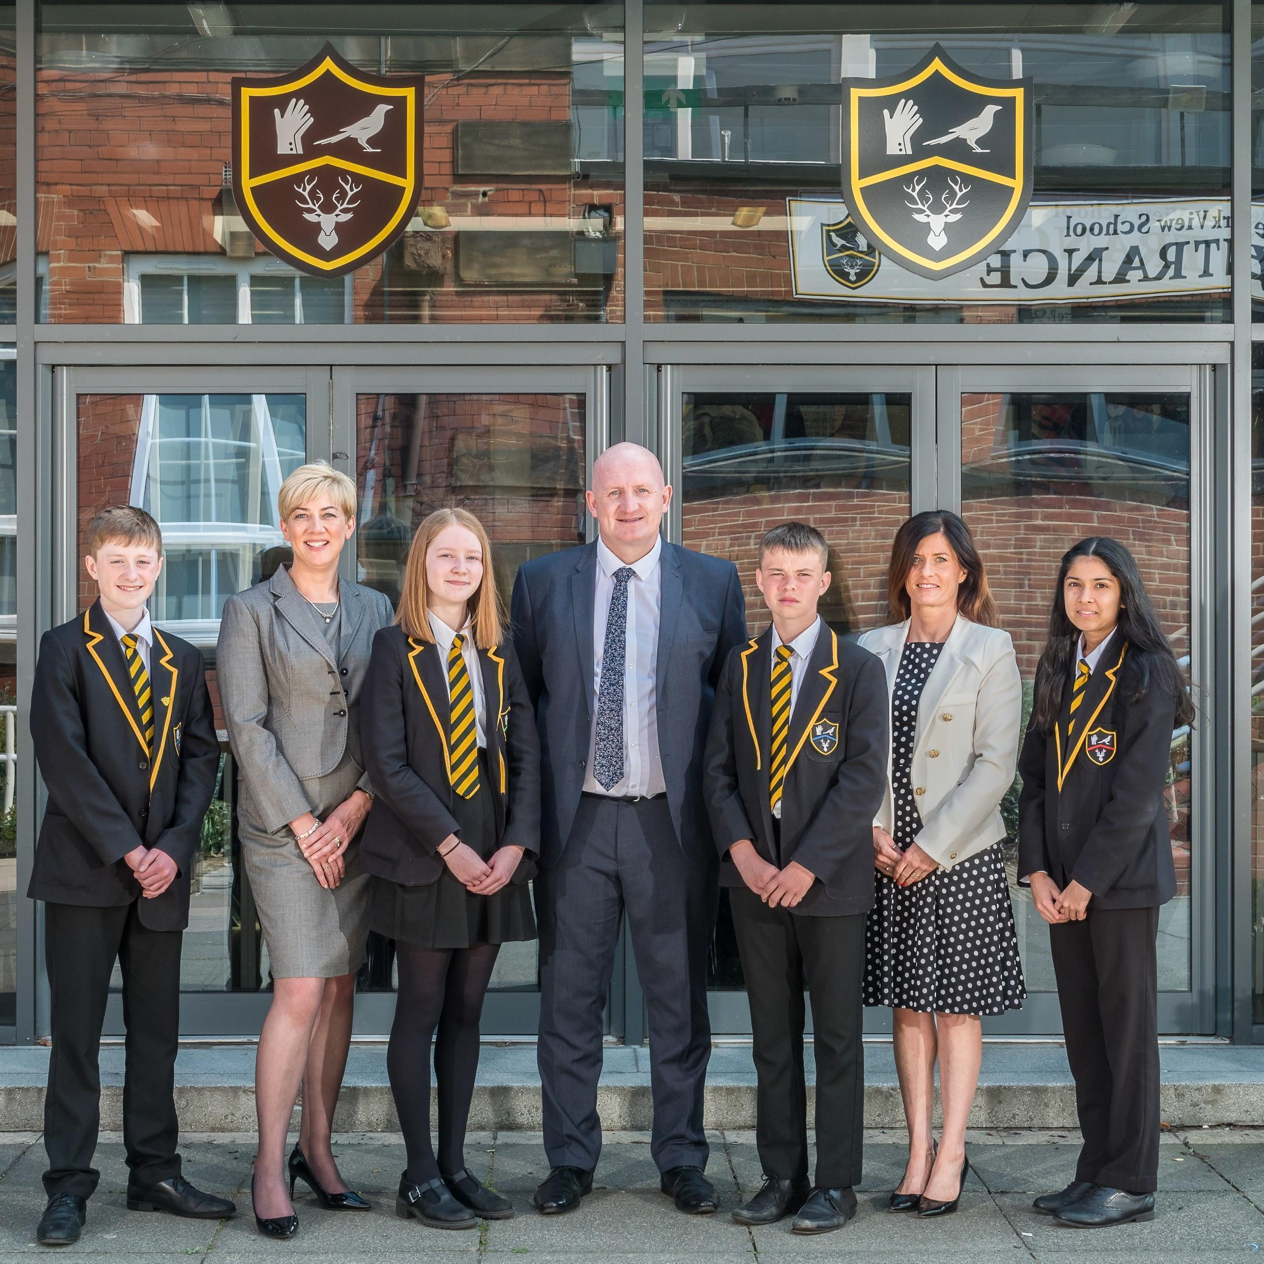
Dear Applicant

Thank you for expressing an interest in the maternity position of Pastoral Manager at Park View School, Chester-le-Street, Durham.

Park View is a popular, oversubscribed, forward thinking, exciting and, most important of all, happy school where children of all abilities, aptitudes and social backgrounds achieve. This has given us a reputation for excellence within the locality of which we are exceptionally proud.

We have been at the heart of Chester-le-Street since 1911, first as the town’s grammar school and latterly as its largest Academy. Our roots in the community are long-established and inform all that we do: thus, although we are innovative and offer children a 21st Century education of real worth, we cherish and foster traditional values. We have 1563 students split across three sites in the town, our Lower School at North Lodge, Upper School at Church Chare and Post 16 Academy of Sport at The Riverside Sports Complex.
We passionately believe that all young people can achieve if challenged to do so, that each has in them special qualities, talents and strengths which it is the duty of true educators to develop. It is this moral imperative which drives us, providing an unflinching focus upon the continued improvement necessary for us to realise our ambition: to be an outstanding school which provides the very best educational experience for all in our care.
To succeed in our ambition, we work closely in partnership with parents and carers. We rely upon support from home and are delighted that the vast majority of our families make an unconditional commitment to trust their children to our care, reinforcing our standards by supporting school actions. It is this mutual trust which sits at the heart of the school and is one of our greatest strengths.
I hope that this document provides you with the information you need. It is intended to give you a flavour of all that happens at Park View and all that we stand for.

The following documents are provided for your information:

1. Application Form (please apply via Google Form, link provided)
2. Job Description
3. Person Specification

Closing date for applications to be received: Thursday 15th February 8am

If you experience any problems completing the Application (Google) Form please email Wendy Taylor: personnel@parkviewlearning.net

On behalf of all at Park View we very much look forward to receiving your application and in the meantime if you require any further information please do not hesitate to contact me.

Yours sincerely



Andrew Finley
Headteacher

Please see further details about our school below.

Values and Ethos
Vision
Park View is an international school at the heart of a local community where all are expected to aspire to academic excellence whilst behaving with empathy and respect to others.
As a school, we aim to:
- Achieve sustained excellence in every aspect of our work.

- Provide all of our students with a secure, inspiring and stimulating environment in which they will enjoy being challenged to think and engage in their own learning.
- Share our own passion for learning, our subjects and life.
- Foster an understanding of the importance of the written and spoken word in society, both as a tool for communication and a way of expressing complex emotions and thoughts.
- Enable all students to experience success and to become active participants in a learning community which has shared beliefs and values.
- Celebrate the contributions and achievements of all who contribute to our success.
In order to achieve this, we will inspire our students to be creators, dreamers, innovators and pioneers who:
- Are proud of who they are as individuals and what they can achieve, and welcome ownership of their learning and their lives
- Are calculated risk-takers who are confident of their place in the world and in their abilities to affect change
- Are healthy, caring, resilient individuals who have the knowledge, skills, understanding and mindset to be active participants in local, national and global communities.
- Enjoy learning and have the confidence to relish the challenge of being stretched beyond their current limits to investigate and then master new ideas, concepts and skills.
- See reading as a vitally important part of their daily routine, one which will allow them to understand and master the ‘craft’ involved in communicating in speech and writing.
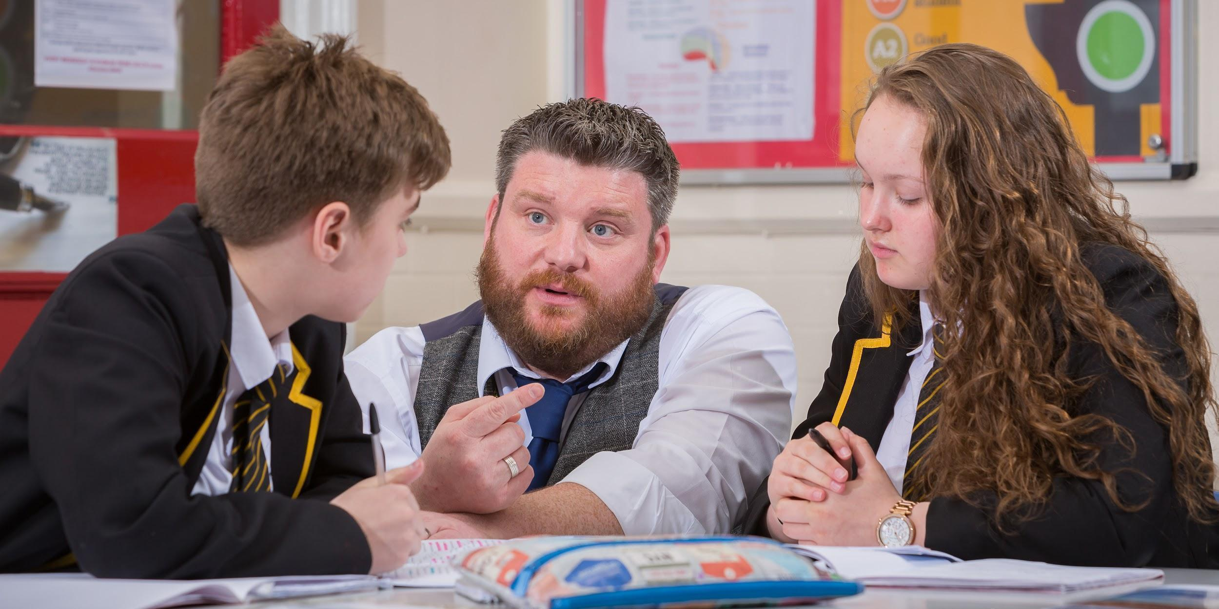
Through achieving these, we aspire to ensure that every child will:
- Gain the necessary attitudes, skills and qualifications needed to take a meaningful place in society.
- Feel cared for, involved and listened to.
- Be noticed and valued as an individual

Our key values centre around:

- Achievement for all
- Compassion
- Fairness
- Friendship
- Honesty
- Integrity
- Kindness
- Open-mindedness
- Participation by all and for all
- Pride
- Respect for self and others
Our lessons are characterised by:
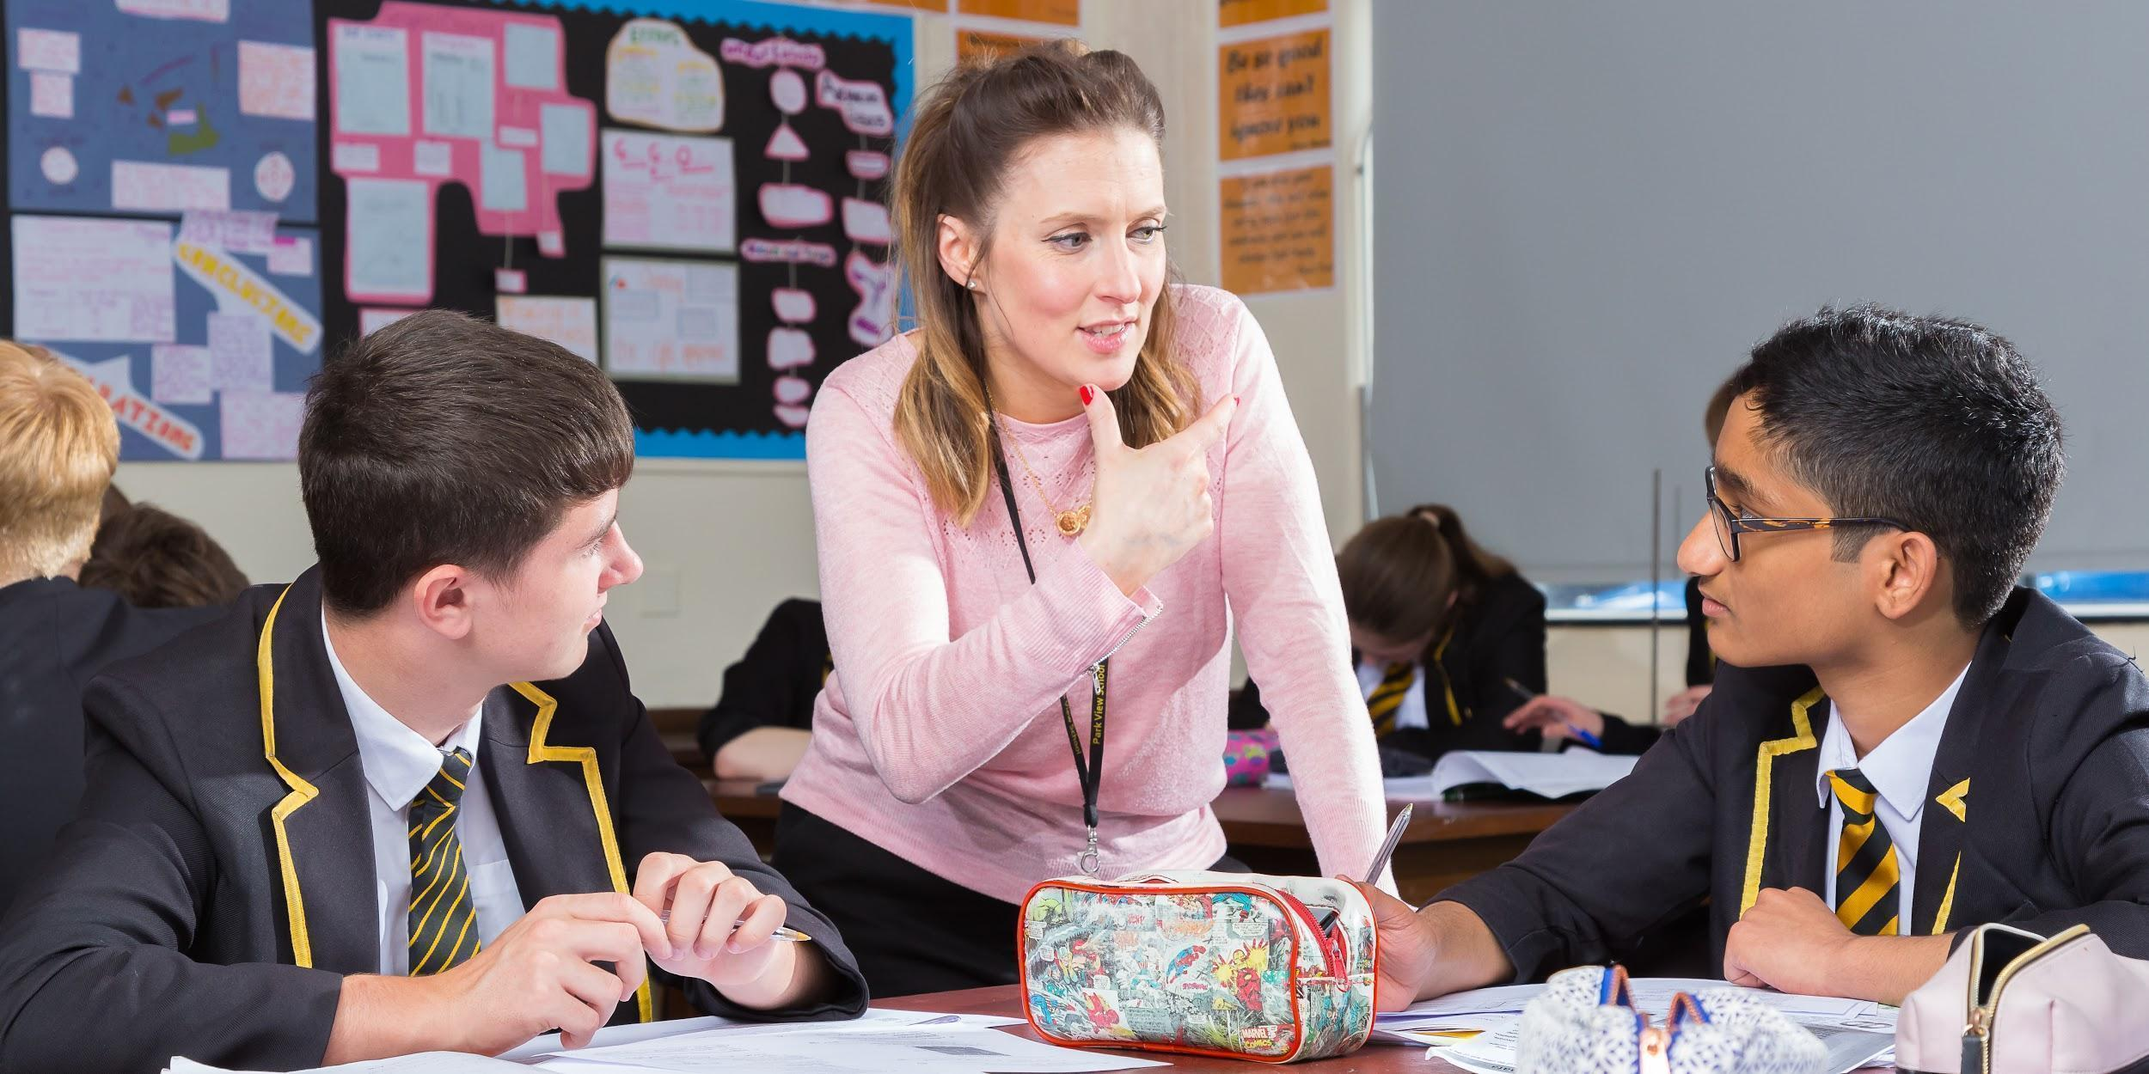
- A burning desire for all children in our care to succeed and a belief that they can.
- Pride, participation and progress.
- Risk-taking and the acceptance that success may not come at the first attempt
- Teachers who clearly love their subject and create inspiring experiences in order to foster in others their sense of awe and wonder and to create a shared thirst for learning.
- A supportive climate in which everyone’s voice matters and all are challenged to think, reason, debate, discuss and collaborate in order to solve problems which have relevance.
- Opportunities for students to question and challenge, critically and evaluatively, in order to gain deep conceptual understanding of topics.
- Activities which demand that students formulate their own questions, develop their own solutions and critique their own performance.
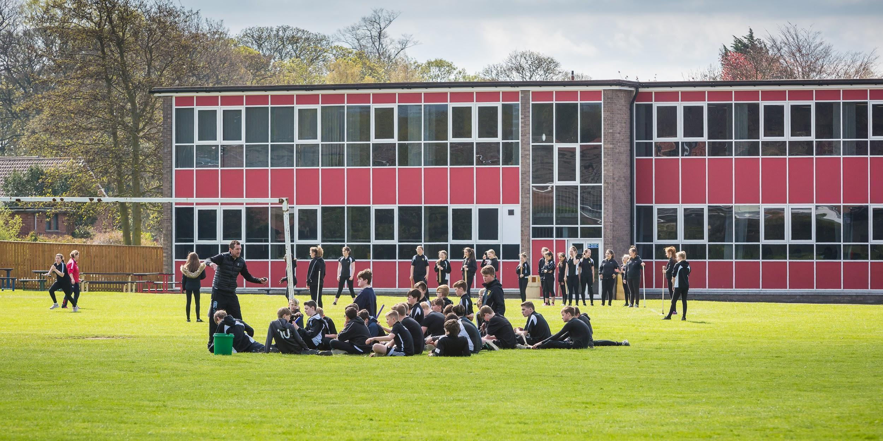
Our School
Our North Lodge Site is where students embark on their learning journey with us as Year 7 and Year 8 students. We offer all students a safe environment in which to thrive; most parents value the fact that Year 7 and 8 are taught on their own, discrete site, 2 miles away from the rest of the school, thus giving them space to mature and grow a little before coming into contact with the older adolescents. Year 7 parents have recently commented:
“I was very worried about my daughter leaving primary school because she was quite shy. I needn’t have worried because she thoroughly enjoys every aspect of school. She has also gone on many trips and has even been given the opportunity to go skiing. Best decision we ever made.”

“My son loves Park View. He enjoys being in the classrooms especially the science labs. He is a very sporty child and Park View offer lots of opportunities for all kinds of sport.”

“My kids are happy to come to school and they really enjoy it. They love the drama club.”

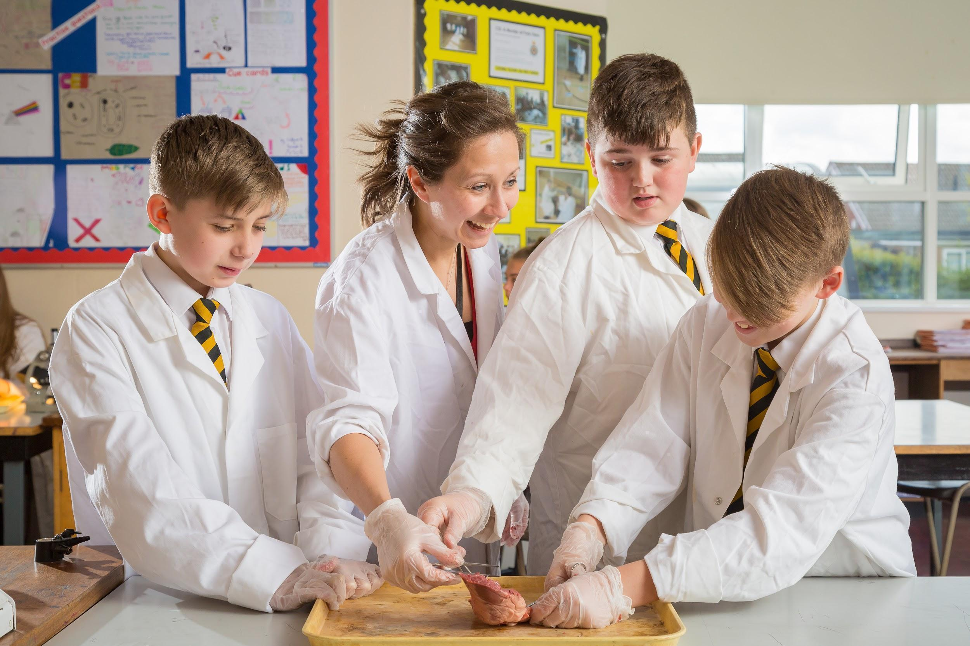
The pastoral care that students receive is second to none with excellent, well established links with local primary schools which ensure that students are fully supported in their transition to secondary school.
Learning at North Lodge is centred around an innovative curriculum and teaching which is designed to develop in our students the skills, habits, attributes and knowledge they will need to be successful in the twenty first century. The site itself has just undergone a £1 million pound refurbishment, substantially improving the environment for all. Student at North Lodge have the following things to say:
“I am pleased that I came here because teachers are really nice, you make loads of friends and you get to try lots of things that you don’t at Primary School. The food is nice with lots of different things to try both hot and cold.”

“I like Park View the work is just right. Teachers are really helpful. I love English because you get to use your imagination most of the time.”

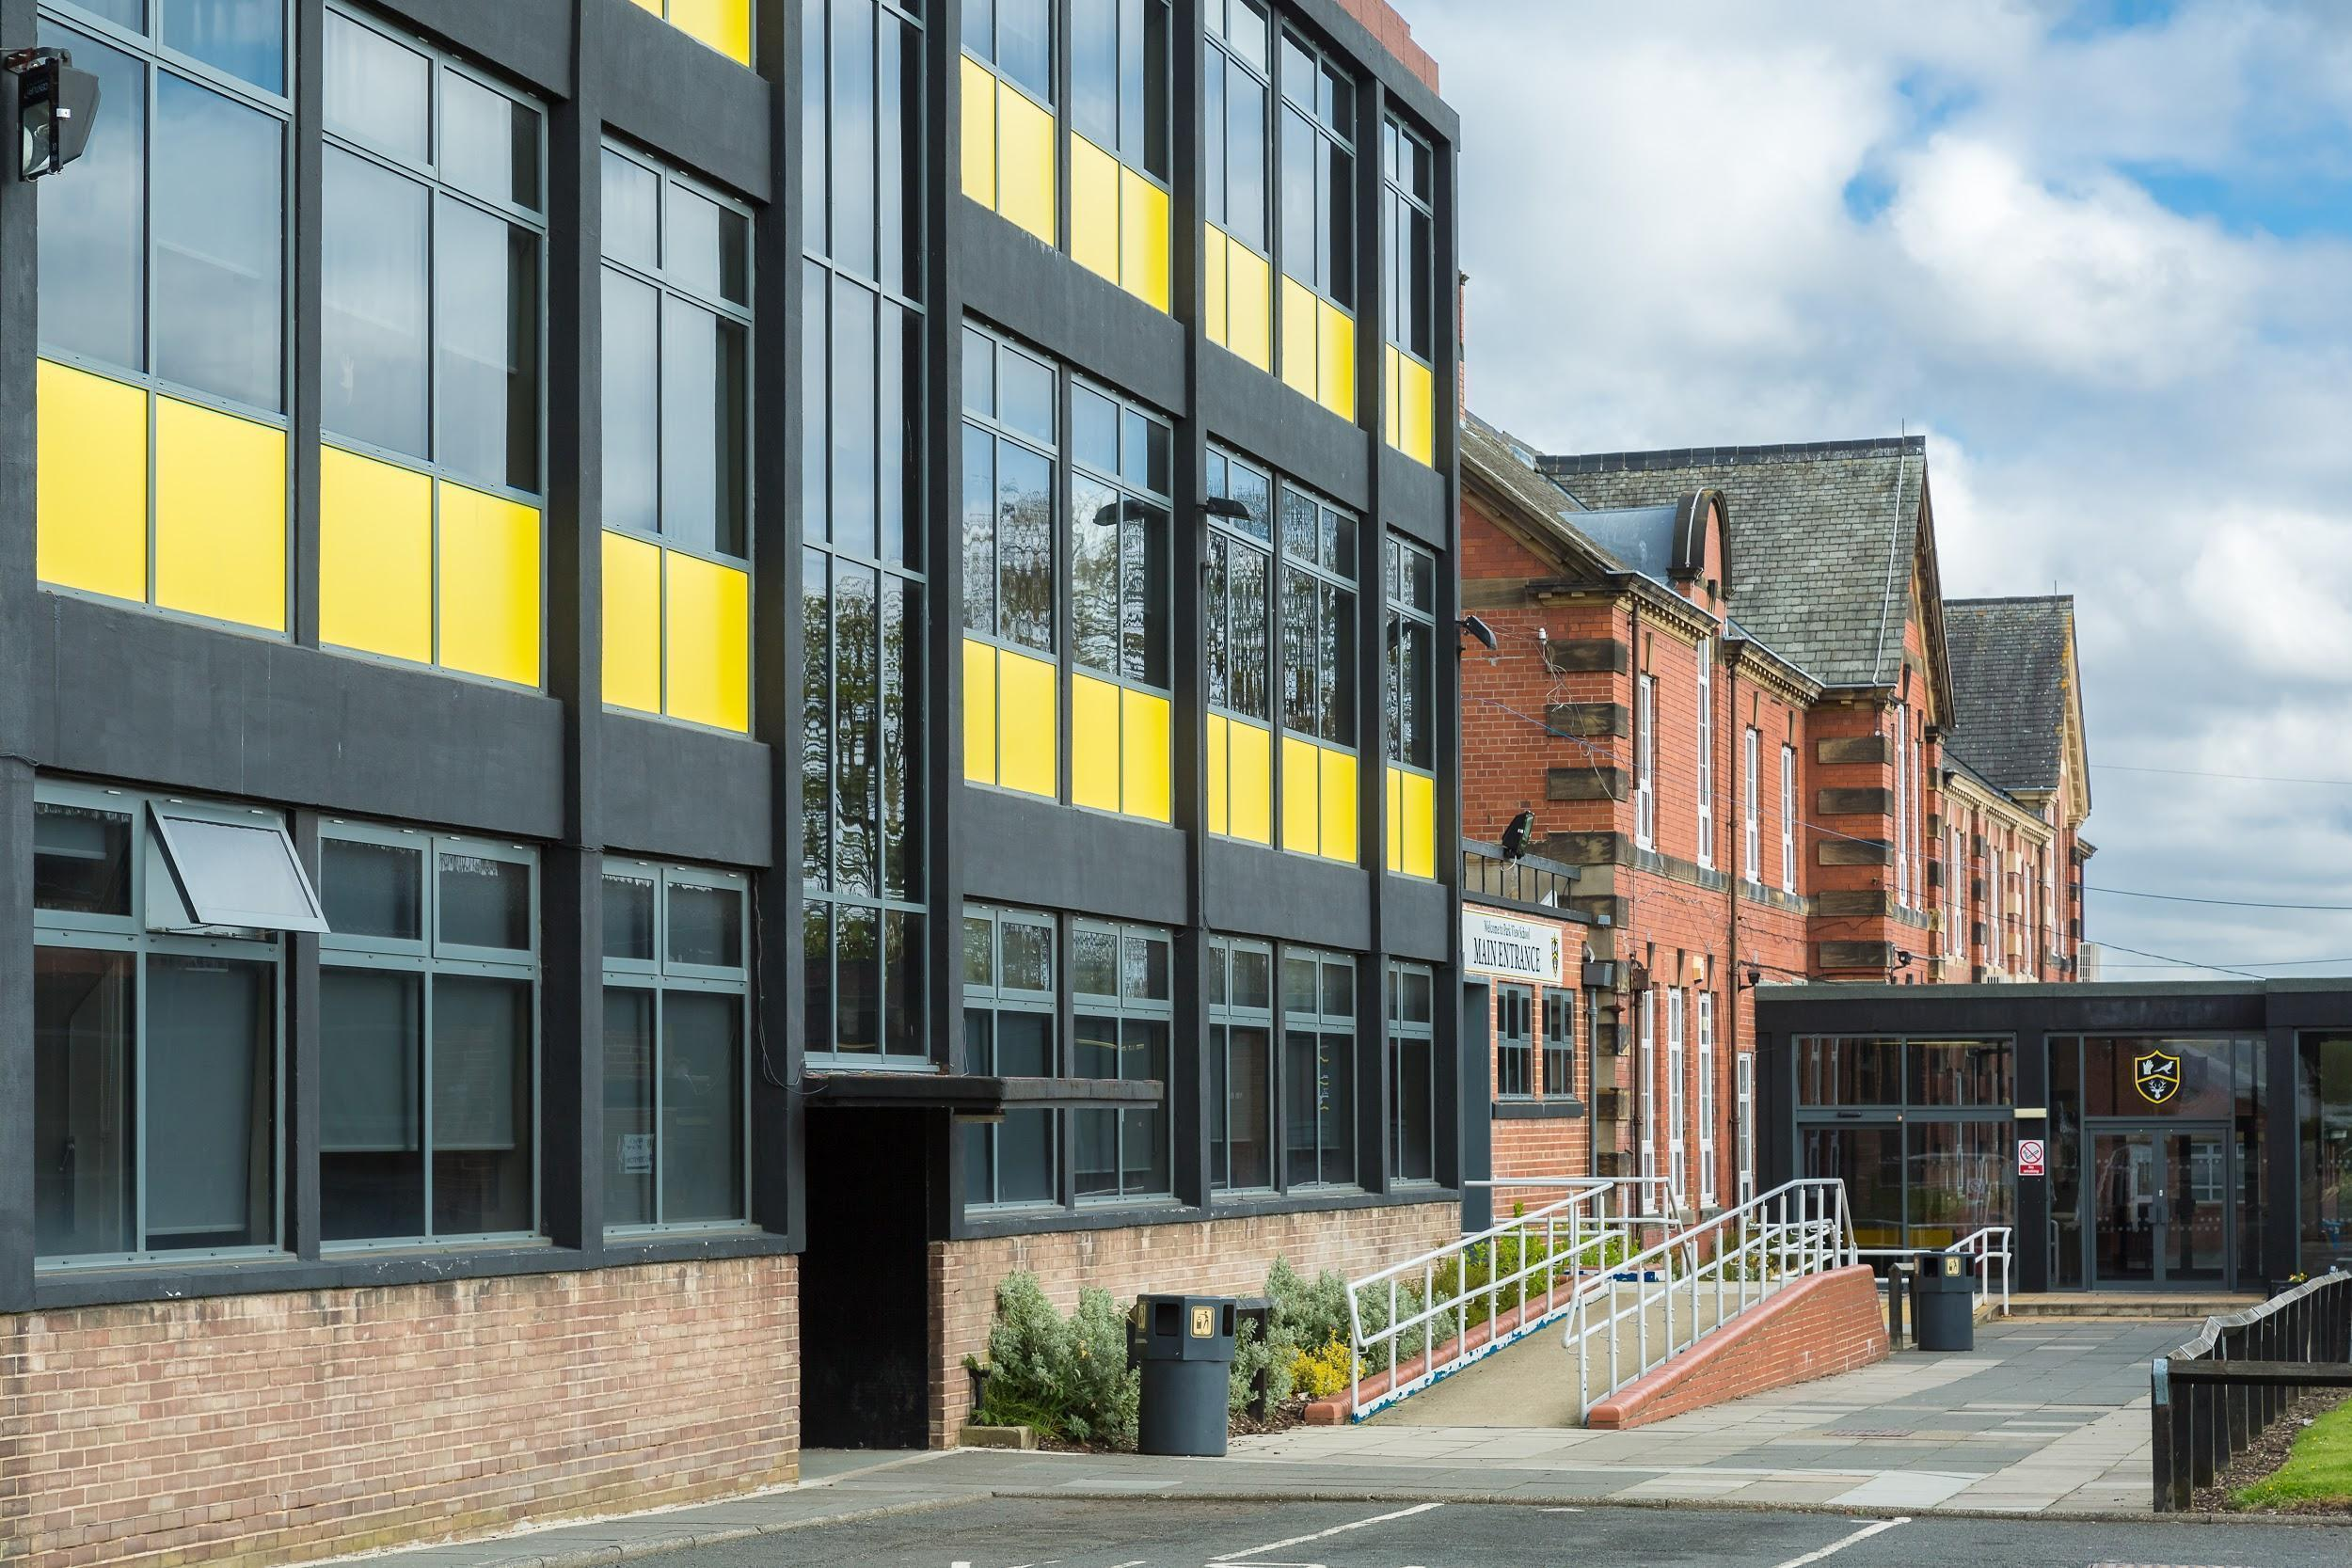
“I like coming to Park View because it is fun and all my friends go there. Lessons are fun because you learn new things which may not have known before and you have an amazing range of different teachers. You never get bored.”

The Church Chare site houses Years 9-11 as well as the Sixth Form. The curriculum is designed to allow students to specialise in their studies as they move into older adolescence in order that they are prepared fully for their chosen futures. In this respect, our size matters as being a large school allows us to run a wide range of courses which suit each individual student’s needs.
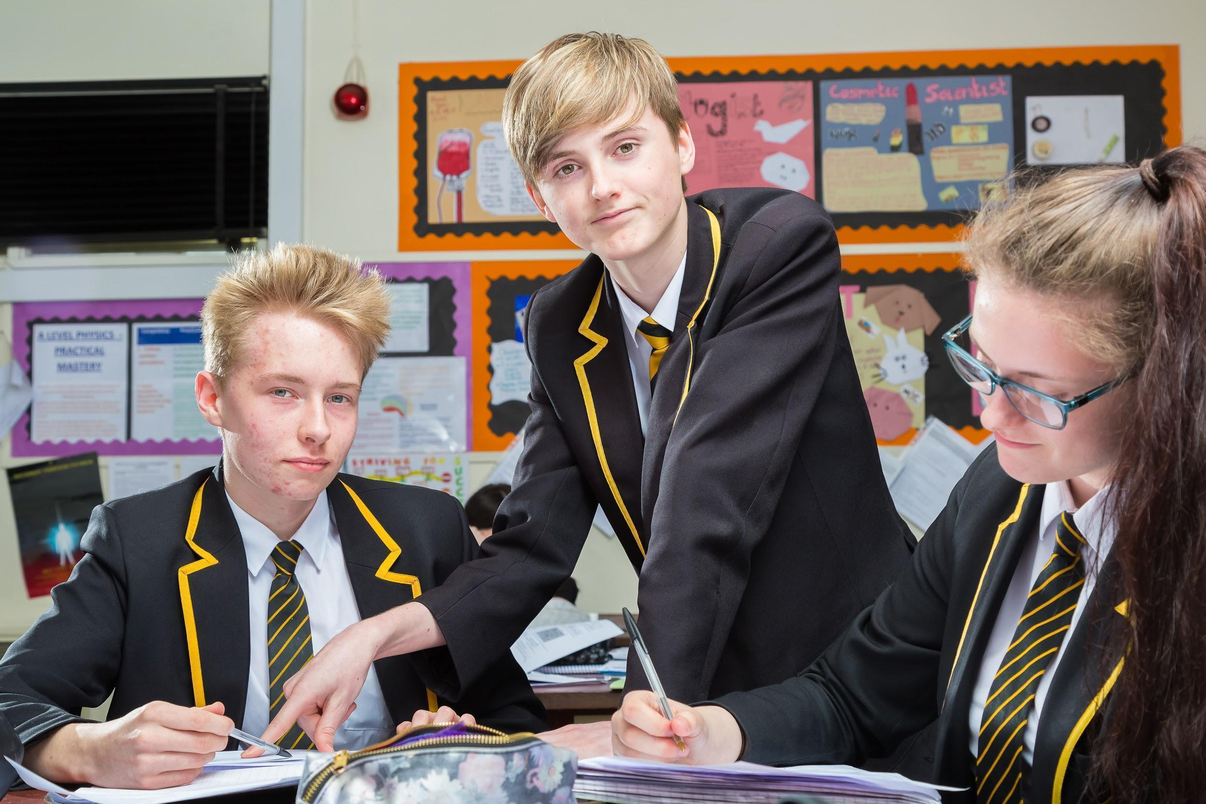
At the end of Year 8, students choose the courses which they will take to GCSE, with extensive counselling supporting both them and their parents/carers in making these decisions. This process is continued throughout Key Stage 4, most prominently in Year 11, where vital decisions about post-16 education or training have to be finalised. The majority of students choose to continue their studies with us into the Sixth Form. We have appointed our own Head of Futures, Mrs Raine, who provides invaluable expertise at this time, as well as in other phases of the school.
The site is designed to enhance learning, with specialist science laboratories, design workshops, performance areas and indoor and outdoor sports facilities all providing students with platforms on which to excel. All teachers of examination classes are subject specialists, with resources carefully targeted to support them in their work. We have recently invested heavily on improving the buildings and updating our ICT network and PC’s.

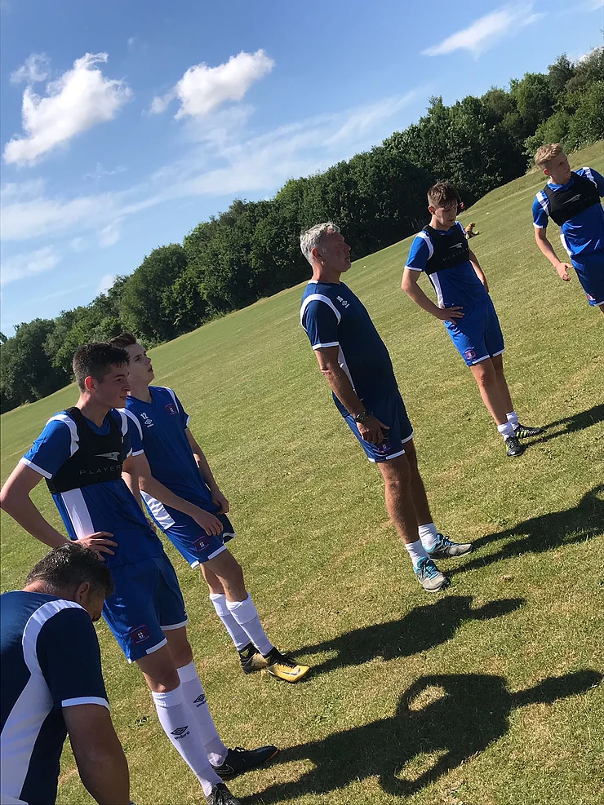
Park View Academy of Sport has been established as a new campus for Park View School. The campus, which is based the Riverside Chester-Le-Street, provides world class sporting facilities which will house aspiring sports men and women. The academy officially opened in September 2017 with the launch of our Men’s Football Performance Centre.
​
The academy is aimed at 16-19 year olds and will see learners combine academic studies with progression in their chosen sport. All learners receive technical coaching, strength and conditioning and access to sports therapy and physiotherapy.

Park View Academy of Sport works alongside Park View Sixth form to give every student the best possible chance of success as they embark on what is a very exciting step in their life. Choosing a place to continue your education is a huge decision for everybody. However, as we are able to offer a fantastic sports programme alongside both A-Levels and a BTEC qualification, we are able to tailor our programme around each and every student, thus giving them the best chance of academic success.



We aim to:
​
- Achieve sustained excellence in every aspect of our work.
- Provide all of our students with a secure, inspiring and stimulating environment in which they will enjoy being challenged to think and engage in their own learning.
- Share our own passion for learning, our subjects and life.
- Foster an understanding of the importance of the written and spoken word in society, both as a tool for communication and a way of expressing complex emotions and thoughts.
- Enable all students to experience success and to become active participants in a learning community which has shared beliefs and values.
- Celebrate the contributions and achievements of all who contribute to our success.

