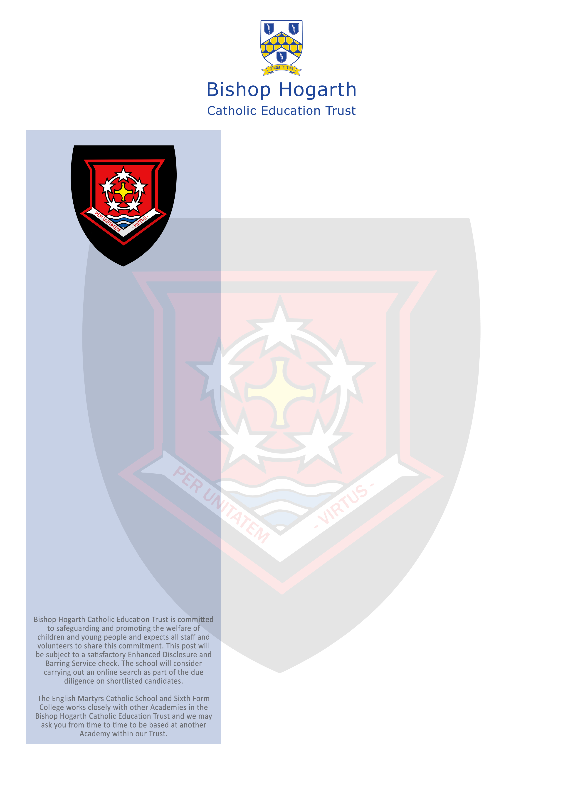

The Director of Bishop Hogarth Catholic Education Trust and Governors of English Martyrs are seeking to appoint an ambitious leader who combines excellent skills with the ability to lead, inspire and motivate both staff and students.

The English Martyrs Catholic School and Sixth Form College promotes high standards in terms of teaching and learning, behaviour and achievement.

The Curriculum Leader in English is a significant leadership role that is central to ongoing and exciting school improvement.
We can offer you:

• The opportunity to join a school with enthusiastic, confident and happy children;
• Dedicated staff who are keen to build on our high standards;
• Excellent collaboration between the existing schools within the expanding Multi Academy Trust;
• Opportunities to share talents within a supportive and trusting network of leaders;
• Opportunities to engage in high quality professional development.

We are looking for a teacher who:

• Fully support our Catholic ethos; Lead the English Department ensuring high standards and student outcomes.
• Will inspire, challenge and encourage our students; to have a love of learning to be confident and skilled orally in reading and writing
• Will enable every child to reach their highest potential; and embed a love of reading
• Has recent curriculum knowledge and the ability and experience to apply this to their teaching to a high standard.

Visits to the schools are warmly welcomed and positively encouraged. For further information, to arrange a school visit please contact Nicola Denham, Office Manager and Headteachers P.A on 01429 273790.

Application forms are available at: https://bhcet.org.uk/vacancies/ and can be returned to recruitment@ems.bhcet.org.uk or by post to Mrs S Crawshaw, The English Martyrs Catholic School and Sixth Form College, Catcote Road, Hartlepool, TS25 4HA.

The English Martyrs Catholic School
and Sixth Form College
Curriculum Leader in English
£53,973 - £59,558
Full time, permanent to commence September
Closing date: 12/05/2023
Interview date: 18/05/2023

