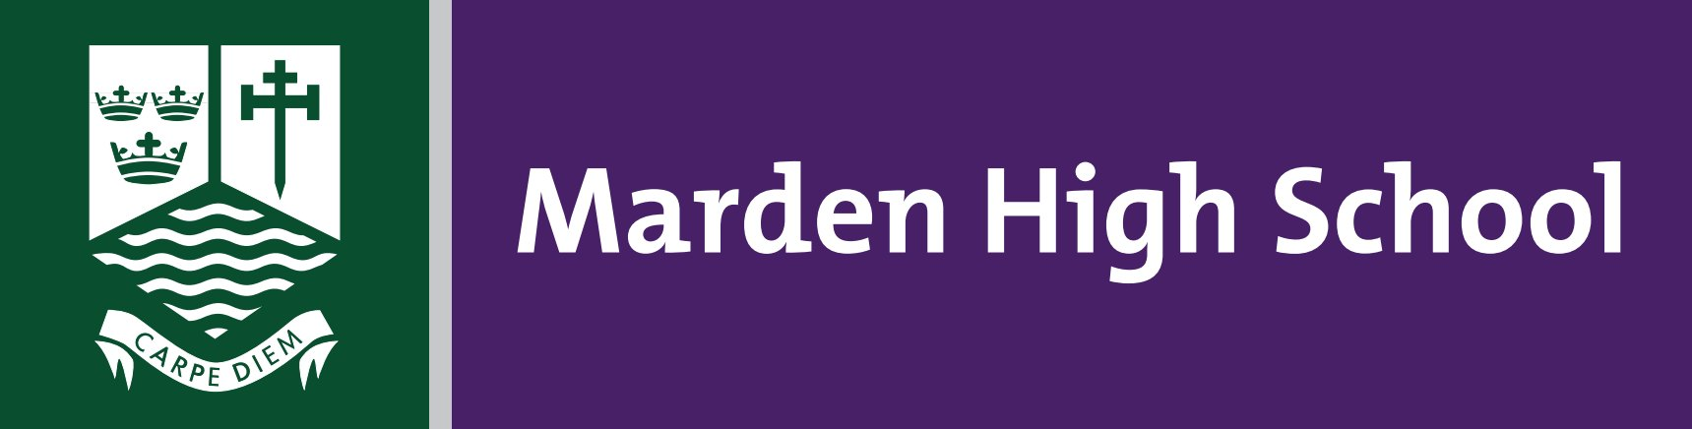
Student Support Manager
Full Time, Permanent Post, From 1 September 2023
£23,606.54 - £25,397.77 pa, Term Time only plus specified days

Marden High is a thriving 11-16 school that represents everything that is exciting about comprehensive education. We are a school with high aspirations for all our students.
We have an enviable record of examination success, and our former students are to be found in many diverse and successful roles, most having moved through further and higher education. Students regularly achieve excellent academic results, well above the national average, but the staff and governors at Marden believe we can always improve even further. We demand that the learning experience for our students moves with the times whilst maintaining the traditions of good manners, discipline and respect for others.
We wish to appoint an enthusiastic and highly skilled Student Support Manager to join our successful school team, to support students’ behaviour for learning, working with young people, teachers and support staff with the aim of every child achieving their full potential.

If you have a minimum of 5 A*-C including English & Maths or equivalent qualification / experience, patience, commitment and excellent communication skills, and are prepared to work hard to have a positive impact on our students, this is the job for you.

Potential candidates are welcome to contact Matt Snape, Headteacher, for an informal briefing on 0191 2962771.

Closing date: 9.00am on Tuesday 13 June 2023
Interviews: Monday 19 June 2023

Application packs can be downloaded from our website: www.mardenhigh.net
(Please do not submit CVs as they will not be accepted).

Marden High School is committed to safeguarding and promoting the welfare of children and young people and expects all staff, volunteers and visitors to share this commitment. The successful applicant will be required to undertake an enhanced DBS disclosure and a range of other recruitment checks.

