January 2023

Dear Applicant
Head of Department - History
Thank you for your interest in the above position which is a full time, permanent position, commencing 1 September 2023.
Marden High School is highly successful, with examination results well in excess of national standards.

If after reading the attached material you would like to apply for the post please complete the application form and submit it, together with a letter of application, outlining how well you meet the person specification, the qualities you will bring to this position and your thoughts on how students gain from excellent History teaching. Your letter should be no longer than 2 sides of A4. Applications can be emailed to e.scott@mardenhigh.net

If you would like an informal chat about this opportunity, do not hesitate to contact me.

The closing date for applications is Tuesday 28 February 2023. Interviews will take place on Monday 6 March 2023.
Yours faithfully
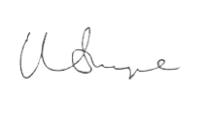

Mr Matt Snape
Headteacher

