Dear Applicant

Thank you for requesting details of the post of Junior School Key Stage 2 Teacher at Newcastle High School for Girls. I hope that the enclosed information will encourage you to apply for a job in our successful and happy school. You will also find the School offers a very pleasant and supportive atmosphere in which to work.

I regard every member of staff as extremely important. It is essential that anyone joining Newcastle High School for Girls has the ability and drive to help us improve further by participating wholeheartedly in all aspects of school life and promoting our ethos.

We are all committed to helping every individual in the School, both staff and pupils, achieve their full potential. We have a thorough Induction Programme for all staff and the Staff Room is lively and welcoming.

Extensive building and refurbishment programmes in recent years mean that both our Senior and Junior School sites have some of the most impressive school facilities in the region and, indeed, the UK.

I do hope that you will apply for this post. Newcastle High School for Girls is a wonderful School in which to work and this is an exciting opportunity. I look forward to hearing from you.

Yours sincerely

Mr M Tippett
Head

About the School

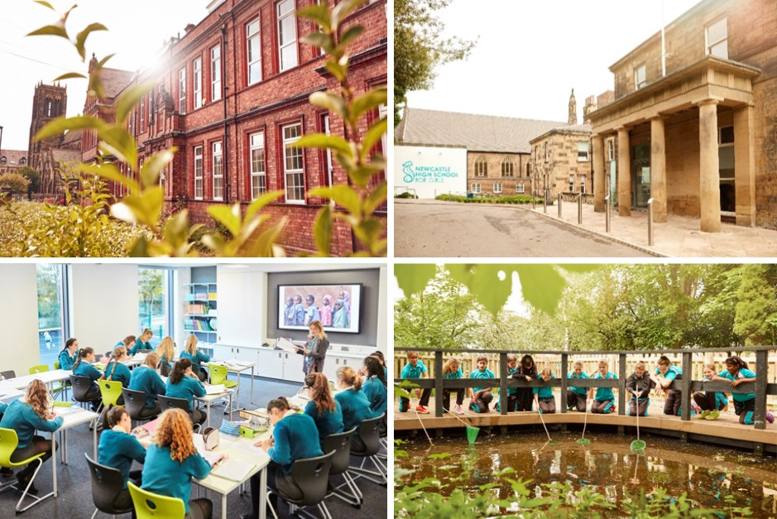

Newcastle High School for Girls is one of the North East’s leading independent girls’ day schools. Founded in 2014 following the merger of two very long-standing predecessor schools, NHSG is a state-of-the-art, modern school with a tradition and history stemming back almost 150 years.

We are an all through school (ages 3-18) with around 250 girls in the Junior School and 450 in the Senior School, including 150 in the Sixth Form, who, together with around 150 staff, make up a friendly and welcoming community.

The Junior and Senior Schools occupy their own separate campuses around a mile apart and this role is based at our Junior School site. Our two campuses are situated within the suburban, leafy, areas of Jesmond and Sandyford, both with excellent transport links to the Tyne & Wear Metro and bus services from across the region.

Our School is a very popular choice at all ages with girls joining us from most parts of the Tyne & Wear metropolitan area as well as areas further afield in Durham, Northumberland, the Tyne Valley, the Borders and Teesside.

Girls who attend NHSG are bright, enthusiastic, eager to learn and have high aspirations. Our public examination results are consistently outstanding, and girls go on to study a wide range of subjects at prestigious universities in the UK and abroad. NHSG is highly regarded for the way it achieves its outstanding outcomes within a particularly warm and supportive environment, with pastoral care and achieving the best for every girl at the heart of everything we do.

About the Girls’ Day School Trust

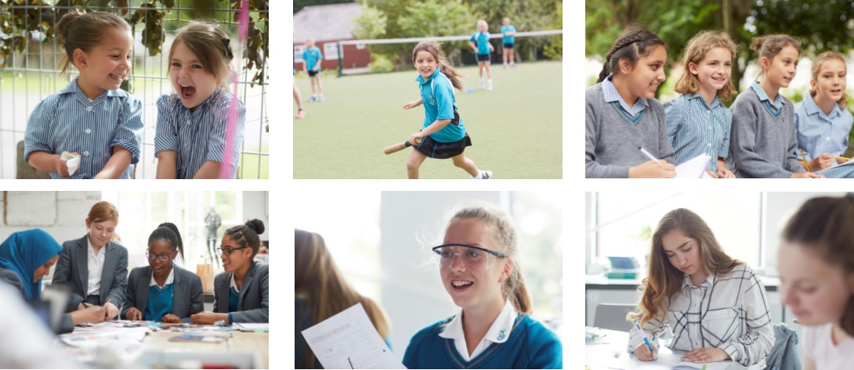

The GDST is a family of 24 independent schools and 2 all girls’ academies across England and Wales. As specialists in girls' education, we tailor our teaching to the way girls learn best and instil in them the conviction that there is no limit to what they can achieve.

At GDST, we focus not only on what is learned but how it is learned. Ensuring our girls are confident and fearless, determined to show what they can do. Nothing holds our girls back – they’re encouraged to embrace every role and subject. As a result, they trust their own abilities and are alive to every opportunity.

We concentrate on creating an environment where all can thrive and learn from one another. Physical and emotional well-being is paramount, which is why every GDST school provides an incredible array of extra-curricular activities and wellbeing programmes.

Within this family, networking opportunities enable staff to share best practice and develop initiatives that benefit all our schools and pupils. In addition to supporting the work of individual schools in providing excellent induction and development opportunities for staff, the GDST provides access to an extensive training programme. This includes development opportunities and grants for individual courses of study.

