Bishop Barrington
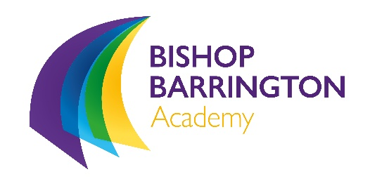

Inclusion Supervisor
(Grade 4 point 5-8)

The school is looking to appoint an enthusiastic member of staff to work within our inclusion unit as a member of the ready to learn team.

Please apply with a letter of application no more than two sides of A4.

The school has recently moved into a brand new state of the art building fully equipped to deliver the highest quality of education to the community of Bishop Auckland.

Further details and application forms are available on the School website or by e-mailing for information.

Bishop Barrington School
Woodhouse Lane
Bishop Auckland
County Durham
DL14 6LA
Telephone: 01388 603307
Email: admin@bishopbarrington.net

Closing date for applications:
Friday 18th June 2021, 12 noon.
Interviews: 23rd June 2021.
We are committed to safeguarding and promoting the welfare of children and young people and to equality of opportunity.
An enhanced DBS check is required for all successful applicants.

