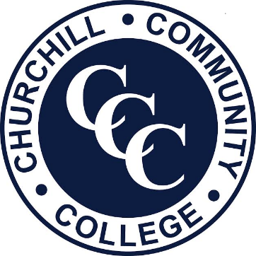
October 2018

Key Stage 4 Progress Tutor

Dear Applicant

Thank you for requesting details for the position of Key Stage 4 Progress Tutor at Churchill Community College. We are planning for the right candidate to start as soon as possible and in the first instance this is a fixed term position until 31st August 2019.

The College is a dynamic, exciting place to work with many opportunities available for staff and students. Churchill has been designated a Teaching School by the DfE and we also lead the ‘The Great North Maths Hub’ for the North of England along with the North Tyneside Learning Trust. This is an exciting initiative that places the college at the centre of innovations in Teaching, Learning and CPD for teachers of all subjects.

Our most recent OfSTED Inspection in May 2014 graded us as Outstanding across all areas. The report said that:

‘Churchill Community College is an outstanding provider of education to young people that prepares them extremely well for their future.’

‘The College has a distinct caring atmosphere and a family feel. The behaviour of students is outstanding. Relationships between staff and students and between students themselves are very strong and supportive. Staff and students are courteous, polite, mature and respectful of each other.’

‘All groups of students in Key Stages 3 and 4, regardless of their backgrounds, make outstanding progress and leave Year 11 with GCSE results well above those found nationally.’

‘Teaching is outstanding. Teachers know their students well, have excellent subject knowledge
and plan activities that lead to rapid learning for all groups of students. Tasks constantly challenge students and inspire and engage them to do well. Students say that they enjoy learning and that teacher’s give them work that is usually both demanding and fun.’

Please read more about our inspection, Assisted Review and the ethos of the College by accessing our website at www.churchillcommunitycollege.org or at the Ofsted website - www.ofsted.gov.uk.

We require an experienced enthusiastic Key Stage 4 progress Tutor to join our dynamic team.

We are looking for someone who:
- Is enthusiastic and highly motivated to bring a sense of energy and passion to the role
- Can use their initiative to work independently and flexibly
- Has an ability to work in a team and form positive relationships with children, parents and staff

The post holder will support and assist teachers in raising standards of students’ achievement and to undertake a range of teaching and learning activities:

To facilitate and support learning opportunities both in the classroom and in small groups under the teacher’s direction

To develop a 1:1 mentoring relationship with targeted students.

To invigilate tests and examinations

To accompany staff and students on educational visits

To provide general/administration support

Please read the enclosed information carefully and decide if Churchill Community College is the place you want to develop your career and help us make a significant difference to the lives of young people. Our staff are dedicated, very hard-working and believe that what we do is vital to improving the life-chances of the young people we work with. I expect that commitment from all staff.

The closing date is 9.00am on Thursday 18th October 2018 and I look forward to receiving your completed application form and a letter of application (this should not exceed two sides of A4) which will outline how your skills and experiences make you the best candidate for this post. A CV is not required.

An outline of the interview process and any presentation or task details will be sent to candidates who are short-listed. In the interest of economy those candidates that are not short-listed will not receive notification and should assume that they have not been successful in this instance. Please also note we do not pay expenses for candidates asked to interview.

Thank you for investing the time in our College.

Yours sincerely

David Baldwin
Headteacher

