Our Ref: FS/EC

November 2016

Dear Applicant

Post of: Temporary Part-time Teacher of Drama (0.6 fte)

Thank you very much for your interest in the post of Teacher of Drama at The Hermitage Academy. I hope you find the information provided useful.

Please complete the application form and return this to me at the Academy along with a supporting letter indicating your suitability to fulfil this role and detailing what qualities you could bring to the post.

Please note also that you must complete the Disqualification from Caring for Children Regulations (DCCR) Disclosure form and return this with your completed application form.

Candidates should provide the names, addresses, telephone numbers and email address of two referees, one of which should be your current Head Teacher if appropriate.

All newly appointed staff will be subject to the usual Disclosure and health checks.

Your completed application, together with your supporting letter, should reach me by 1.00 pm on Friday 25 November 2016. Successful candidates will be contacted by telephone and invited to interview. If you do not receive a telephone call from the Academy inviting you to interview, you may assume that you have been unsuccessful on this occasion.

I hope you decide to make a firm application for this post and I look forward to meeting the successful candidates in due course.

Yours sincerely

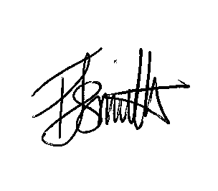
Felicity Smith
Principal

