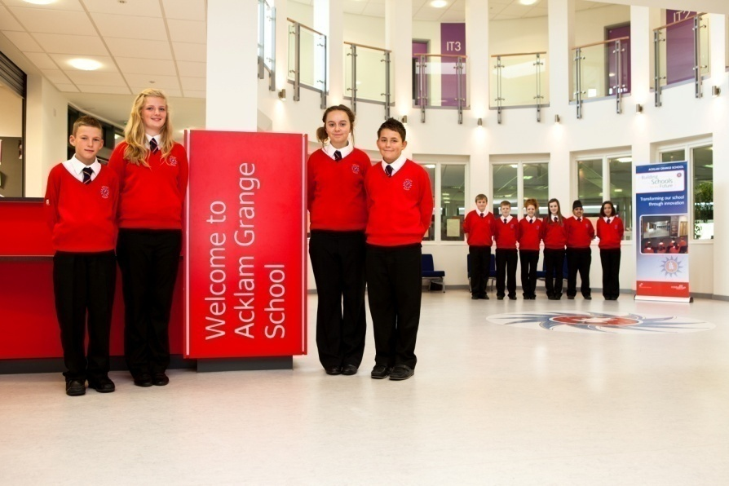

Assistant Headteacher (Teaching and Learning)

Acklam Grange School
Lodore Grove
Middlesbrough
TS5 8PB
01642 277700

www.agsrecruit.com
www.acklamgrange.org.uk

Contents
- Explanatory notes including application process
- Further information including:
  - Information about Acklam Grange School
  - Job Description
  - Person Specification
  - Application Form
  - Equal Opportunities Recruitment Monitoring Form

Explanatory Notes - please read carefully before completing the application form.

Thank you for your enquiry regarding the post of Assistant Headteacher (Teaching and Learning) at Acklam Grange School. We hope that you find this pack informative. It includes a job description and person specification plus general details about our school.

Application Process

Should you wish to apply for this position, please send the following:

- A completed application form, and equal opportunities monitoring form (templates attached).

- In support of your application you may include a curriculum vitae and covering letter as well as, but not in place of, the application form.

- Applications should be made electronically in Word or PDF format to:

humanresources@acklamgrange.org.uk

- Enquiries may be made to Miss Rebecca McGurrell, Human Resources Manager

Closing date: Thursday 20 October 2016

Please advise your referees that they may be contacted and asked to provide a reference at short notice.

Acklam Grange School is a large and over-subscribed 11-16 Secondary School in West Middlesbrough (NO 1410). Under Building Schools for the Future (BSF) programme our building opened in September 2010.
Acklam Grange is a comprehensive and inclusive school in Middlesbrough with a focus on learning for all the family. A big school with a big heart our priority is our students’ achievement, empowering every child to exceed expectations and be the best that they can be.
Every child benefits from an individual learning experience in a family focussed learning community that recognises their specific needs through curriculum choice and tailored support.
High quality facilities offer an exceptional environment where learning is fun, accessible and relevant, preparing students for further and higher education and the world of work.
We are proud of our students, our values and our drive to succeed, balancing the principles by which we live; ‘Care’, ‘Courtesy’ and ‘Consideration’, with the principles by which we work; ‘Pace’, ‘Passion’ and ‘Purpose’.
We will provide:
- A nationally recognised, highly personalised professional development programme – AGS Inspire – www.agsinspire.com which supports and develops staff at any stage in their career.
- A personalised staff well-being programme led by a NHS practitioner including:
- flu jabs, health checks
- workshops on nutrition, sleep, resilient thinking, time management, mindfulness
- fitness classes
- free breakfasts and breaktime refreshments
- excellent facilities with suited faculties, interactive whiteboards in every classroom, iPads, lap tops and PCs plus subject specific technology to support learning
- well motivated students with a strong commitment to leadership, community and charity and supportive parents.
Strengths at Acklam Grange School
- Community Cohesion including Meserani Projects and links with Kashmir Education Foundation
- Student Leadership
- Pastoral Care
- SMSC experiences
A visit to our school is always welcomed and visitors never fail to be impressed with the enthusiasm, passion and positive ethos shared by staff and students alike.

Equal opportunities

It is the policy of Middlesbrough Council to provide equal employment opportunities and consideration will be given to all suitably experienced and qualified applicants irrespective of disability, gender, race, religion and belief, age, sexual orientation, marital or civil partnership status.

At Acklam Grange School we afford equal opportunities in all aspects of employment in support of the Equality Act 2010. In order to help us monitor equal opportunities please complete the enclosed equal opportunities recruitment monitoring form and return with your completed application.

Applicants with disabilities

Under the Equality Act 2010 and in support of Middlesbrough Council’s Recruitment Policy, a person with a disability, who meets all the essential criteria in the person specification, is guaranteed an interview. Please ensure that you complete the relevant section of the application form if you wish to claim this guaranteed interview.

Acklam Grange School encourages applications from individuals with a disability who are able to carry out the duties of the post. If you have special needs in relation to your application please contact Denise Hersi, Human Resources Officer.

Travel expenses

Acklam Grange School will reimburse travel expenses within the United Kingdom, with prior agreement and authorisation between the applicant and Ms Crawshaw, Headteacher. Please contact Denise Hersi, Human Resources Officer for further clarification.

Response

Please note that we are only able to inform short listed candidates of the outcome of their application. If you do not hear from us within four weeks of the closing date, please assume that you have been unsuccessful on this occasion. We would like to assure you that every application we receive is considered in detail, and a shortlist only drawn up after careful reference to a detailed person specification.

Therefore, if your application is not successful, we hope that you will not be discouraged and will still apply for other suitable vacancies at Acklam Grange School, as and when they are advertised.

Thank you for your interest in Acklam Grange School.

