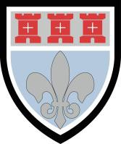 St Mary’s Catholic School
St Mary’s - An Outstanding School

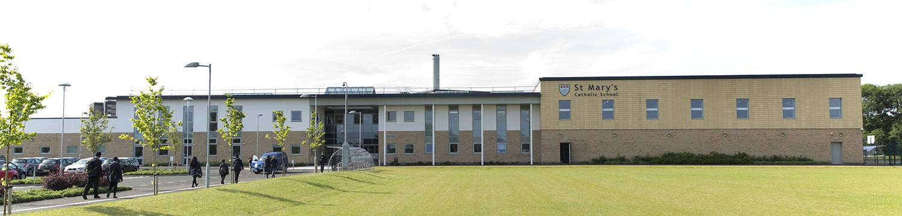

St Mary’s was judged as an ‘Outstanding’ school by Ofsted in May 2009. The report states, ‘Students’ achievements are outstanding, as is their personal development and well-being’. Read the report at:

http://stmarysnewcastle.co.uk

St Mary’s also received a letter from Her Majesty’s Chief Inspector, Christine Gilbert, in July 2009 stating, ‘The judgement of outstanding means that St Mary’s is exceptional and significant elements of the school's work are exemplary’. Read what others have said at:

http://stmarysnewcastle.co.uk/ofsted/

We were visited by a Diocesan Inspection team in June 2009 and January 2016 and were again judged as an ‘Outstanding’ School. The 2009 report states, ‘St Mary’s is an outstanding Catholic school providing an education which enables students to flourish’ and ‘Students thrive in a community where they feel accepted and empowered to discover and use their gifts and talents’. Read the report at:

http://stmarysnewcastle.co.uk/ofsted/

Finally, in February 2010 St Mary's was again judged as 'Outstanding' by Ofsted during an English subject inspection in February 2010. The report states, 'Students' strong involvement in learning and excellent progress results from teaching which is routinely good and often outstanding'. Read the report at:

http://stmarysnewcastle.co.uk/ofsted/

School Information

St Mary’s is a very successful, popular and happy school, rated Outstanding by the Diocese and Ofsted. We became an academy in 2013 and enjoy outstanding facilities in a new building which opened in 2011. We are a National Support School, increasingly engaged in school to school support, as well as a core partner in a Teaching School Alliance. Opportunities for professional development are, therefore, wide-ranging and an added attraction for potential new staff.

St Mary’s uniqueness – the only mixed, Catholic secondary school in the city

We are the only mixed, Catholic secondary school in Newcastle and are proud of our Catholic distinctiveness. We aim to live by the message of the Gospel in every aspect of school life and we take Christ as our example. We work closely in partnership with our Catholic partner primary schools from where most children come and with whom we share the same ethos. Our school is also enriched by children who come from other schools in Newcastle and beyond, including

from overseas. We welcome all students equally to St Mary’s from a variety of Faith backgrounds. Everyone who chooses St Mary’s can be assured of the best possible education.

St Mary’s popularity

- St Mary’s has grown in popularity in recent years. We are oversubscribed with a rising roll (850 in 2009 - 1200 in 2015).

We have been able to offer places to students from many different primary schools.

The core values of St Mary’s Catholic School

- An excellent school which celebrates each student`s unique set of God-given gifts and talents and ensures that students use their gifts and talents to the full.

- A school which strives to live by the message of the Gospel, offering students opportunities for spiritual growth and development, whatever their faith background, supporting them on their individual journey and preparing them for their life to come.

- A school which strives for excellence in everything it does, whether in the academic achievement of our students or in the quality and range of opportunities which we provide for their all-round development outside the classroom.

- A school which puts learning and teaching at the heart of school life and prepares students really well for the next stage in their education, whether at University or in the workplace.

- A school of which we can all be rightly proud, offering our students a first class education and helping them to develop as well rounded individuals who are ready and able to take their place in the wider world, as happy, confident and self- aware young adults with a sense of service to their communities.

Exam success at St Mary’s

Our students’ progress and attainment are excellent, among the very best in the north-east and UK. St Mary’s is one of 6 north-east schools with the highest value added achievement score, when measured across all the Ebacc subjects of English, Maths, Sciences, Languages and Humanities.

Attainment over the last years has averaged the following very high figures:-

- Best 8 Value Added has been significantly above the national average for the last 5 years
- 4 year average of 69% A*-C with English and Maths, well above the national average
- Excellent English and Maths results over the last 4 years, 77% A*-C and 79% respectively
- Outstanding Expected Progress results in both English, 82% and Maths, 79%, in last 4 years
- Outstanding score of 807 points per A level student in 2015

In the Sixth Form, our students have an excellent track record of gaining a place at their first or second choice university. We have successfully prepared students for entry into leading universities such as Oxbridge, St Andrews, Durham, Edinburgh and Russell Group Universities to study Medicine, Law, Architecture, Maths, Languages and many other challenging degree courses. Sixth Form numbers have consequently increased steadily over the last few years and now stand at around 200 students, all following a wide range of A level courses.

Positive climate for learning at St Mary’s

You will find St Mary’s to be an orderly, well-disciplined community, where learning flourishes for all students. Ofsted described student behaviour as outstanding. We have high standards and high expectations of students regarding behaviour and readiness for learning. Students know where they stand. Rules are simple, sensible and consistently applied so that students feel safe and secure and know what is expected of them. We are smaller than some of the very large secondary schools in the city and we believe that this is a distinct advantage, as our smaller tutor groups and class sizes allow us to get to know our students really well and offer excellent pastoral care.

We praise students for their efforts and celebrate their achievements in many different ways. We believe that such a positive climate promotes learning and inspires students to fulfil their potential. Excellent student behaviour has played a major part in our record results in the last three years. Students of all abilities and backgrounds mix really well together at St Mary’s and there is a positive and happy atmosphere in the school.

Partnership with Parents

We place a high value on working closely in partnership with parents to ensure the best for your children. Any parent who decides to entrust their child into our care can be assured that he or she will receive an excellent, all round education.

St Mary’s - the new school
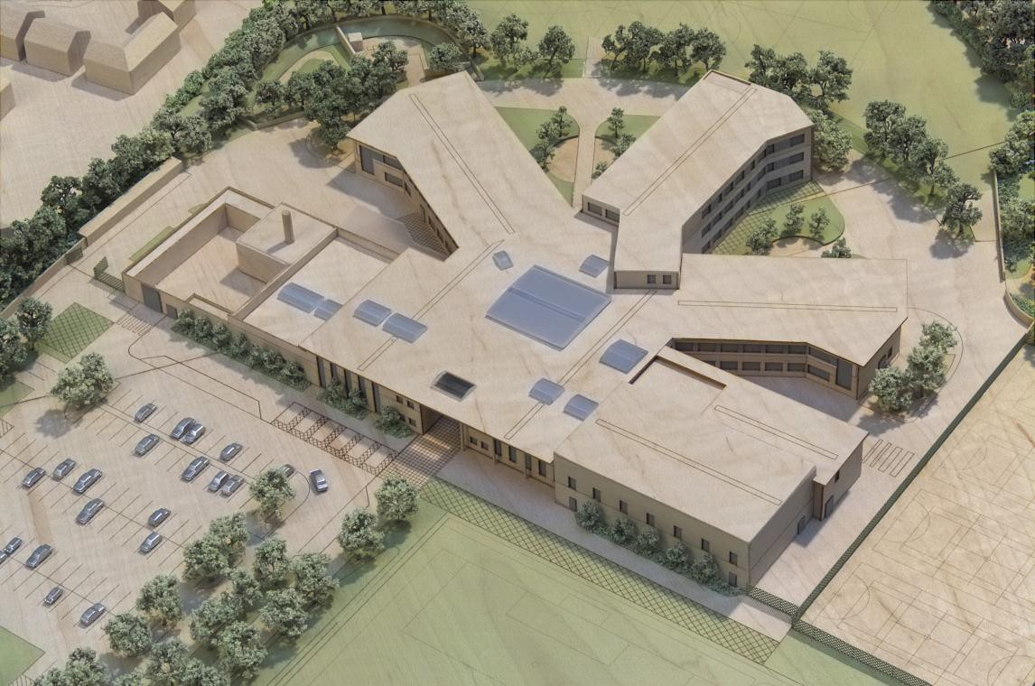

Main entrance

Aerial model of the new school building – opened in September 2011

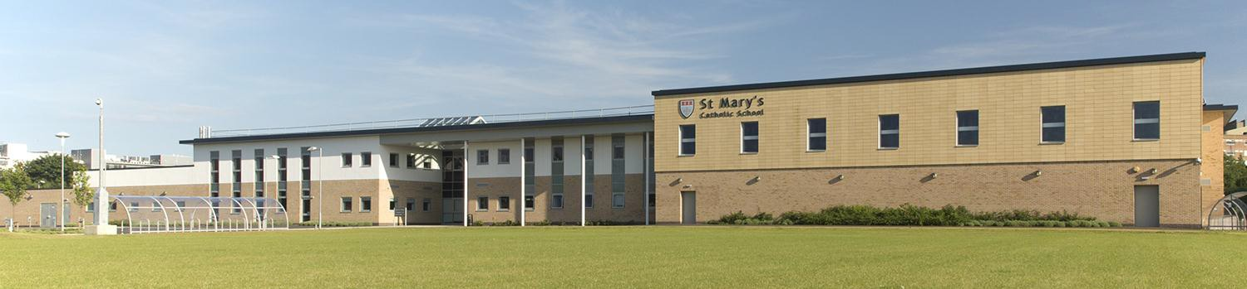

The new school – front elevation

We are all still very excited about working and learning in the new school, the novelty has not worn off. We are sure that our new state-of-the-art facilities will be a catalyst to even further improvement and achievement for our students in the future.

At the heart of the school is our chapel, which overlooks a large, two storey atrium space where students gather before school, at break and lunchtimes. This space is also used for teaching, display or presentations, after school or evening activities. Around the sides of the atrium are the pastoral offices where students can find their Head of Year and Form Tutors.

The three main teaching blocks radiate outwards from the atrium. Two of the teaching blocks are two storeys and the third is a three storey block. It is on the top floor of this block that the Sixth Form has a dedicated suite of rooms, study area and café style work space. Departments have suites of classrooms and other teaching areas in the three main blocks linked by corridors, staircases and lifts.

The school hall and dining room can be found along the front of the school, together with an impressive range of sports facilities. These facilities include a multipurpose sports hall, fitness suite and activity studio (gymnasium). The Inclusion Suite and library are also in this area. All areas of the school are easily accessible from the atrium.

Externally, we have an extensive range of sports areas, a memorial garden, a wildlife area, seating areas for students and outdoor teaching spaces.

The school is an innovative, exciting design which we all look forward to enjoying for many years to come.

The Atrium

