

Post: Science Teacher
For: September 2016
Temporary Post: 1 year


Dear applicant

First and foremost, thank you for applying to Park View School – we are always delighted when other professionals take an interest in us.

The school has been in Chester-Le-Street for over 100 years, starting life as a selective grammar, becoming a state school in the early Seventies and then a converter academy in August 2011. We are split over two sites, with Years 7 and 8 educated two miles away from the rest of the school population; the students stay on their respective sites whilst the staff travels when required to do so, at break and/or lunchtime. In national terms, we are a large school, with 1385 students, 285 of whom are in the Sixth Form.

In a recent Ofsted inspection, in which we were graded Good with Outstanding for Behaviour, an inspector commented that Park View was the happiest secondary school he had been in, such was the strength of relationships between the staff and the students. This is a matter of great pride to us as we do not want simply to produce excellent academic results; we want the children to feel part of a nurturing community in which they are cared for as individuals and expected to give something back in return. It goes without saying that we have high expectations of them both academically and in terms of their conduct: we provide them with a safe and secure environment, with clearly defined rules for what is acceptable, and, in return, they flourish. I may be biased but I believe that I have the finest, most talented young people you will ever meet in my school; to be with them on a daily basis is both a pleasure and a privilege.

Park View has a reputation for being at the forefront of learning, largely because I have a staff that sees it as their moral duty as educators to provide the best experience possible for our students. Our aim is to produce excellent results but to avoid being an exam factory; instead to provide the children with a rounded education in which they develop the skills, habits of mind and attitudes to life which they will need to take their place in the world. We were proud to be a Language College and have retained both a suite of languages and a curriculum infused with the international dimension. In addition, we have developed a learning model, Park View Learning, which has evolved from Guy Claxton’s ‘Building Learning Power’, and have recently been working with Hi-Tech High in San Diego to explore the benefits of project-based learning. Whilst we have many computer rooms on each site, a team of volunteer staff, ‘the digital leaders’, have also explored the potential offered by wireless technology and mobile devices. All of this means that this is a very exciting time to be joining the school!

This vacancy has been created by an experienced colleague taking a one year sabbatical. We are looking to appoint a teacher who is passionate about science and who would like to be a part of an incredibly talented faculty. The personnel who make up the team are amongst the most outstanding teachers within Park View, bringing to their lessons drive, challenge and genuine enjoyment : it goes without saying that we regard them as very much as jewels in the crown. We have no preference at all about age or experience; the ideal candidate will be one who:
- Genuinely enjoys teaching and is keen to develop his/her practice.
- Prizes academic excellence and has the determination needed to ensure that his/her lessons are a model of achievement and good practice
- Has a burning passion which will communicate itself to others and inspire them.
- Sees science as the vehicle by which all children can understand the awe and wonder of the universe they inhabit and is committed to developing a curriculum and an extra-curricular programme which will be exciting, innovative and alive.
- Loves working with young people and takes a pride and delight in their development.

I sincerely hope that you will follow up your interest by making an application to join us. Should you do so, please send your application by email to personnel@parkviewlearning.net or hard copy to Mrs Wendy Taylor at Park View School, Church Chare, Chester-le-Street. Co Durham DH3 3QA

I wish you every luck in securing the position!

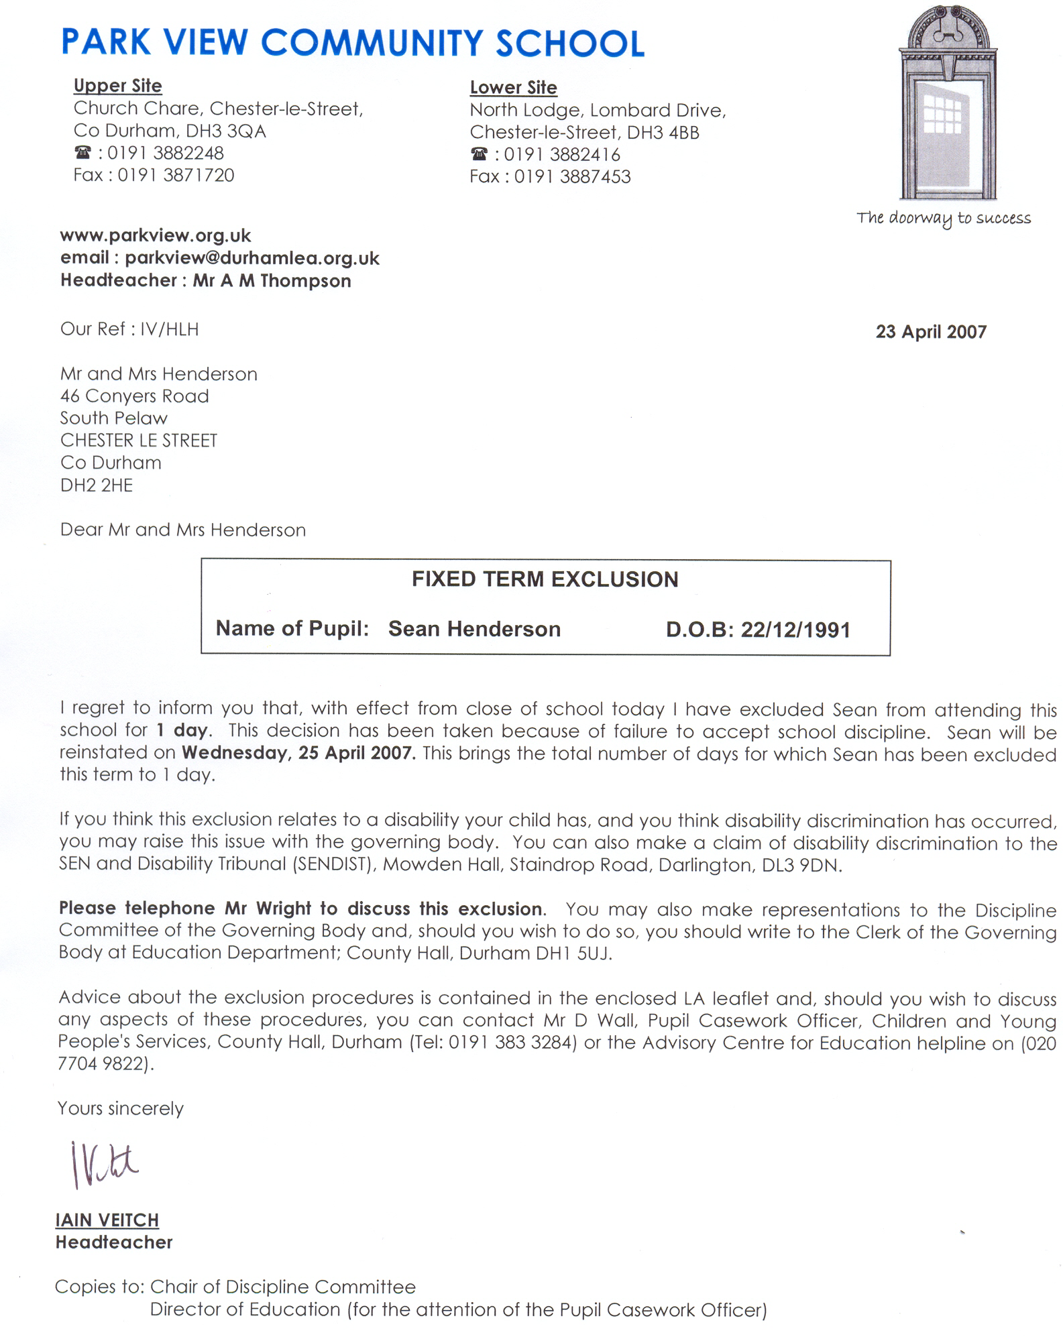
Yours faithfully

I.R. Veitch

