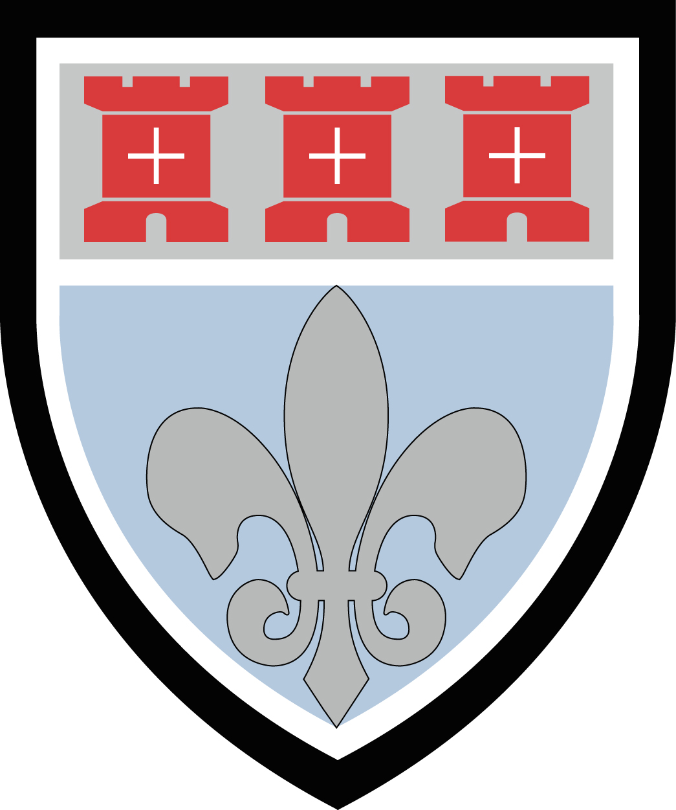
St Mary’s Catholic School

RE TEACHER

PERSON SPECIFICATION

Qualifications and Experience

Essential | Desirable
- A degree in an appropriate discipline  - Qualified Teacher Status  - Ability to teach across the full ability and age range | - Experience of teaching at Key Stage 3 & 4  - Experience of teaching A Level RE

Knowledge and Skills

Essential | Desirable
- Ability to teach high quality lessons to all ages and abilities- lessons that challenge and ensure the progress of all learners  - Excellent skills in classroom management  - High standard of preparation and marking  - Highly developed organisational skills.  - Ability to contribute positively to a team, and willing to take responsibility and demonstrate good leadership  - Highly developed oral and written communication skills  - A willingness to partake and share good practice  - Commitment to role of Form Tutor and providing an excellent holistic education for students  - Ability to form productive relationships with young people | - A willingness to contribute to and lead extra-curricular activities within, and outside of, the department  - Pastoral experience as a Form Tutor

Personal Qualities

Essential | Desirable
- Professional vision  - Ability to enthuse young people in the study of RE  - Outstanding role model for children  - Ability to respond to change  - Ability to relate well to colleagues  - Ability to think clearly, calmly and to complete tasks successfully  - Willing to be involved in the whole life of the school  - Fully supportive of the schools’ Catholic/Christian ethos and a willingness to promote this ethos at every opportunity | - An optimist who brings out the best in people  - Good sense of humour

