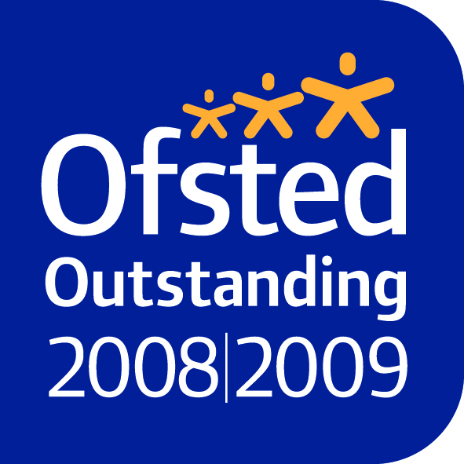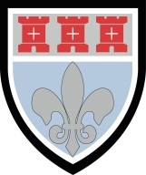

**St Mary’s Catholic School**

*where everyone can succeed*

Benton Park Road, Newcastle upon Tyne. NE7 7PE

Tel: 0191 2153260 Fax: 0191 2153279 mail@st-marys.newcastle.sch.uk www.stmarysnewcastle.co.uk

**Headteacher’s Introduction**

Thank you for your interest in our Teacher of Religious Education post which, we believe, is a great opportunity to join our highly successful school at a very exciting point in its development.

St Mary’s is a great place to work, first and foremost because of our fantastic students. The majority come from our nine Catholic partner primaries and a sizeable minority from other schools across the city and beyond, including from overseas. The majority are Catholics but we welcome equally students from many Faith backgrounds. There is an excellent ethnic, socio-economic and academic mix in the school. Children from 40 countries are on roll, with 30+ mother tongues, though the majority of these EAL students have good English. This diversity within the student body is one of the many positive features of St Mary’s and it is very rewarding to serve these wonderful students in a happy and inclusive community. The roll was just 850 in 2009 and has grown to 1200 in September 2015, with full year groups of c. 200 in Years 7-11. The Sixth Form currently has around 200 students and this is set to grow to 300 over the next three years. The school’s significant growth in recent years is all the more noteworthy as it has come at a time of surplus places and falling rolls elsewhere in Newcastle’s secondary sector.

St Mary’s benefits from having excellent staff, both teaching and support. The staff are the school’s greatest asset and, therefore, the task of appointing new staff is always given great importance. Governors are really committed to the school and are very supportive of staff, as are parents. In parental surveys, the average satisfaction rate to questions about the school is regularly well over 90%. We also enjoy a very strong partnership with our family of primaries, all of whom are fully supportive of St Mary’s. Links with parishes are strong as is our partnership with Diocesan and Local Authority schools.

St Mary’s has been judged Outstanding three times in the last four years, in our full Ofsted inspection, in our subject inspection of English and most recently in our Diocesan inspection. I would encourage you to read our inspection reports to get a sense of some of the school’s many strengths. Since our last full inspection in 2009, our School Improvement Partner’s Annual Reports to Governors have continued to grade all aspects of the school as Outstanding. The LA supports this view of St Mary’s, as does the Diocese. The DfE recognised St Mary’s status as an outstanding school by naming us as a National Support School (NSS) in 2011. We do increasing amounts of school to school support as a NSS.

Our students’ progress and attainment are excellent, among the very best in the north-east and UK. St Mary’s is one of 6 north-east schools with the highest value added achievement score, when measured across all the Ebacc subjects of English, Maths, Sciences, Languages and Humanities. Recent attainment has averaged the following very high figures:-

* Best 8 Value Added has been significantly above the national average for the past 5 years
* 4 year average of 69% A*-C with English and Maths, well above the national average
* Outstanding Expected Progress results in both English, 82% in last 4 years, and Maths, 79%
* Excellent English, 77% A*-C, and Maths, 79% A*-C results over the last 4 years
* Similar excellent attainment in all major GCSE subjects
* In 2015, outstanding score of 807 points per A level student

In terms of the Religious Education department student achievement is excellent and some of the recent highlights are:-

**Key Stage 4**

43% A*-A and 90% A*-C in GCSE RE in 2015

**Key Stage 5**

100% pass rate over the last 3 years

67% A*-C in A Level RE over the last 3 years

High standards of academic achievement are, however, just one element of our mission to provide our students with the best possible holistic education. Their all-round development is equally important. As a Catholic school, nurturing children’s spiritual development is central to everything we do. This aspect of school life is flourishing. Teachers and school leaders do not need to be Catholic to work here but they do need to be committed to understanding and actively promoting the school’s distinctive Catholic/Christian ethos in their daily work. We have an excellent climate for learning in school. Students are extremely well behaved in and out of lessons. This is a key ingredient in the school’s on-going success and popularity with parents. I would strongly encourage you to read our Main School Prospectus, as it will give you a good flavour of our pastoral distinctiveness and the curriculum organisation of the school.

The appointment of high calibre staff from within and beyond the school has been a significant factor in St Mary’s achievements and as such the appointment of a teacher of Religious Education, is an extremely important one. We are seeking an excellent classroom practitioner, to build on St Mary’s existing strengths in Religious Education and to contribute to this excellent department. The Job Description outlines the main responsibilities of the post and the Person Specification summarises the key qualities required.

I hope that once you have had the chance to read the information in this pack and find out more about the school, you will be keen to apply.  Should you be successful, I can assure you that you will be given unstinting support.  To apply, please complete the CES application form and include a supporting letter outlining the qualifications (including degree level), experience, skills and attributes which you will bring to the post.  Your letter should be no more than 1,300 words. Please note there is no need to complete section 8, the supporting statement section of the application form, as your covering letter should outline your suitability for the post. Could I ask all applicants to include in the qualifications section of the form, details of their degree class and division, as well as A-level grades, as the CES form, which we cannot alter, does not make this clear. Your completed application form and letter, along with your completed disclosure form, should be returned, marked for the attention of Mrs Julie Patterson (Headteacher’s P.A.) by **9:00am on Friday 13th May 2016** to the above address, or alternatively emailed to **julie.patterson@st-marys.newcastle.sch.uk**.

Signature - J Foster

John Foster

Headteacher