INFORMATION PACK
NORTHERN SAINTS Church of england (VA) Primary School
ASSISTANT hEAD (EYFS)
ASSISTANT HEAD (Yr 3/4)
Salary: Leadership Scale £40,552 - £49,481
(plus school Teachers’ Pay and Conditions)

About Northern Saints

Northern Saints is known as a school of innovation, high standards and excellence. Progress that falls within the UK 100 Top Performing Schools 2015 does not come easily and working with us requires determination and an inexhaustible supply of enthusiasm.

We are Sunderland’s largest primary with 517 pupils aged 4-11 yrs currently on roll and expanding to 3-form entry reaching 630 pupils by 2021.
The school is led by Steve Williamson an experienced Head Teacher, with a strong background in supporting school improvement and staff development, being a head in both London and Manchester before locating to Sunderland. He was initially appointed to bring the former Hylton Red House Primary out of special measures, then incorporated Bishop Harland CofE Primary and amalgamated the two to form Northern Saints in September 2013.
Steve says:
“I could not have foreseen how rapidly the school would grow in the confidence of the community it serves. Our success has only been possible because we have embraced the values that put the needs of the children first and have sought to make this a place of wonder and excitement, creating resilient and enthusiastic learners where high standards prevail. There can be no sustained school improvement without staff development opportunities and we seek to maximize every learning conversation in a culture of ‘high challenge – high support’ to grow confidence and experience leading to maximum impact. I thoroughly enjoy working with such a dedicated team.”
As part of the 2013 amalgamation Governors spent £1.8m to refurbish and rebuild giving much needed space to staff and pupils as part of our belief that we learn best when we live in an organised and engaging learning community. Learning hubs, shared dining areas and a quality environment are provided to foster attitudes of mutual respect and sharing amongst children and staff. We have specialisms in outdoor education, the arts and reading for pleasure. The school is situated in the north of the city on the Red House Estate, very close to the site of the new bridge being built to connect the two halves of the city. This means we are located in the middle of the new economic strategic ‘corridor’, an area that will see increased investment in the near future.
Rotherham Road, Redhouse, Sunderland SR5 5QL
Tel: 0191 5535580
Email: reception@nsprimary.org.uk
About the immediate future
The formation of Northern Saints was never intended to be the end of the journey. Our next step is obtaining academy status, which should be granted by September 2016. We will become a multi-academy trust and would seek to be supporting other good and failing schools soon afterwards. School improvement and school to school support will be important aspects of our work across the schools and will therefore be an important part of the role of any member of the school leadership team.

The Leadership Team from September 2016 onwards
The two new Assistant Head Teachers will join the existing leadership team so that in future the leadership of the phases across the school can be better managed strategically, forming 4 self-managing teams.

Each Assistant Head teaches for 4 days per week with one day release for leadership time. We have found that by keeping our leadership team as class teachers, they have an opportunity to do what they do best, set an outstanding model of classroom practice and influence their team daily as well as during leadership time when they have a range of monitoring and teacher support activities set up in the strategic plan each year.

About the Roles - Assistant Head Early Years

We are looking for candidates who understand collaboration as a means to strive for excellence in both their own professional development and for first class provision for all of our children. Successful candidates will have the energy, experience and passion to help realise their own and our aspirations.
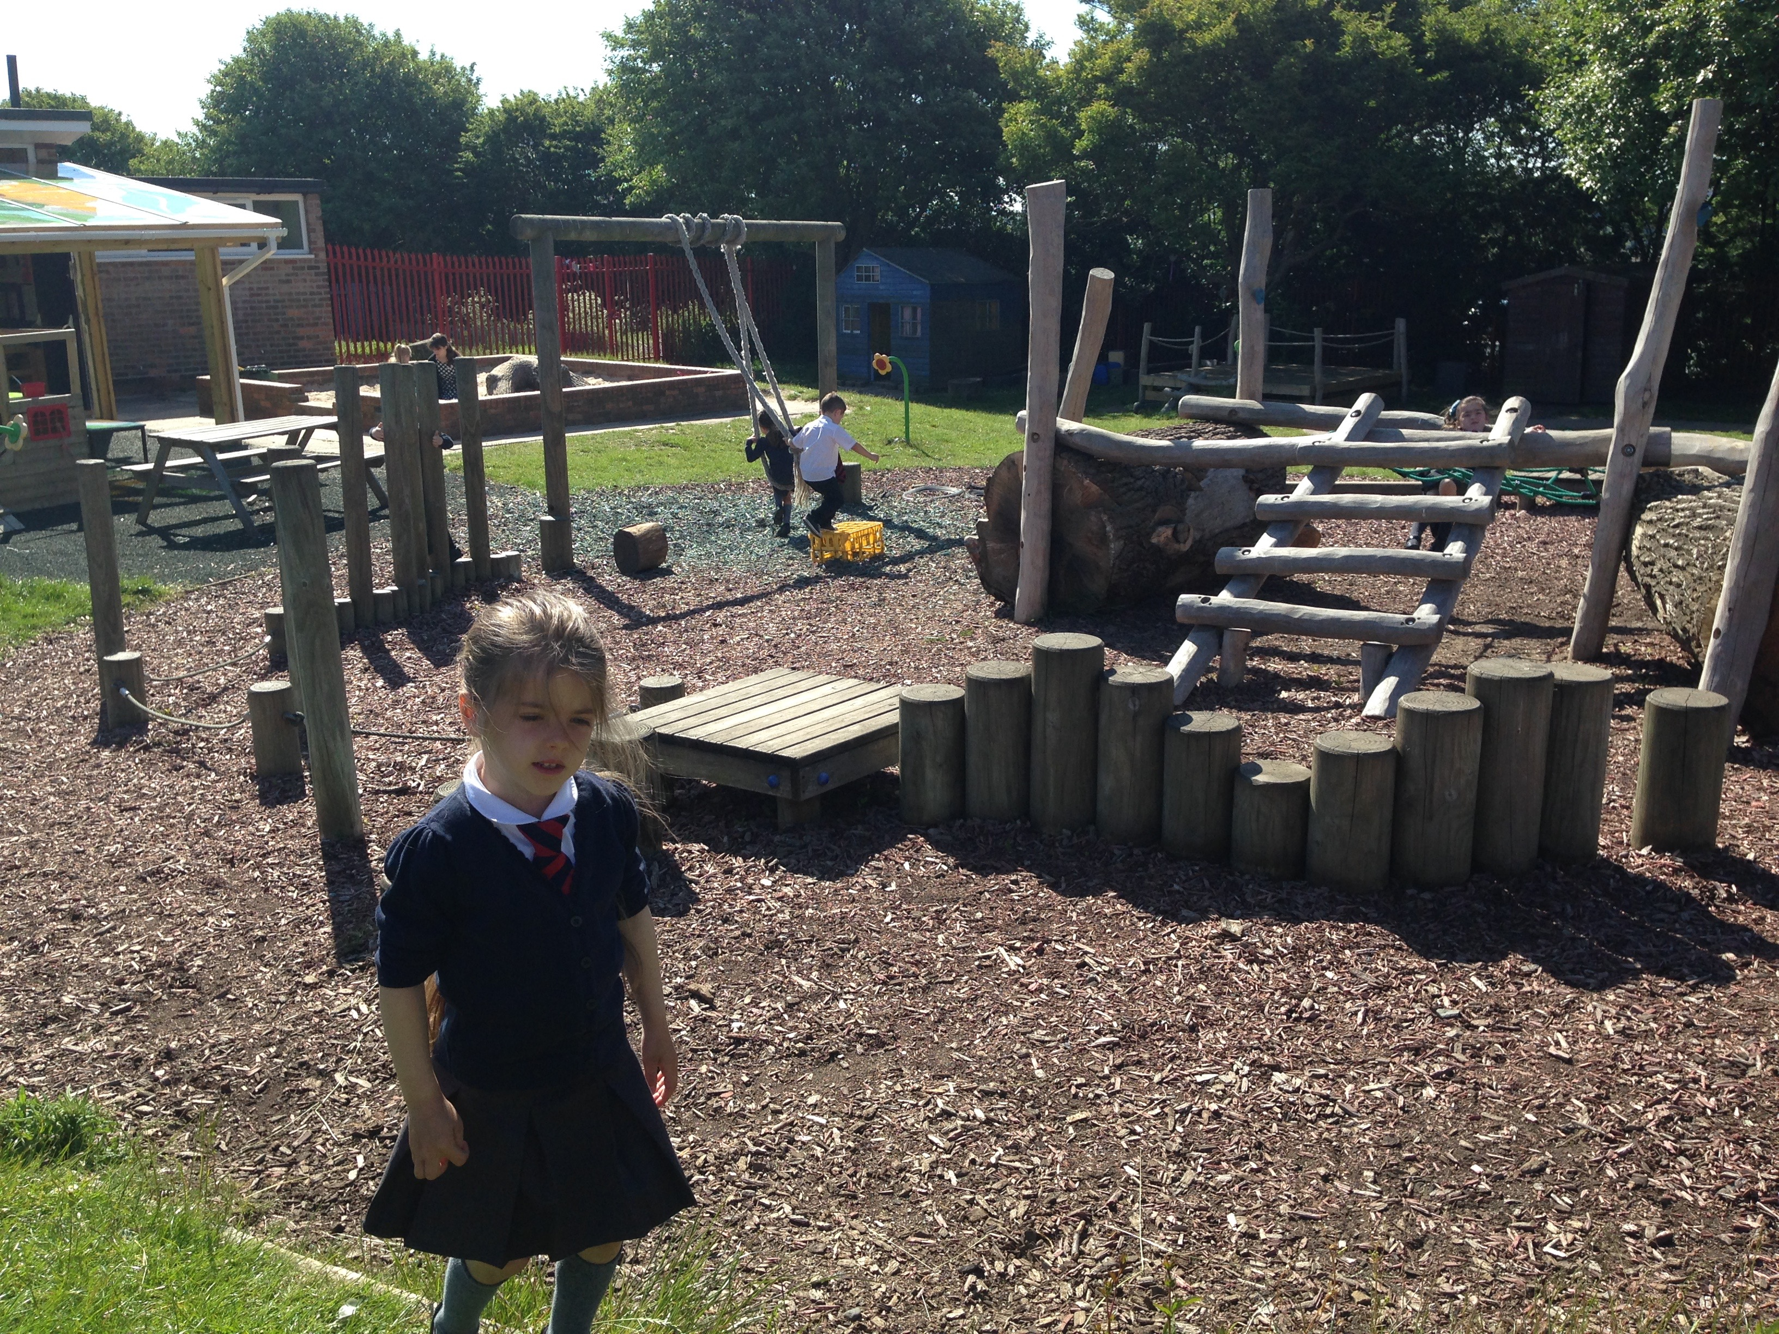
The provision in early years is spread over three classrooms, which are temporarily divided into three separate spaces with access to a shared outdoor area, which is large and ripe for development. We recently spent £60k on developing the outdoors and the linked forest school area but there is much more to be done to provide a stimulating and learner-led environment.

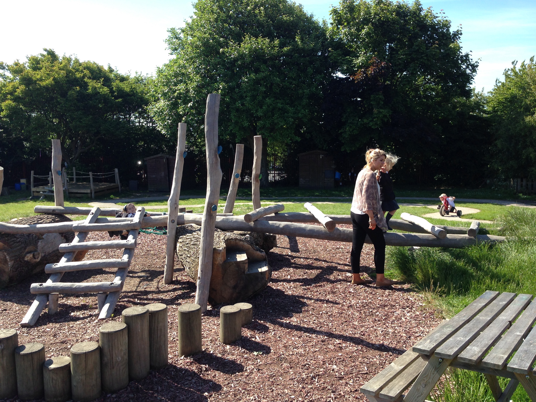
With strong leadership of the team our plan is to ensure that a through unit providing continuous provision is more fully established – a provision, which promotes learning but also ensures high quality learning behaviours. We would prefer a plan-do-review system of learning but one that ensures pupils are ready to meet the new standards at Key Stage 1. It will be important that any successful candidate feels confident they can raise standards across the EYFS curriculum (currently just below national), can do this in a relatively short period of time and can be ready to share good practice with others.

We have felt that Pupil Premium funding is often targeted higher in the school and the needs of pupils in EYFS are not always recognised quickly enough to establish spending priorities and narrow performance gaps. The other Assistant Heads manage 6 classes and a core subject so to make sure this post is on par the post holder will be responsible (with the support of the Head Teacher) to manage, direct and report on the impact of our pupil premium expenditure which is currently £0.34m. We don’t expect the successful candidate to have a thorough knowledge in this area, but would expect them to have the skills and ability to quickly come to terms with the strategies and cross school partnership activities needed to narrow the gap. We also believe that this will place EYFS at the centre of all the school does and not the forgotten or marginalised phase it is in many schools.

We pride ourselves on being an incredibly creative and innovative organisation. We expect all of our Leaders to be a major contributor to the school vision and to support in leading our schools to outstanding achievement, contributing to their continuing rich development within the schools and the local and wider community, which is essential in providing a highly valued education that is committed to excellence.

Our leaders are role models within, between and beyond our school, building a strong sense of community, relationally connected and responsive to others.

About the Roles - Assistant Head Year 3/4

We are looking for candidates who understand collaboration as a means to strive for excellence in both their own professional development and for first class provision for all of our children. Successful candidates will have the energy, experience and passion to help realise their own and our aspirations.

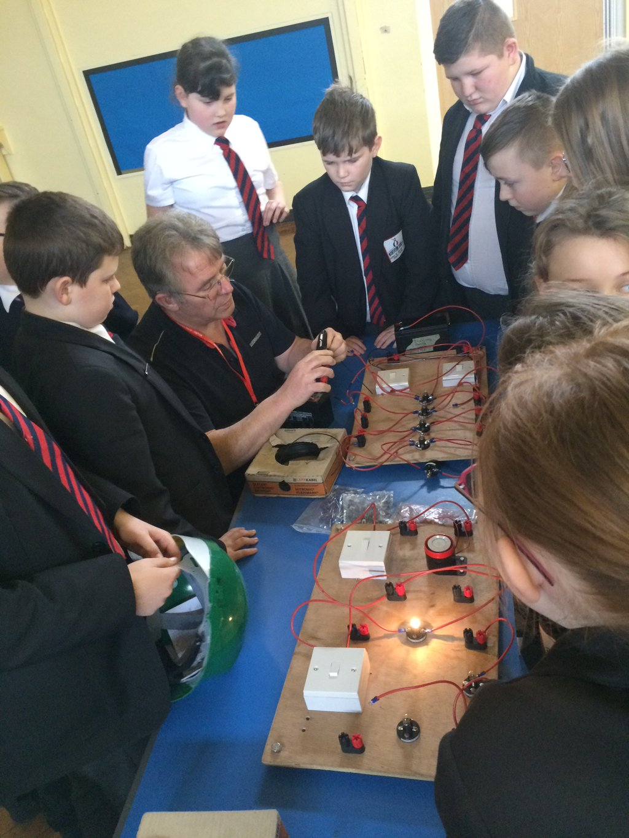
The provision in Year 3/4 is divided over 5/6 classrooms. There is easy access to the developing school farm and ECO garden from the phase, which enables teachers to enrich learning from first hand experience. The phase is in the oldest part of the school, which requires refurbishment scheduled for summer 2017. The new post holder should be a key planner in the design and working with the Head Teacher to create the very best learning environment. The phase leader post has been vacant this year and the team are currently made up of one experienced member of staff with others being NQTs or new to us.

With strong leadership of the team our plan is to ensure that this reasonably in-experienced team can quickly become high-performing and it will be important that any successful candidate feels confident they can continue to raise standards across the phase (currently above national but variable), can do this in a relatively short period of time and can be ready to share good practice with others. An ability to coach others is essential.

The post holder will be expected to lead a high profile subject across the school. Current needs for subject leadership are in Basic Skills (Literacy and Maths), History, ICT and Music. However, you may have another subject specialism and we are keen to maximise skills and abilities new staff can contribute.

We pride ourselves on being an incredibly creative and innovative organisation. We expect all of our Leaders to be a major contributor to the school vision and to support in leading our schools to outstanding achievement, contributing to their continuing rich development within the schools and the local and wider community, which is essential in providing a highly valued education that is committed to excellence.

Our leaders are role models within, between and beyond our school, building a strong sense of community, relationally connected and responsive to others.

Our Assistant Heads are assigned responsibilities from the generic job description below and we will endeavor to encourage innovation, share best practice and develop skills and knowledge across our own and any future schools joining the academy Trust.

PURPOSE OF JOB

- To support the Head Teacher in the provision of professional leadership and management of the school ensuring that high quality education is provided for all pupils.

- To share with the Head Teacher through positive leadership and personal example the task of leading, motivating and supporting staff in the development of a positive ethos which reflects the school’s commitment to high expectations and achievement in all areas of learning.

- To be an exemplar of excellent primary practice and provide a model of excellent professional practice for other staff.

MAIN DUTIES

- To undertake the professional responsibilities of a teacher as listed in the current School Teachers’ Pay and Conditions document. These shall include:

- Planning and preparing lessons.

- Teaching the pupils assigned to you including the setting and marking of work to be carried out by pupils in school and elsewhere.

- Assessing, recording and reporting on the development, progress and attainment of pupils.
- Ensuring the well being of individual pupils and of any class or group of pupils.

- Keeping records of and reports on the personal and social needs of pupils.

- Communicating and consulting with parents/carers of pupils.

- Liaising with outside agencies to support the needs of the pupils where necessary.

- Implementing agreed behaviour management strategies to maintain good order and discipline and ensuring the health and safety of all pupils.

- Co-ordinating and managing the work of other teachers and support staff who are deployed in your classroom.

ASSISTANT HEAD LEADERSHIP DUITIES

- To deputise for the Deputy Head Teacher in his/her absence.

- To lead a significant curriculum area, formulating policies, writing and carrying out an action plan, with clear evidence of impact on pupil progress.

- To be an effective and proactive member of both the Strategic Leadership Team and the Management Team.

- To assist the Head Teacher in the formulation, implementation and review of the School Improvement Plan and school targets.

- To play a key role in the whole school self-evaluation process.

- To assist the Head Teacher in monitoring and evaluating the quality of teaching and learning and in tracking pupil progress.

- To be a Team Leader in the Performance Management Process.

- Oversee the management of budgets for specific responsibilities.

- Line manages staff in the relevant phase.

- To identify the continuing professional development needs of staff through peer coaching and performance management review.

- To ensure that a high standard of physical and emotional care is maintained and a high standard of pupil behaviour is promoted and realised in line with school aims and policies.

- To promote and develop positive relationships with and between pupils, parents/carers, staff, governors, other agencies and the local and wider community.

- To lead school acts of worship.

- To attend and lead staff meetings/inset and parent/carers’ meetings, chairing as appropriate.

- To display an active interest in extra-curricular activities.

- To undertake such other responsibilities as the Head Teacher and Governing Body may reasonably request which are consistent with the statutory and contractual duties of the Deputy Head Teacher.

The post holder must carry out their duties with full regard to the Governing Body’s Equal Opportunities Policy, Code of Conduct and all other Governing Body Policies.

The post holder must comply with the Governing Body’s Health and Safety rules and regulations and with Health and Safety legislation.

The post holder must act in compliance with Data Protection principles in respecting the privacy of personal information held by the Governing Body.

The post holder must comply with the principles of the Freedom of Information Act 2000 in relation to the management of Governing Body records and information.

About the person - Assistant Head Teacher

 | Essential | Desirable
Qualifications,  Education,  Training | Degree and/or teaching qualification.  Recent relevant in-service training. | Post-graduate qualification.  Professional qualification e.g. “NPQSL” or “Outstanding Teacher Programme”.
Relevant  Experience | Successful teaching experience  Successful leadership within a substantial middle or senior management role.  Experience in developing whole-school policies and strategies. | Evidence of a contribution to wider educational issues.  Evidence of cross school improvement/development
Knowledge, Skills,  Abilities | Understanding the principles of effective teaching and learning.  A track record of raising standards and achievement through excellence in teaching and learning.  Very good oral and written communication skills.  Excellent classroom practitioner.  Excellent ICT skills.
Leadership & Management | Ability to manage, motivate, support and inspire trust in others.  Ability to work as part of a team.  Ability to work well under pressure.  Ability to formulate, monitor, evaluate and review plans and policies.  Ability to confront and resolve problems.  Ability to innovate and manage change.  Ability to lead INSET and research at school / Trust level.
Dispositions and Attitudes | Hold and articulate clear values and moral purpose.  Have vision and values aligned with the school’s high aspirations and high expectations for children, staff and families.  A relentless focus on improvements through a deep understanding of issues and insisting on high academic standards.  Understands how to set high aspirations and lead effective strategies across all aspects of a primary school including learning, accountability, curriculum, administration, and communication.  Promote diversity; champion the vulnerable.  Clear understanding of the ethos and strategies to establish consistently high standards of outcomes and attitudes and behaviour in an area of socio-economic challenge and commitment to relentlessly securing those standards.
Further information and application details

We are proud to offer...
- An innovative professional learning environment
- Children who are proud of their school and want to achieve
- A genuinely committed staff
- A commitment to the health and well-being of all of our staff
- Professional development opportunities second to none
Closing date: Monday 9th May 12 noon
Recruitment Events
Tuesday 26th April 2016 4-6pm
Thursday 5th May 2016 4-6pm
Come along and meet our staff, senior pupils and Governors, see our facilities and hear some short presentations
Interviews are scheduled for 18th May 2016 between 0930 – 1630hrs but shortlisted candidates will also be invited to complete a personality/leadership online test to help us determine your suitability to work with us.

The main contact for applications or any queries relating to the advertisement, please contact:

Dionne Hall, HR Clerk/PA to Head Teacher - 0191 5535580
Email - dionne.hall@nsprimary.org.uk

Rotherham Road, Redhouse, Sunderland, SR5 5QL
Tel: 0191 5535580
Email: reception@nsprimary.org.uk

