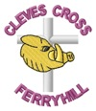

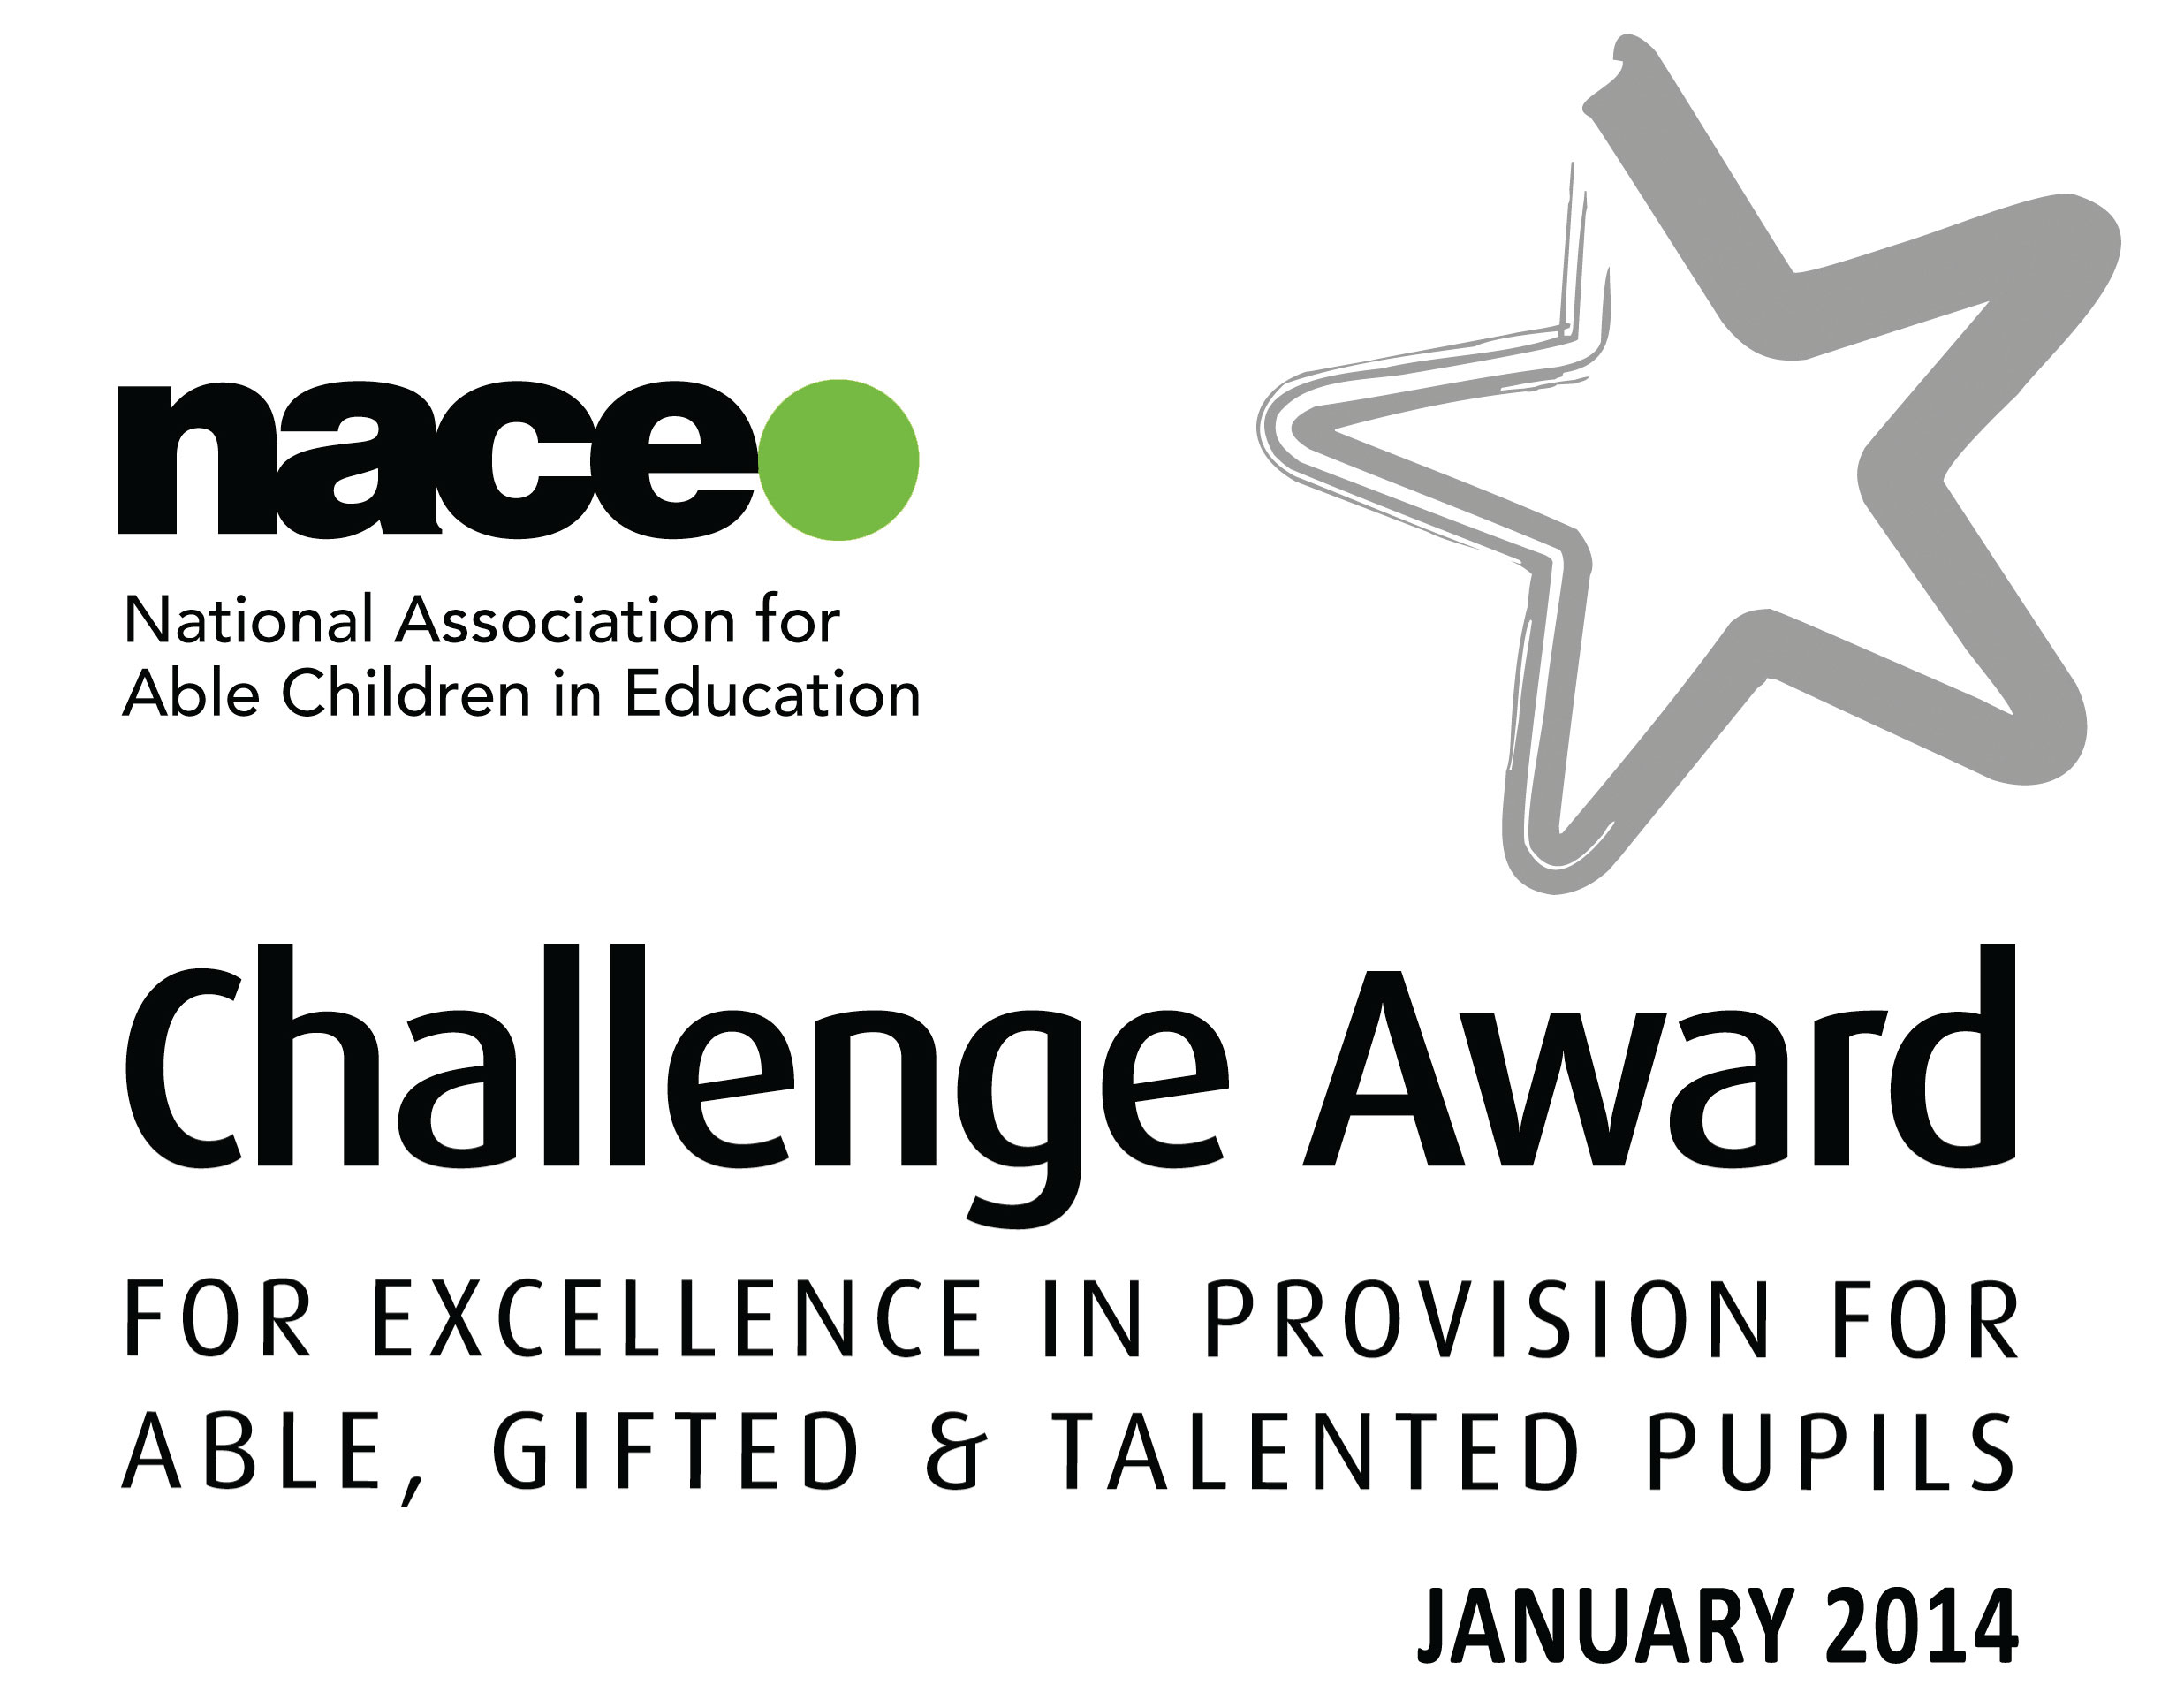

Cleves Cross Primary School
Cleves Cross
Ferryhill
Co. Durham
DL17 8QY
Telephone: 01740 651599
clevescross@durhamlearning.net

Dear Applicant,

Thank you for your interest in the post of Early Years Foundation Stage Leader that we currently have advertised. Please download the detailed Person Specification and Job Description in relation to the post.

The staff and governors here at school look forward to meeting prospective candidates during the appointments process in the knowledge that the successful candidate will become a key part of our happy, supportive and dedicated school team.

Should you decide to apply for the position and would like to see more of our school, I have arranged for two opportunities for visits. One visit will be during the school day and one after school:

Wednesday 13th April at 4.00pm or Thursday 14th April at 2.00pm

If you would like to attend either of these visits, please contact Mrs. Pauline Foster, School Business Manager to arrange.

Once again, thank you for the interest you have shown in our vacancy and I look forward to meeting you either on a visit or at interview, should you be successful.

Yours sincerely
Alison Lazenby
Mrs. A. Lazenby

Head Teacher

