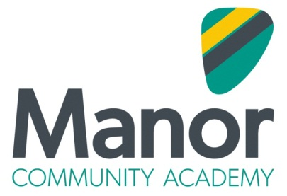

Manor Staff Charter
All staff at Manor Community Academy are committed to the values and ethos of the academy. To promote and maintain these values and ethos staff:
- Actively promote and contribute to the inclusion of all students
- Plan learning experiences which are of a high standard and are tailored to the individual needs of all students
- Demonstrate commitment to the progress and attainment of all students
- Recognise and act upon their role in ensuring the wellbeing, welfare and safety of all students
- Support and promote extra-curricular experiences
- Guide and nurture the social and personal development of students and encourage and reward active citizenship
- Maintain a culture of positivity which celebrates achievement
- Promote a culture of resolution and understanding

To support and enhance the promotion of the academy’s values and ethos, there is a commitment to:

- Promote a professional and collegiate culture amongst all staff
- Provide relevant and appropriate continued professional development and career stage support
- Ensure that effective coaching and mentoring networks are able to support all staff across the academy
- Provide opportunities for action research, project based learning and engagement in academy wide and Trust wide initiatives
- Support and nurture a professional culture of distributed leadership and empowered autonomy
- Recognise and celebrate staff commitment to the academy and its continued improvement

