Park End Primary School
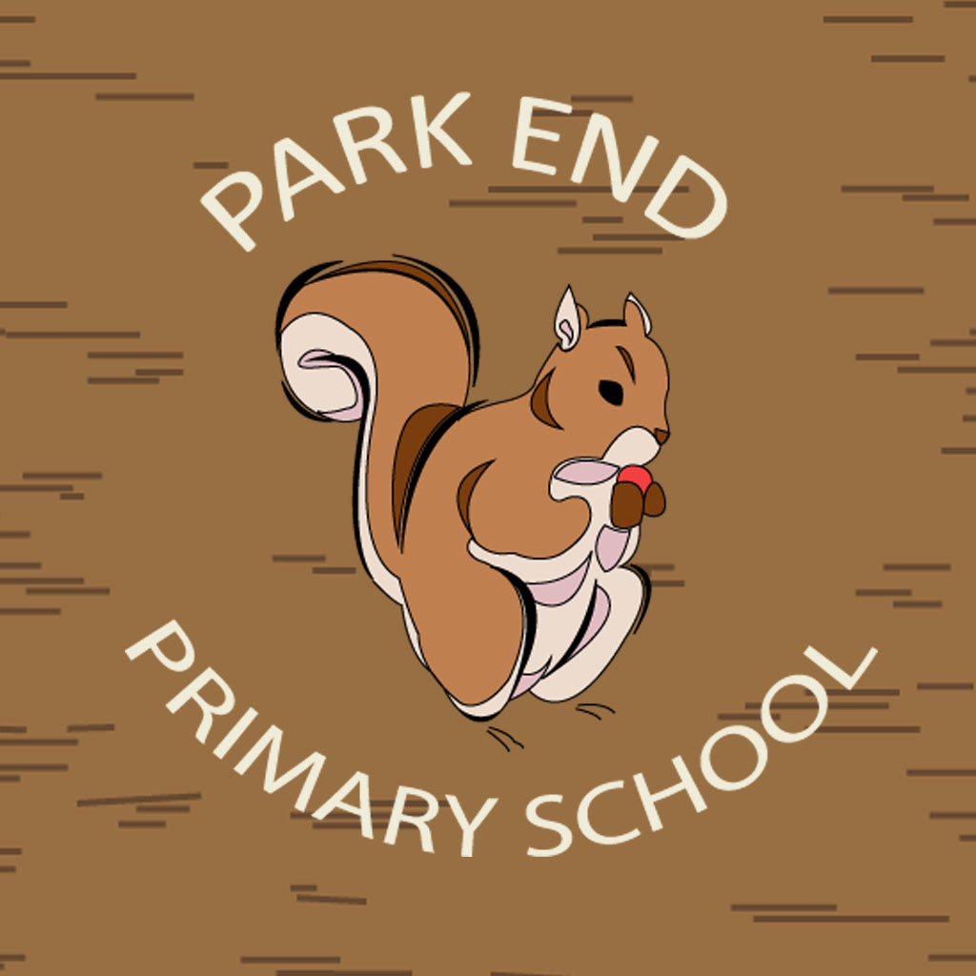
Overdale Road
Park End
Middlesbrough
TS3 0AA
Tel: 01642 314309
Website: www.parkend.uk.org

Headteacher Mary Hall

Classroom Teachers

Required September 2016 – August 2017

Fixed Term
Salary: Main Scale/Upper Pay Scale
Governors, staff and children would like to invite dynamic, effective and aspiring teachers who are passionate about learning to join our school.
We would like to hear from you if you enjoy the challenge of making a difference to children's lives and are:-
- Passionate about teaching and learning;
- Reflective and eager to improve your own skills;
- Achievement focused;
- Keen to become part of a supportive and effective team.

We are looking for teachers who have:-
- The ability to be excellent practitioners with high expectations and a commitment to raising standards;
- Excellent classroom management and be proficient in planning, assessment and target setting so that all children make good or better progress;
- The capacity to inspire and motivate children within a creative curriculum;
- The ability to be a reflective practitioner dedicated to their own professional development;
- The enthusiasm and dedication to be involved in the wider life of the school.

If you have then Park End School can offer you:
- A welcoming school with a very friendly and enthusiastic staff team;
- A dedicated and supportive governing body;
- Enthusiastic, well-behaved children who are keen to learn.

Visits to the School are welcome. Please contact the school office on 01642314309 to arrange a visit on Friday 26th February at either 1.30 am or 3.30 pm.
Application Forms are available on line or via the school office.
The School is committed to safeguarding and promoting the welfare of children and young people and expects all staff and volunteers to share this commitment. Safer recruitment practice and pre-employment checks will be undertaken before any appointment is confirmed. This post is subject to an enhanced Disclosure and Barring Service (DBS) check.

Closing Date: Friday 4th March 2016
Shortlisting : Tuesday 8th March 2016 pm
Interviews: Monday 14th March 2016

