


Post: Teacher of Science
Pay scale: Common Pay Scale
For: September 2016

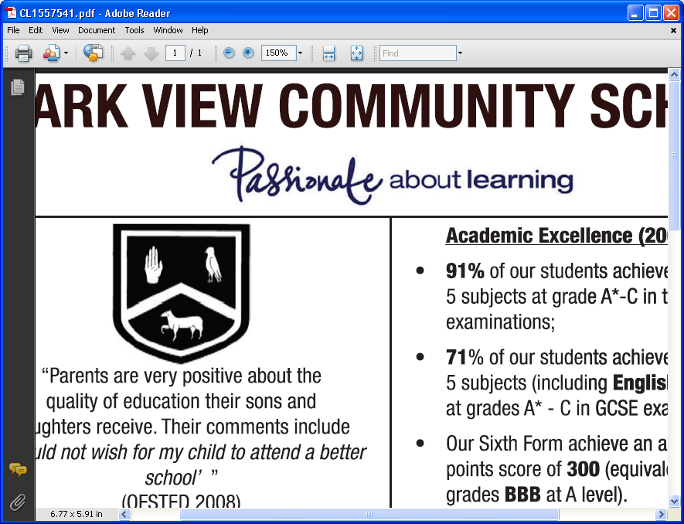

Dear applicant

First and foremost, thank you for applying to Park View School – we are always delighted when other professionals take an interest in us.

The school has been in Chester-Le-Street for over 100 years, starting life as a selective grammar, becoming a state school in the early Seventies and then a converter academy in August 2011. We are split over two sites, with Years 7 and 8 educated two miles away from the rest of the school population; the students stay on their respective sites whilst the staff travels when required to do so, at break and/or lunchtime. In national terms, we are a large school, with 1385 students, 285 of whom are in the Sixth Form.

In a recent Ofsted inspection, in which we were graded Good with Outstanding for Behaviour, an inspector commented that Park View was the happiest secondary school he had been in, such was the strength of relationships between the staff and the students. This is a matter of great pride to us as we do not want simply to produce excellent academic results; we want the children to feel part of a nurturing community in which they are cared for as individuals and expected to give something back in return. It goes without saying that we have high expectations of them both academically and in terms of their conduct: we provide them with a safe and secure environment, with clearly defined rules for what is acceptable, and, in return, they flourish. I may be biased but I believe that I have the finest, most talented young people you will ever meet in my school; to be with them on a daily basis is both a pleasure and a privilege.

Park View has a reputation for being at the forefront of learning, largely because I have a staff that sees it as their moral duty as educators to provide the best experience possible for our students. Our aim is to produce excellent results but to avoid being an exam factory; instead to provide the children with a rounded education in which they develop the skills, habits of mind and attitudes to life which they will need to take their place in the world. We were proud to be a Language College and have retained both a suite of languages and a curriculum infused with the international dimension. In addition, we have developed a learning model, Park View Learning, which has evolved from Guy Claxton’s ‘Building Learning Power’, and have recently been working with Hi-Tech High in San Diego to explore the benefits of project-based learning. Whilst we have many computer rooms on each site, a team of volunteer staff, ‘the digital leaders’ have also been looking at the potential offered by wireless technology and mobile devices. All of this means that this is a very exciting time to be joining the school!

We are looking to appoint a professional who is passionate about both Science and teaching to join a faculty of fourteen specialist teachers. We have no preference at all about age or experience, as long as you are capable of teaching three sciences to GCSE and at least one to A-level and have a desire to see enjoyment and engagement at the heart of the school.(The ability to teach A Level Physics may be an advantage)

I sincerely hope that you will follow up your interest by making an application to join us. Should you do so, please have your application to us by 12 noon on Thursday 25th February. It may be submitted by email to personnel@parkviewlearning.net or hard copy to Mrs Wendy Taylor at Park View School, Church Chare, Chester-le-Street. Co Durham DH3 3QA

I wish you every luck in securing the position!

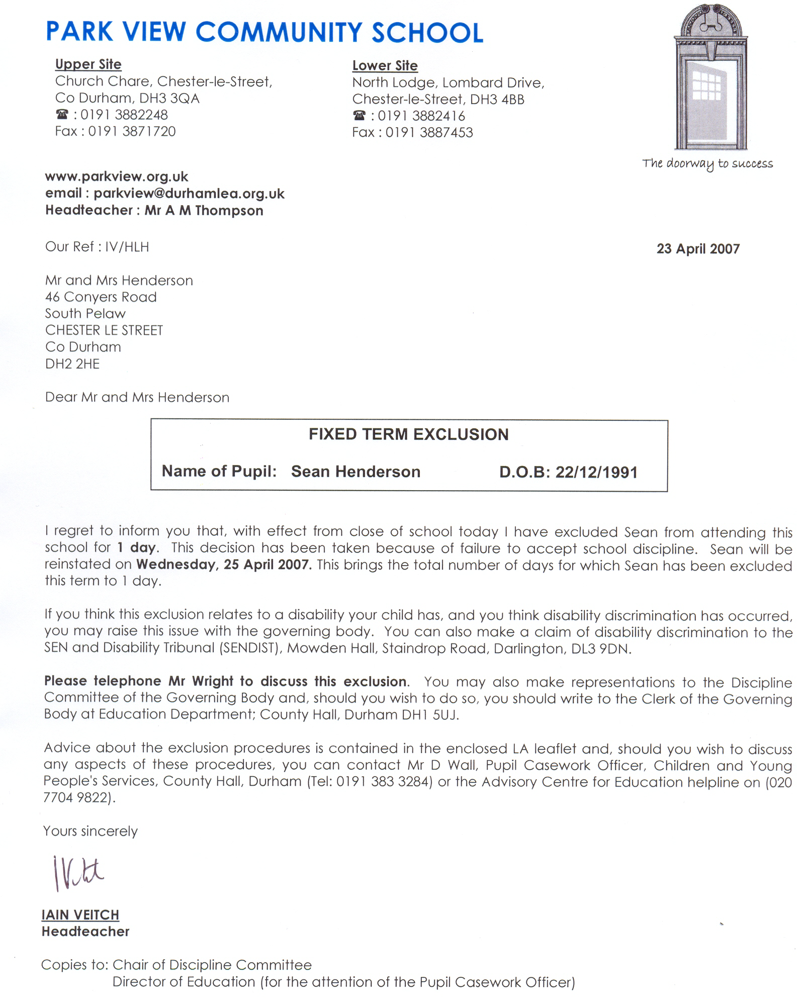
Yours faithfully

I.R. Veitch

