East Boldon Infant School
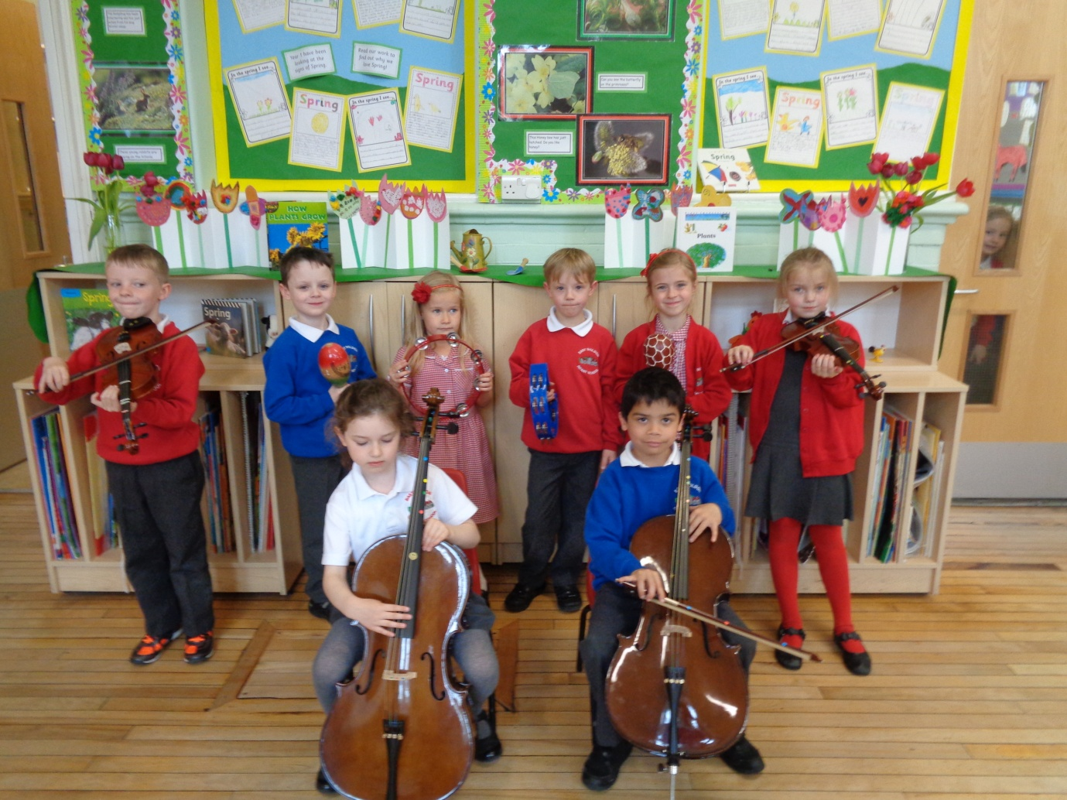

Head Teacher Recruitment Information Pack

EAST BOLDON INFANT SCHOOL
FRONT STREET
EAST BOLDON
TYNE & WEAR
NE36 0SW
Telephone : 0191 5367292
Fax: 0191 5194598
www.eastboldoninfants.co.uk

How to apply

To apply, please send a completed application form together with a supporting statement of no more than 2 sides of A4 outlining how you satisfy all the essential and as many as possible of the desirable elements of the personal specification, how your experience to date makes you suitable for the role and your motivation for applying.

Closing Date is noon on Monday 15th February.

Please send your completed application form and letter of application to

HR Services, Hawthorne, Rolling Mill Road, Viking Industrial Park, Jarrow, Tyne and Wear, NE32 3DP

or by e-mail to jobs@southtyneside.gov.uk

Selection Process:

Stage 1: Teaching Observation and Unseen Task

Thursday 10th March or Friday 11th March

Stage 2 : Presentation and Interview

Wednesday 23rd March

You are welcome to visit the school on Wednesday 3rd February or another date if this is not convenient. To arrange a visit please contact Mrs.V Gasston (Head Teacher) on 0191 5367292

Personal Specification

[A] TRAINING AND QUALIFICATIONS

 | Essential | Desirable | Source  A- application  I - interview  R - references O-observa- tion  C -certificates
Qualified teacher status. |  |  | AC
Degree. |  |  | AC
Higher degree. |  |  | AC
Post-entry curriculum or management qualification. |  |  | AC
National Professional Qualification for Headship. |  |  | AC
Evidence of continuous Professional development relating to school leadership and management and teaching and learning. |  |  | ARC

[B] EXPERIENCE OF TEACHING AND SCHOOL MANAGEMENT

 | Essential |  | Desirable |  | Source
Substantial successful recent leadership experience at Head teacher level in a school including KS1 provision. |  |  |  |  | ARI
Substantial successful current leadership experience at Senior Leadership level in a school which has KS1 provision |  |  |  |  | ARI
A proven record as an outstanding teacher. |  |  |  |  | ARIO
A proven track record in raising standards and improving teaching and learning. |  |  |  |  | ARI
A good understanding of using school data to evaluate progress and target set for improvement. |  |  |  |  | ARI
Successful experience of financial planning and resource management to develop whole school improvement. |  |  |  |  | ARI
Successful experience of managing whole school initiatives. |  |  |  |  | ARI
Knowledge and specific experience of proven strategies to support learning needs of targeted groups to include children with Special Educational Needs, higher achieving and disadvantaged pupils. |  |  |  |  | ARI
A secure understanding of safeguarding requirements |  |  |  |  |  | ARI

[C] PROFESSIONAL KNOWLEDGE AND UNDERSTANDING

Applicants should be able to demonstrate a good knowledge and understanding of the following areas relevant to the specific phase.
 | Essential | Desirable | Source
A thorough understanding of the Early Years Foundation Stage and Key Stage 1 curriculum. |  |  | ARI
Pupil’s educational development. |  |  | ARI
Curriculum and assessment. |  |  | ARI
Effective Teaching and Learning Strategies. |  |  | ARI
Local and national priorities and policies and statutory frameworks, including safeguarding. |  |  | ARI
School Improvement strategies and rigorous self-review processes. |  |  | ARI
Role of the Governing Board. |  |  | ARI
Awareness of the role of the school and potential contribution to the local and wider community |  |  | AIRI

[D] PERSONAL SKILLS AND ABILITIES

Applicants should be able to provide evidence that they have the necessary personal skills and abilities required by the post:
 | Essential | Desirable | Source
Excellent verbal and written communication skills |  |  | AI
Excellent Interpersonal skills |  |  | AIR
An ability to motivate and inspire all pupils and staff to fulfill their potential |  |  | I
Ability to work with local partners and the community. |  |  | ARI
Clear vision and the ability to innovate to raise standards |  |  | I
Ability to motivate and enthuse others through effective leadership |  |  | I
High levels of stamina and resilience |  |  | I
To be an inspirational role model and lead by example. |  |  | IR
An ability to develop effective relationships with parents, staff and governors |  |  | IR
Good listening Skills |  |  | I
Excellent personal ICT skills and an ability to appreciate how innovative ICT can impact on teaching and learning |  |  | AI
Proactive in sharing their skills and interacting with parents and children |  |  | AI
Proven record of working with external agencies |  |  | AI

[E] OTHER REQUIREMENTS

Application forms should be completed in full |  |  | A
Should address the criteria identified in the person specification |  |  | A
Personal statement/letters of application are to be limited to a maximum of 2 sides of A4 using font 11 |  |  | A
Enhanced clearance from the Disclosure and Barring Service |  |  | DBS Check

[F] CONFIDENTIAL REFERENCES AND REPORTS

 | Essential
Two Written reference(s) only: one of which must be from current or last employer | 
Confirming professional & personal knowledge, skills & abilities referred to above. | 

Our Mission Statement

At East Boldon Infant School we pride ourselves on providing children with a happy and stimulating environment in which they can learn, develop and achieve. We are committed to providing a warm and supportive ethos where staff, children and the whole school community work together to ensure all feel happy, safe and cared for.
We work in partnership with parents, governors and the local community, to provide a culture of excellence, where pupils are encouraged to reach their full potential. We teach and learn in an inclusive atmosphere where every child is encouraged and supported to be successful. It is important to us that every child is valued and that their unique qualities are recognised. The children’s self- respect, confidence and ability to work both independently and co-operatively are positively promoted.
Our challenging, creative and exciting curriculum, combined with our high quality teaching, allows us to meet the diverse needs of all our pupils. We teach our children to have self-discipline, self-motivation and a sense of responsibility for their own well-being and for that of other people and their environment.

Job Description

POST TITLE: Head Teacher (East Boldon Infant School)

GRADE: L15 – L21

The appointment is subject to the current conditions of service for head teachers contained in the School Teachers’ Pay and Conditions document and other current education and employment legislation. In carrying out his/her duties the head teacher shall consult, where appropriate, the governing board, the Local Authority, the staff of the school and the parents of its pupils.

KEY AREA OF RESPONSIBILITY

1. STRATEGIC DIRECTION AND DEVELOPMENT OF THE SCHOOL

The strategic direction and development of a school stems from the school's Mission Statement and School Improvement Plan.

The head teacher works with the governing board to develop a vision and strategic view for the school in its service to the community. He or she analyses and plans for future needs and further development within, local and national contexts.

MAIN TASKS

1.1 To work with the governing board and staff, to determine and fulfil the Mission Statement.

1.2 To work with the governing board, in formulating the educational aims, objectives and targets of the school and policies for their implementation and publication on the schools website.

  - To ensure and agree the production of the School Improvement Plan.

1.4 To monitor and evaluate the performance of the school and its achievements, responding and reporting to the governing board as required.

  - To motivate staff and pupils through interest, encouragement and recognition of their unique value.

  - To implement and promote the governing board’s policies on equal opportunities.

  - To promote and safeguard the welfare of the children and young people

  - To participate, to such an extent as may be appropriate having regard to the head teacher’s other duties, in the teaching of pupils at the school.

1.9 To ensure that the management, finances, organisation and administration of the school support it’s vision and aims and are appropriate to the school’s present and likely future resources.

1.10 To arrange for a deputy head teacher or other suitable person to assume responsibility for the discharge of the head teacher’s functions at any time when absent from school.

KEY AREA OF RESPONSIBILITY

2. TEACHING AND LEARNING

In schools the search for excellence is expressed in teaching and learning, which responds to the needs and aspirations of its pupils and acknowledges their individual worth. The head teacher works with the governing board to secure and sustain effective teaching and learning throughout the school. He or she monitors and evaluates the quality of teaching and standards of attainment, using relevant benchmarks and setting targets for improvement.

MAIN TASKS

2.1 To be an excellent classroom practitioner modelling and demonstrating an unrelenting focus on the learning and teaching process.

2.2 To determine, organise and implement, in collaboration with other appropriate persons or bodies, a curriculum which:

Follows the curriculum policy of the governing board and meets statutory requirements.
- Is relevant to the needs, experience, interests, aptitudes and stages of development of all pupils, including those with special educational needs.
- Ensures the locally agreed policy on Religious Education is fulfilled.
- Fulfils the head teacher’s statutory duties in relation to the curriculum including the National Curriculum.
- Includes arrangements for the daily act of collective worship and the spiritual life of the school.

2.3 To develop means whereby:

- School policies on curriculum, assessment, recording and reporting inform effective teaching and learning.
- The arrangements for teaching and learning form a co-ordinated, coherent curriculum entitlement for all pupils.
- Information on pupils’ progress is used to improve teaching and learning, to inform and motivate pupils, to inform parents, to provide necessary references for other educational institutions and employers, and to aid governors in fulfilling their responsibilities for the school.
- There is continuity of learning and of progression for all pupils.
- Challenging targets are set for pupils’ attainment leading to whole school improvement.

2.4 To provide a curriculum for the spiritual, moral, social and cultural development of all pupils.

2.5 To ensure appropriate pastoral care and guidance for all in accordance with the mission statement.

2.6 To determine appropriate pupil groupings, which reflect the values of the Mission Statement.

2.7 To determine and publicise the means for promoting:

- Pupils’ self discipline.
- Respect for self, others and authority.
- Good behaviour on and off school premises.
2.8 To handle pupil disciplinary cases, in accordance with school policy and the provisions of the School Standards and Framework Act, 1998.

2.9 To promote a school ethos, which extends opportunities for learning and encourages extra-curricular activities.

KEY AREA OF RESPONSIBILITY

3. LEADING AND MANAGING STAFF

The head teacher's leadership should motivate, support, challenge and develop staff.

MAIN TASKS

3.1 To assist the governing board in determining the staffing structure of the school.

3.2 To assist the governing board and participate in the key task of selecting and appointing teaching and non-teaching staff, having regard to Local Authority guidelines and advice.

3.3 To deploy and manage all teaching and support staff appointed to the school by allocating particular duties, including such duties of the head teacher as may be properly delegated in a manner that is reasonable and consistent with their conditions of employment.

  - To ensure that cover is provided for absent teachers and is shared as equitably as possible.

  - To promote and develop good management practice, positive staff participation, effective communication and clear procedures.

  - To supervise and participate in arrangements made in accordance with the regulations for the management of the performance of teachers in the school, including participating in the identification of areas in which he/she would benefit from further training and undergoing such training.

  - To implement staff development policies appropriate to the nature of the school in relation to:

- The induction of new and newly qualified teachers and other staff.
- The development of professional knowledge, skills and abilities including those necessary for career development.
- The provision of professional advice, support and training.
- The provision of references where relevant to career progression.

  - To implement rigorous safeguarding policies and procedures to ensure that all members of the school community are kept safe,including when using online systems.

KEY AREA OF RESPONSIBILITY

4. EFFICIENT AND EFFECTIVE DEPLOYMENT OF STAFF AND RESOURCES

The deployment of staff, finance, material resources, time and energy should promote the common good of the community in accordance with the school’s Mission Statement.

The head teacher deploys staff and other resources efficiently and effectively to meet specific objectives in line with the school’s Mission Statement and with the strategic plans determined by the governing board.

MAIN TASKS

4.1 To implement the policies and procedures of the governing board concerning the resource and premises management of the school, in accordance with the Mission Statement, other guidance and any legal requirements.

4.2 To allocate, control and account for those financial and material resources of the school that are delegated to the head teacher. This also to include effective use of pupil premium allocation and appropriate monitoring of it’s effectiveness.

4.3 To ensure the security, maintenance and cleanliness of the school and its surroundings in accordance with governing board responsibilities under health and safety and other relevant legislation.

4.4 To seek to provide an attractive environment which stimulates learning and enhances the appearance of the school.

4.5 To ensure that any agencies and services contracted to the school work effectively and safely

KEY AREA OF RESPONSIBILITY

5. ACCOUNTABILITY

The head teacher should fulfil his or her responsibilities in accordance with the Mission Statement. The head teacher supports the governing board in fulfilling its responsibilities in accordance with national legislation.

The head teacher accounts for the efficiency and effectiveness of the school to the governing board and the wider community of the school.

MAIN TASKS

5.1 In relation to the governing board:

- To advise and assist in the exercising of its functions.
- To attend meetings of the governing board (without prejudice to any rights the head teacher may have as a governor of the school).
- To report to the governing board as required.

5.2 In relation to the community:

- To develop and maintain positive relationships with the local community.
- To ensure that the school recognises and meets its responsibilities to the life of the local community.
- To develop links with local employers for the benefit of the pupils and the school.
- To promote a positive image of the school in accordance with the mission statement.

5.3 In relation to parents and those with parental responsibility:

- To build an effective partnership between parents and the school, recognising them as the first educators of their children.
- To promote understanding of the mission, aims and ethos of the school by providing regular information to parents about:
The school curriculum.
The progress of their children.
Other matters relating to teaching methods and organisation.
- To contribute to the provision by the governors of a school prospectus and to their annual report to parents.
- To provide opportunities for dialogue between parents and staff and to encourage their involvement.
- To promote involvement in the wider life of the school.
- To be responsible for ensuring that the school website provides all partners with appropriate information both statutory and non-statutory.

5.4 In relation to the Local Authority:

- To ensure liaison and co-operation with officers and support services.
- To work with officers in the monitoring and evaluation of the school according to such arrangements as may be required by and/or agreed between the governing board and the Local Authority.
- To make such reports in connection with the discharge of the head teacher’s functions as may properly be required.
- To have regard to the provisions of the Code of Practice on Local Education Authority/School Relations.
- To take responsibility of the welfare of Looked after Children (LAC) and to be involved with the support and monitoring in a Care Plan.

5.5 In relation to other schools, colleges and educational bodies:

- To promote continuity of learning, progression of achievement and curriculum development.
- To arrange for effective transfer and induction of pupils.
- To maintain effective liaison.
- To maintain effective relationships with other schools.
- To provide training and work experience placements for school and college students as appropriate and in accordance with school policy.

5.6 In relation to other professional bodies, agencies and services:

To liaise, in the best interests of pupils or in the meeting of statutory obligations, with other educational professionals, medical, social and other support services.

This job description will be reviewed annually, as part of the performance management process. A review may be initiated at any other time by either the post-holder or the governing board.

